**WIKI 48 IN 1 KEYESTUDIO KS0349 SENSOR KIT**

[**https://wiki.keyestudio.com/Ks0349\_keyestudio\_48\_in\_1\_Sensor\_Kit**](https://wiki.keyestudio.com/Ks0349_keyestudio_48_in_1_Sensor_Kit)

## **Contents**

* [1 Keyestudio 48 in 1 Sensor Kit](https://wiki.keyestudio.com/Ks0349_keyestudio_48_in_1_Sensor_Kit" \l "Keyestudio_48_in_1_Sensor_Kit)
* [2 Description](https://wiki.keyestudio.com/Ks0349_keyestudio_48_in_1_Sensor_Kit" \l "Description)
* [3 Kit Contents](https://wiki.keyestudio.com/Ks0349_keyestudio_48_in_1_Sensor_Kit" \l "Kit_Contents)
* [4 Arduino IDE and Driver Installation](https://wiki.keyestudio.com/Ks0349_keyestudio_48_in_1_Sensor_Kit" \l "Arduino_IDE_and_Driver_Installation)
* [5 Example for Using Arduino IDE](https://wiki.keyestudio.com/Ks0349_keyestudio_48_in_1_Sensor_Kit" \l "Example_for_Using_Arduino_IDE)
* [6](https://wiki.keyestudio.com/Ks0349_keyestudio_48_in_1_Sensor_Kit" \l "Example_Projects) **Example Projects**
  + [6.1](https://wiki.keyestudio.com/Ks0349_keyestudio_48_in_1_Sensor_Kit" \l "Project_1:_White_LED) **Project 1: White LED**
  + [6.2](https://wiki.keyestudio.com/Ks0349_keyestudio_48_in_1_Sensor_Kit" \l "Project_2:_RGB_LED) **Project 2: RGB LED**
  + [6.3](https://wiki.keyestudio.com/Ks0349_keyestudio_48_in_1_Sensor_Kit" \l "Project_3:_3W_LED) **Project 3: 3W LED**
  + [6.4](https://wiki.keyestudio.com/Ks0349_keyestudio_48_in_1_Sensor_Kit" \l "Project_4:_Traffic_Light) **Project 4: Traffic Light**
  + [6.5](https://wiki.keyestudio.com/Ks0349_keyestudio_48_in_1_Sensor_Kit" \l "Project_5:_Buzzer_Beeping) **Project 5: Buzzer Beeping**
  + [6.6](https://wiki.keyestudio.com/Ks0349_keyestudio_48_in_1_Sensor_Kit" \l "Project_6:_Passive_Buzzer) **Project 6: Passive Buzzer**
  + [6.7](https://wiki.keyestudio.com/Ks0349_keyestudio_48_in_1_Sensor_Kit" \l "Project_7:_Digital_Push_Button) **Project 7: Digital Push Button**
  + [6.8](https://wiki.keyestudio.com/Ks0349_keyestudio_48_in_1_Sensor_Kit" \l "Project_8:_Collision_Flash) **Project 8: Collision Flash**
  + [6.9](https://wiki.keyestudio.com/Ks0349_keyestudio_48_in_1_Sensor_Kit" \l "Project_9:_Line_Tracking) **Project 9: Line Tracking**
  + [6.10](https://wiki.keyestudio.com/Ks0349_keyestudio_48_in_1_Sensor_Kit" \l "Project_10:_Infrared_Obstacle_Avoidance) **Project 10: Infrared Obstacle Avoidance**
  + [6.11](https://wiki.keyestudio.com/Ks0349_keyestudio_48_in_1_Sensor_Kit" \l "Project_11:_Photo_Interrupter) **Project 11: Photo Interrupter**
  + [6.12](https://wiki.keyestudio.com/Ks0349_keyestudio_48_in_1_Sensor_Kit" \l "Project_12:_Hall_Magnetic) **Project 12: Hall Magnetic**
  + [6.13](https://wiki.keyestudio.com/Ks0349_keyestudio_48_in_1_Sensor_Kit" \l "Project_13:_Knock_Sensor) **Project 13: Knock Sensor**
  + [6.14](https://wiki.keyestudio.com/Ks0349_keyestudio_48_in_1_Sensor_Kit" \l "Project_14:_Digital_Tilt_Sensor) **Project 14: Digital Tilt Sensor**
  + [6.15](https://wiki.keyestudio.com/Ks0349_keyestudio_48_in_1_Sensor_Kit" \l "Project_15:_Capacitive_Touch) **Project 15: Capacitive Touch**
  + [6.16](https://wiki.keyestudio.com/Ks0349_keyestudio_48_in_1_Sensor_Kit" \l "Project_16:_Flame_Alarm) **Project 16: Flame Alarm**
  + [6.17](https://wiki.keyestudio.com/Ks0349_keyestudio_48_in_1_Sensor_Kit" \l "Project_17:_Reed_Switch) **Project 17: Reed Switch**
  + [6.18](https://wiki.keyestudio.com/Ks0349_keyestudio_48_in_1_Sensor_Kit" \l "Project_18:_PIR_Motion_Sensing) **Project 18: PIR Motion Sensing**
  + [6.19](https://wiki.keyestudio.com/Ks0349_keyestudio_48_in_1_Sensor_Kit" \l "Project_19:_Analog_Temperature) **Project 19: Analog Temperature**
  + [6.20](https://wiki.keyestudio.com/Ks0349_keyestudio_48_in_1_Sensor_Kit" \l "Project_20:_Analog_Rotation) **Project 20: Analog Rotation**
  + [6.21](https://wiki.keyestudio.com/Ks0349_keyestudio_48_in_1_Sensor_Kit" \l "Project_21:_Photocell) **Project 21: Photocell**
  + [6.22](https://wiki.keyestudio.com/Ks0349_keyestudio_48_in_1_Sensor_Kit" \l "Project_22:_Analog_Sound) **Project 22: Analog Sound**
  + [6.23](https://wiki.keyestudio.com/Ks0349_keyestudio_48_in_1_Sensor_Kit" \l "Project_23:_Water_Level) **Project 23: Water Level**
  + [6.24](https://wiki.keyestudio.com/Ks0349_keyestudio_48_in_1_Sensor_Kit" \l "Project_24:_Soil_Moisture) **Project 24: Soil Moisture**
  + [6.25](https://wiki.keyestudio.com/Ks0349_keyestudio_48_in_1_Sensor_Kit" \l "Project_25:_Analog_Gas) **Project 25: Analog Gas**
  + [6.26](https://wiki.keyestudio.com/Ks0349_keyestudio_48_in_1_Sensor_Kit" \l "Project_26:_Analog_Alcohol) **Project 26: Analog Alcohol**
  + [6.27](https://wiki.keyestudio.com/Ks0349_keyestudio_48_in_1_Sensor_Kit" \l "Project_27:_Steam_Moisture) **Project 27: Steam Moisture**
  + [6.28](https://wiki.keyestudio.com/Ks0349_keyestudio_48_in_1_Sensor_Kit" \l "Project_28:_Analog_Ceramic_Vibration) **Project 28: Analog Ceramic Vibration**
  + [6.29](https://wiki.keyestudio.com/Ks0349_keyestudio_48_in_1_Sensor_Kit" \l "Project_29:_Voltage_Detection) **Project 29: Voltage Detection**
  + [6.30](https://wiki.keyestudio.com/Ks0349_keyestudio_48_in_1_Sensor_Kit" \l "Project_30:_Pressure_Detection) **Project 30: Pressure Detection**
  + [6.31](https://wiki.keyestudio.com/Ks0349_keyestudio_48_in_1_Sensor_Kit" \l "Project_31:_Ambient_Light) **Project 31: Ambient Light**
  + [6.32](https://wiki.keyestudio.com/Ks0349_keyestudio_48_in_1_Sensor_Kit" \l "Project_32:_Ultraviolet_Light) **Project 32: Ultraviolet Light**
  + [6.33](https://wiki.keyestudio.com/Ks0349_keyestudio_48_in_1_Sensor_Kit" \l "Project_33:_Digital_IR_Receiver) **Project 33: Digital IR Receiver**
  + [6.34](https://wiki.keyestudio.com/Ks0349_keyestudio_48_in_1_Sensor_Kit" \l "Project_34:_Digital_IR_Transmitter) **Project 34: Digital IR Transmitter**
  + [6.35](https://wiki.keyestudio.com/Ks0349_keyestudio_48_in_1_Sensor_Kit" \l "Project_35:_Pulse_Rate_Monitor) **Project 35: Pulse Rate Monitor**
  + [6.36](https://wiki.keyestudio.com/Ks0349_keyestudio_48_in_1_Sensor_Kit" \l "Project_36:_Joystick) **Project 36: Joystick**
  + [6.37](https://wiki.keyestudio.com/Ks0349_keyestudio_48_in_1_Sensor_Kit" \l "Project_37:_Rotary_Encoder) **Project 37: Rotary Encoder**
  + [6.38](https://wiki.keyestudio.com/Ks0349_keyestudio_48_in_1_Sensor_Kit" \l "Project_38:_Single_Relay) **Project 38: Single Relay**
  + [6.39](https://wiki.keyestudio.com/Ks0349_keyestudio_48_in_1_Sensor_Kit" \l "Project_39:_Linear_Temperature) **Project 39: Linear Temperature**
  + [6.40](https://wiki.keyestudio.com/Ks0349_keyestudio_48_in_1_Sensor_Kit" \l "Project_40:_Temperature_and_Humidity_Display) **Project 40: Temperature and Humidity Display**
  + [6.41](https://wiki.keyestudio.com/Ks0349_keyestudio_48_in_1_Sensor_Kit" \l "Project_41:_Magical_Light_Cup) **Project 41: Magical Light Cup**
  + [6.42](https://wiki.keyestudio.com/Ks0349_keyestudio_48_in_1_Sensor_Kit" \l "Project_42:_Attitude_Sensor) **Project 42: Attitude Sensor**
  + [6.43](https://wiki.keyestudio.com/Ks0349_keyestudio_48_in_1_Sensor_Kit" \l "Project_43:_Optical_Proximity_Detection) **Project 43: Optical Proximity Detection**
  + [6.44](https://wiki.keyestudio.com/Ks0349_keyestudio_48_in_1_Sensor_Kit" \l "Project_44:_Triaxial_Digital_Acceleration_Detection) **Project 44: Triaxial Digital Acceleration Detection**
  + [6.45](https://wiki.keyestudio.com/Ks0349_keyestudio_48_in_1_Sensor_Kit" \l "Project_45:_Micro_Servo) **Project 45: Micro Servo**
  + [6.46](https://wiki.keyestudio.com/Ks0349_keyestudio_48_in_1_Sensor_Kit" \l "Project_46:_Ultrasonic_Ranger) **Project 46: Ultrasonic Ranger**
  + [6.47](https://wiki.keyestudio.com/Ks0349_keyestudio_48_in_1_Sensor_Kit" \l "Project_47:_LCD_Display) **Project 47: LCD Display**
  + [6.48](https://wiki.keyestudio.com/Ks0349_keyestudio_48_in_1_Sensor_Kit" \l "Project_48:_Dot_Matrix) **Project 48: Dot Matrix**
* [7 Resource Download](https://wiki.keyestudio.com/Ks0349_keyestudio_48_in_1_Sensor_Kit" \l "Resource_Download)
* [8 Get One Now](https://wiki.keyestudio.com/Ks0349_keyestudio_48_in_1_Sensor_Kit" \l "Get_One_Now)

## **Keyestudio 48 in 1 Sensor Kit**

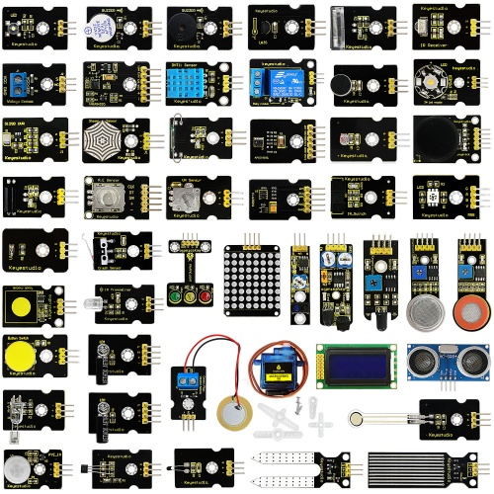

## Description

This sensor kit contains 48 kinds of commonly used sensor modules in playing the microcontroller, such as active buzzer module, 5V relay module, temperature and humidity module and so on. It is compatible for various microcontrollers and Raspberry Pi. At the same time, we also provide some detailed projects for each sensor based on development board, including wiring method, test code, etc. It can help you have further understanding of those sensor modules and can apply them to interactive projects.  
Note that in the following projects, the main board and other wires are Not Included in this kit. You need to prepare them by yourself.

## Kit Contents

|  |  |  |  |
| --- | --- | --- | --- |
| No. | Product Name | Quantity | Picture |
| 1 | White LED Module | 1 |  |
| 2 | RGB LED Module | 1 |  |
| 3 | 3W LED Module | 1 |  |
| 4 | Traffic Light Module (Black and Eco-friendly) | 1 |  |
| 5 | Active Buzzer Module | 1 |  |
| 6 | Passive Buzzer Module | 1 |  |
| 7 | Digital Push ButtonModule | 1 |  |
| 8 | Collision Sensor | 1 |  |
| 9 | Line Tracking Sensor | 1 |  |
| 10 | Infrared Obstacle Avoidance Sensor | 1 |  |
| 11 | Photo Interrupter Module | 1 |  |
| 12 | Hall Magnetic Sensor | 1 |  |
| 13 | Knock Sensor Module | 1 |  |
| 14 | Digital Tilt Sensor | 1 |  |
| 15 | Capacitive Touch Sensor | 1 |  |
| 16 | Flame Sensor | 1 |  |
| 17 | Reed Switch Module | 1 |  |
| 18 | PIR Motion Sensor | 1 |  |
| 19 | Analog Temperature Sensor | 1 |  |
| 20 | Analog Rotation Sensor | 1 |  |
| 21 | Photocell Sensor | 1 |  |
| 22 | Analog Sound Sensor | 1 |  |
| 23 | Water Sensor | 1 |  |
| 24 | Soil Humidity Sensor | 1 |  |
| 25 | Analog Gas Sensor | 1 |  |
| 26 | Analog Alcohol Sensor | 1 |  |
| 27 | Steam Sensor | 1 |  |
| 28 | Analog Piezoelectric Ceramic Vibration Sensor | 1 |  |
| 29 | Voltage Sensor | 1 |  |
| 30 | Thin-film Pressure Sensor (Black and Eco-friendly) | 1 |  |
| 31 | TEMT6000 Ambient Light Sensor | 1 |  |
| 32 | GUVA-S12SD 3528 Ultraviolet Sensor | 1 |  |
| 33 | Digital IR Receiver Module | 1 |  |
| 34 | Digital IR Transmitter Module | 1 |  |
| 35 | Pulse Rate Monitor Module | 1 |  |
| 36 | Joystick Module | 1 |  |
| 37 | Rotary Encoder Module | 1 |  |
| 38 | 5V Single Relay Module | 1 |  |
| 39 | LM35 Linear Temperature Sensor | 1 |  |
| 40 | DHT11 Temperature and Humidity Sensor | 1 |  |
| 41 | Magical Light Cup Module | 2 |  |
| 42 | APDS-9930 Attitude Sensor Module | 1 |  |
| 43 | ALS Infrared LED Optical Proximity Detection Module | 1 |  |
| 44 | MMA8452Q Module Triaxial Digital Acceleration Tilt Sensor | 1 |  |
| 45 | keyestudio 9G Servo Motor Blue 180° | 1 |  |
| 46 | HC-SR04 Blue Ultrasonic Sensor | 1 |  |
| 47 | Keyestudio 0802 LCD module 5V blue screen（with backlight） | 1 |  |
| 48 | keyestudio I2C 8x8 LED Dot Matrix | 1 |  |

## Arduino IDE and Driver Installation

When getting the development board, first of all you have to install the Arduino IDE and the driver, and all relevant files can be found on the official website.  
The following link includes various systems, various versions of the Arduino IDE and drivers whatever you choose.   
[https://www.arduino.cc/en/Main/OldSoftwareReleases#1.5.x](https://www.arduino.cc/en/Main/OldSoftwareReleases" \l "1.5.x)

Next, we first introduce the installation method of Arduino IDE-1.5.6 version in the Windows system.

The file downloaded is an arduino-1.5.6-r2-windows.zip compression folder, please unzip it to the hard disk. Double-click Arduino-1.5.6 .exe file. Please refer to the following setup figures:   
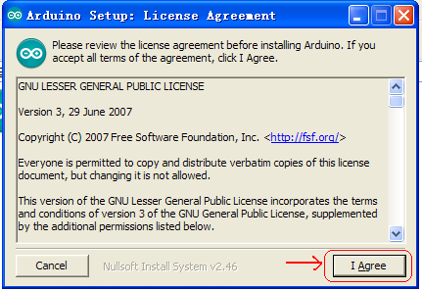

Click “I Agree”. Then, click “Next”   
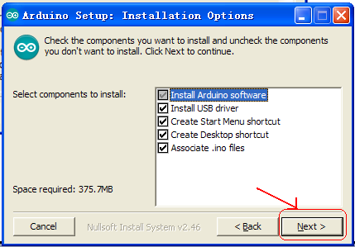

Next, click “Install”.   
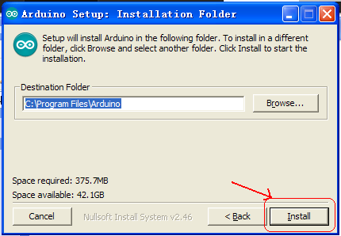

Finally, click “Close” after completing the installation.   
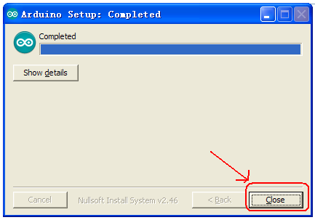

The figure below shows the Arduino 1.5.6 version:   
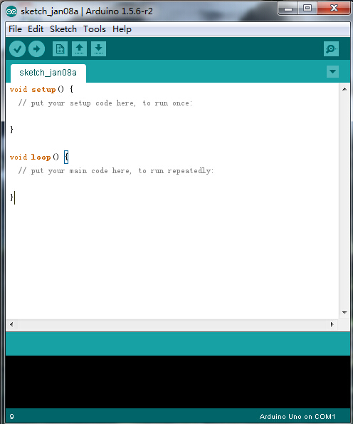

Next, we will introduce the driver installation of keyestudio UNO R3 development board. You can also follow it to install the driver for MEGA2560 R3 development board. The installation method is similar and you can use the same drive file.

Let’s move on to the driver installation in the WIN 7 system.

* When you connect UNO board to your computer at the first time, right click “Computer” —>“Properties”—> “Device manager”, you can see “Unknown devices”. First, right click “Computer” —>select “Properties”—> click “Device manager”, you should see an icon for ‘unknown device’ with a little yellow warning triangle next to it. This is your Arduino.   
  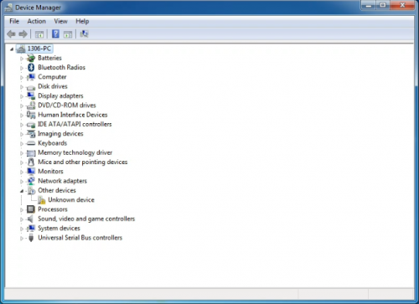
* Right-click on the device and select the top menu option (Update Driver Software...).   
  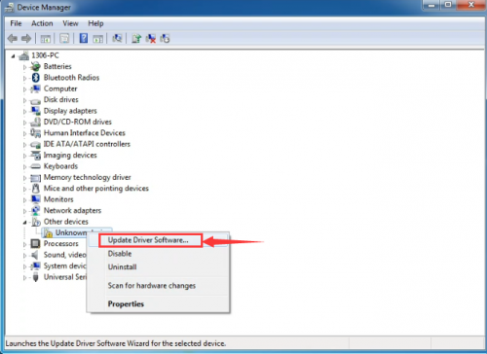
* You will then be prompted to either ‘Search Automatically for updated driver software’ or ‘Browse my computer for driver software’. In this page, click “Browse my computer for driver software”.   
  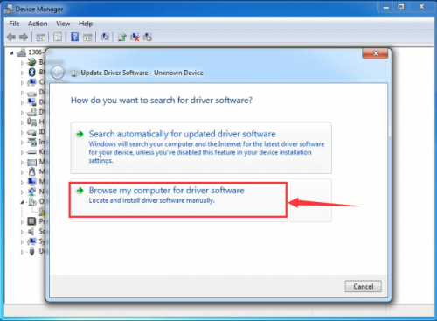
* Select the option to browse and navigate to the drivers folder.   
  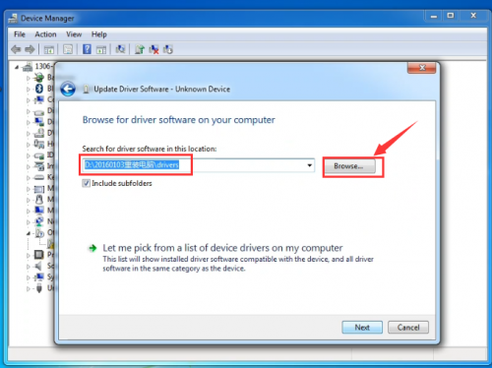
* Click 'Next' and you may get a security warning, if so, allow the software to be installed. Once the software has been installed, you will get a confirmation message.   
  
* Installation completed, click “Close”.   
  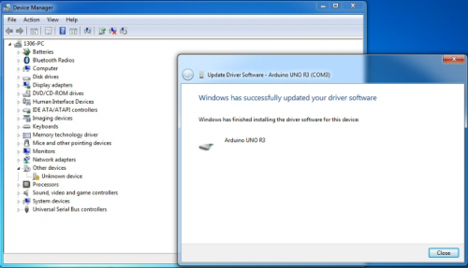
* After installation, go to check the “Device manager” again. right click “Computer” —> “Properties”—> “Device manager”, you can see the device shown as below figure.   
  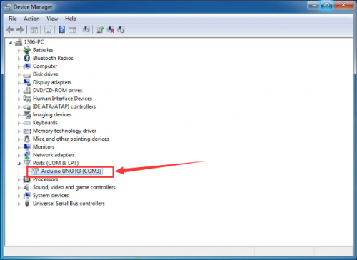

## Example for Using Arduino IDE

When successfully installing the USB driver for UNO R3 board, you can find the corresponding serial port in Windows Device Manager.  
Next, we will show you the program “Hello World!” displayed on the serial monitor of Arduino IDE. Here we use the Arduino 1.5.6 version.

**Sample Code as below:**   
Copy and paste the following source code to Arduino IDE.

int val;

int ledpin=13;

void setup()

{

Serial.begin(9600);

pinMode(ledpin,OUTPUT);

}

void loop()

{

val=Serial.read();

if(val=='R')

{

digitalWrite(ledpin,HIGH);

delay(500);

digitalWrite(ledpin,LOW);

delay(500);

Serial.println("Hello World!");

}

}

Then,set the Board and COM port, shown below.   
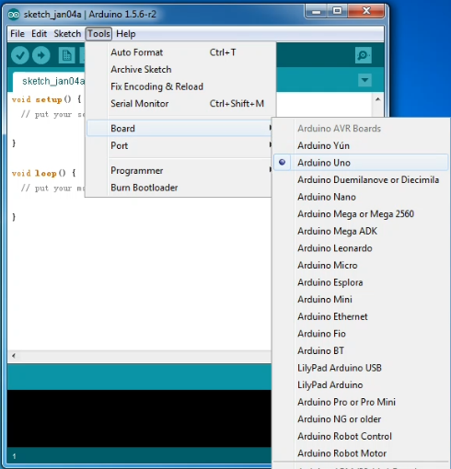  
  
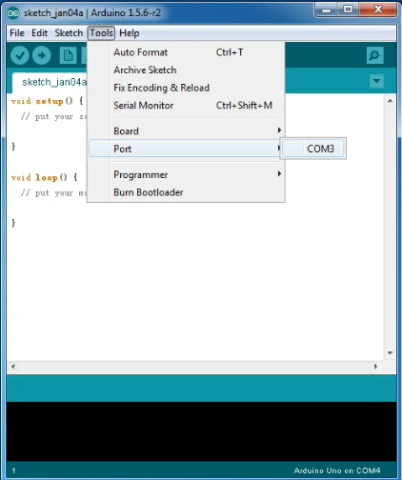

If setting well the board and port, you can see it display on the bottom right corner, which is the same as the Device Manager display.   
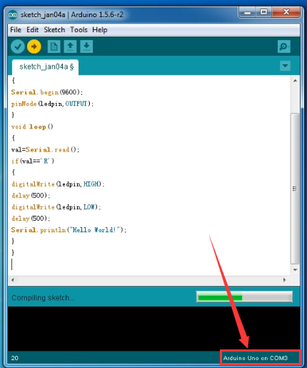

Then, click the verify to compile the sketch, if no mistake, click upload to upload the program.   
Done uploading, open the serial monitor on the upper right corner and set the baud rate as 9600, enter an “R” and then click “Send”, finally you can see the D13 indicator on the UNO R3 board blinks once, and “Hello World!” is displayed on the serial monitor. Shown below.   
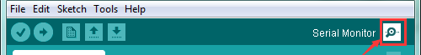  
  
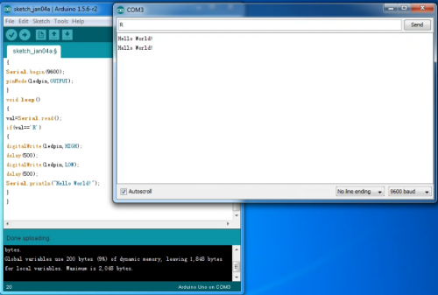

Congrats. Your first programming is done well!

## **Example Projects**

### *Project 1: White LED*

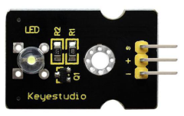

**Description**  
This white LED light module is ideal for Arduino starters. It can be easily connected to IO/Sensor shield. It enables interaction with light-related works.  
Note: You can choose other LED modules to emit different color like yellow, red, green and blue.

**Specification**

* White LED module
* Type: Digital
* PH2.54 socket
* Size: 30\*20mm
* Weight: 3g

**Connection Diagram**  
First, you need to prepare the following parts before connection:  
UNO board\*1  
White LED module \*1  
USB Cable\*1  
Jumper wire\*3  
Connect the S pin of module to Digital 3 of UNO board, connect the negative pin to GND port, positive pin to 5V port.  
  
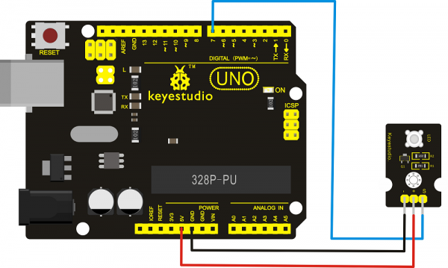

**Sample Code**  
Copy and paste the below code to Arduino software.

int led = 3;

void setup()

{

pinMode(led, OUTPUT); //Set Pin3 as output

}

void loop()

{

digitalWrite(led, HIGH); //Turn on led

delay(2000);

digitalWrite(led, LOW); //Turn off led

delay(2000);

}

**Example Result**  
Done wiring and powered up, upload well the code, you will see the LED module emit the white light.   
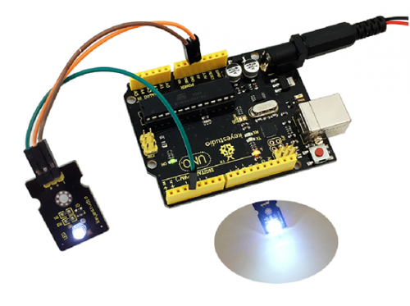

### *Project 2: RGB LED*

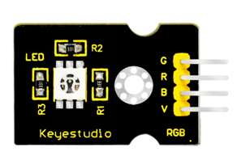

**Description**  
This is a full-color LED module, which contains 3 basic colors－red, green and blue. They can be seen as separate LED lights. After programming, you can turn them on and off by sequence or can also use PWM analog output to mix three colors to generate different colors.

**Specification**

* Color: red, green and blue
* Brightness: High
* Voltage: 5V
* Input: digital level
* Size: 30\*20mm
* Weight: 3g

**Connection Diagram**  
First, you need to prepare the following parts before connection:  
UNO Board\*1  
RGB LED module \*1  
USB Cable\*1  
Jumper Wire\*4

Connect the V pin of module to 5V port of UNO board, connect the B pin to Digital 9, R pin to Digital 10, G pin to Digital 11 .  
  
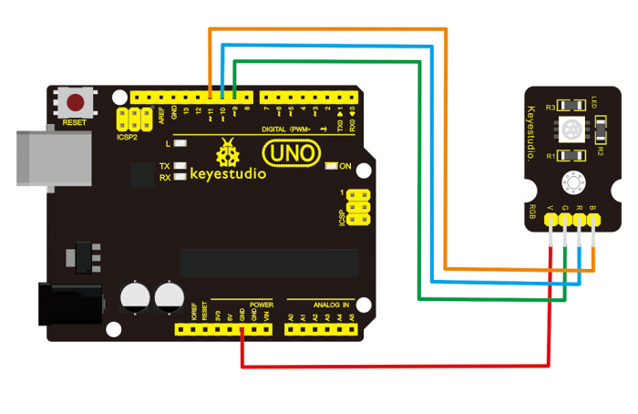

**Sample Code**  
Copy and paste the below code to Arduino software.

int redpin = 11; //select the pin for the red LED

int bluepin =10; // select the pin for the blue LED

int greenpin =9;// select the pin for the green LED

int val;

void setup() {

pinMode(redpin, OUTPUT);

pinMode(bluepin, OUTPUT);

pinMode(greenpin, OUTPUT);

}

void loop()

{for(val=255; val>0; val--)

{analogWrite(11, val);

analogWrite(10, 255-val);

analogWrite(9, 128-val);

delay(1);

}

for(val=0; val<255; val++)

{analogWrite(11, val);

analogWrite(10, 255-val);

analogWrite(9, 128-val);

delay(1);

}

}

**Example Result**  
Done wiring and powered up,upload well the code, you will see the RGB LED module emit shiny colors.   
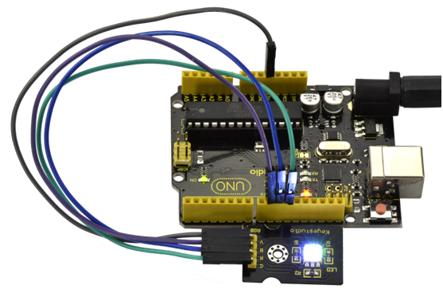

### *Project 3: 3W LED*

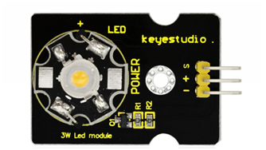

**Description**  
This LED module is of high brightness because the lamp beads it carries is 3w. You can apply this module to Arduino projects, ideal for Robot or search and rescue platform application. For example, intelligent robots can use this module for illumination purpose.   
Please note that the LED light can't be exposed directly to human eyes for safety concerns.

**Specification**

* Color temperature: 6000~7000K
* Luminous flux: 180~210lm
* Current: 700~750mA
* Power: 3W
* Light angle: 140 degree
* Working temperature: -50~80'C
* Storage temperature: -50~100'C
* High power LED module, controlled by IO port microcontroller
* IO Type: Digital
* Supply Voltage: 3.3V to 5V
* Size: 40x28mm
* Weight: 6g

**Connection Diagram**  
First, you need to prepare the following parts before connection:  
UNO Board\*1  
3W LED module \*1  
USB Cable\*1  
Jumper Wire\*3

Connect the S pin of module to Digital 13 of UNO board, connect the negative pin to GND port, positive pin to 5V port.  
  
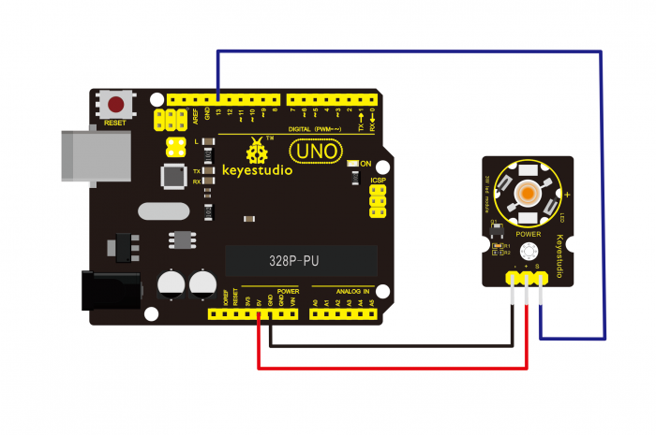

**Sample Code**  
Copy and paste the below code to Arduino software.

// the setup function runs once when you press reset or power the board

void setup() {

// initialize digital pin 13 as an output.

pinMode(13, OUTPUT);

}

// the loop function runs over and over again forever

void loop() {

digitalWrite(13, HIGH); // turn the LED on (HIGH is the voltage level)

delay(1000); // wait for a second

digitalWrite(13, LOW); // turn the LED off by making the voltage LOW

delay(1000); // wait for a second

}

### *Project 4: Traffic Light*

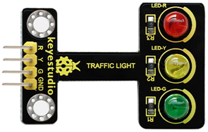

**Description:**  
When learning the microcontroller, you may usually use three LEDs, namely red, green and yellow lights to simulate the traffic light blinking via external connection.   
This time we specially design this module which is very convenient for wiring, and on the module you can see the red, yellow and green LED. This module is fully compatible with Arduino microcontroller and Raspberry Pi system.

**Specification:**

* Working Voltage: 3.3-5v
* Interface Type: digital
* PH2.54 Socket

**Connection Diagram:**  
First, you need to prepare the following parts before connection:  
UNO Board\*1  
Traffic light module \*1  
USB Cable\*1  
Jumper Wire\*4

Connect the R pin of module to Digital 5 of UNO board, connect the Y pin to Digital 4, G pin to Digital 3, GND pin to ground port.  
  
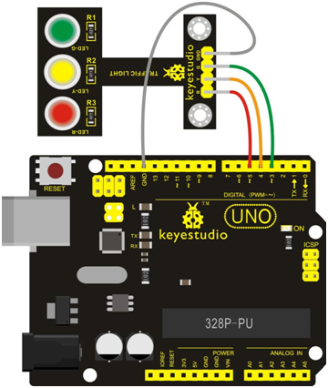

**Sample Code:**  
Copy and paste the below code to Arduino software.

int redled =5; // initialize digital pin 5.

int yellowled =4; // initialize digital pin 4.

int greenled =3; // initialize digital pin 3.

void setup()

{

pinMode(redled, OUTPUT);// set the pin with red LED as “output”

pinMode(yellowled, OUTPUT); // set the pin with yellow LED as “output”

pinMode(greenled, OUTPUT); // set the pin with green LED as “output”

}

void loop()

{

digitalWrite(greenled, HIGH);//// turn on green LED

delay(5000);// wait 5 seconds

digitalWrite(greenled, LOW); // turn off green LED

for(int i=0;i<3;i++)// blinks for 3 times

{

delay(500);// wait 0.5 seconds

digitalWrite(yellowled, HIGH);// turn on yellow LED

delay(500);// wait 0.5 seconds

digitalWrite(yellowled, LOW);// turn off yellow LED

}

delay(500);// wait 0.5 seconds

digitalWrite(redled, HIGH);// turn on red LED

delay(5000);// wait 5 seconds

digitalWrite(redled, LOW);// turn off red LED

}

**Example Result:**  
Done uploading the code, powered up, three LEDs on the module will automatically simulate the traffic light on and off, circularly.   
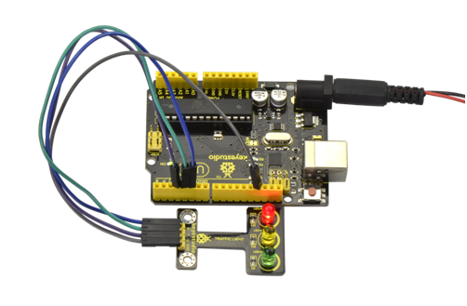

### **Project 5: Buzzer Beeping**

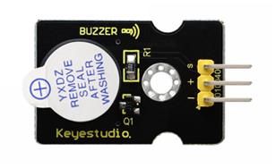

**Introduction:**  
Here is the simplest sound making module. You can use high/low level to drive it. Changing the frequency it buzzes can produce different sounds. This module is widely used on our daily appliances like PC, refrigerator, phones, etc. In addition, you can create many interesting interactive projects with this small but useful module.Just try it!! You will find the electronic sound it creates so fascinating.

**Specification:**

* Working voltage: 3.3-5v
* Interface type: digital
* Size: 30\*20mm
* Weight: 4g

**Connection Diagram:**  
First, you need to prepare the following parts before connection:  
UNO Board\*1  
Active buzzer module \*1  
USB Cable\*1  
Jumper Wire\*3

Connect the S pin of module to Digital 3 of UNO board, connect the negative pin to GND port, positive pin to 5V port.  
  
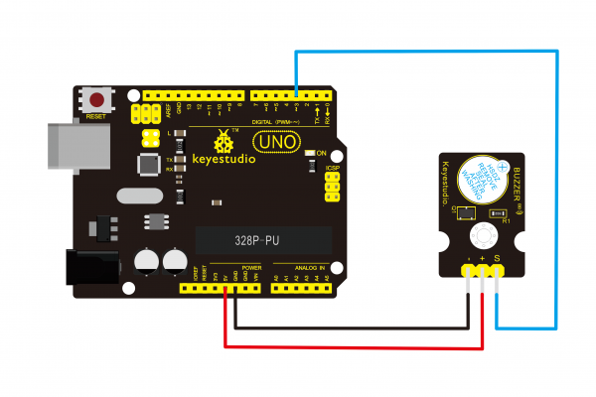

**Sample Code:**  
Copy and paste the below code to Arduino software.

int buzzPin =3; //Connect Buzzer on Digital Pin3

void setup()

{

pinMode(buzzPin, OUTPUT);

}

void loop()

{

digitalWrite(buzzPin, HIGH);

delay(1);

digitalWrite(buzzPin, LOW);

delay(1);

}

**Example Result:**  
Done uploading the code to board, the buzzer will make a sound.   
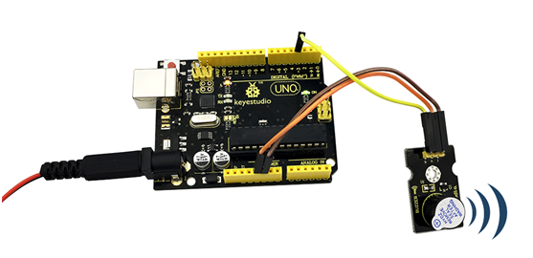

### *Project 6: Passive Buzzer*

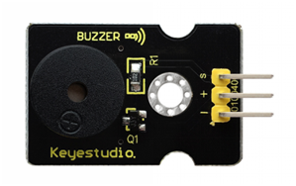

**Introduction:**  
We can use Arduino to make many interactive works of which the most commonly used is acoustic-optic display. The circuit in this experiment can produce sound. Normally, the experiment can be done with a buzzer or a speaker, while buzzer is simpler and easier to use. The buzzer we introduced here is a passive buzzer. It cannot be actuated by itself, but by external pulse frequencies. Different frequencies produce different sounds. You can use Arduino to code the melody of a song, quite fun and simple.

**Specification:**

* Working voltage: 3.3-5v
* Interface type: digital
* Size: 30\*20mm
* Weight: 4g

**Connection Diagram:**  
First, you need to prepare the following parts before connection:  
UNO Board\*1  
Passive buzzer module \*1  
USB Cable\*1  
Jumper Wire\*3

Connect the S pin of module to Digital 3 of UNO board, connect the negative pin to GND port, positive pin to 5V port.  
  
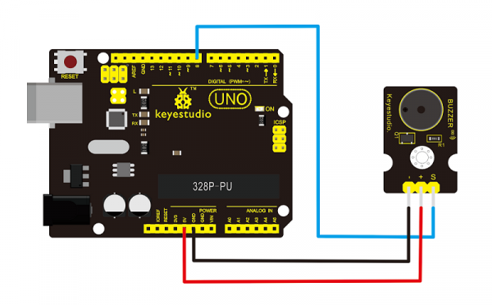

**Sample Code:**  
Copy and paste the below code to Arduino software.

int buzzer=3;//set digital IO pin of the buzzer

void setup()

{

pinMode(buzzer,OUTPUT);// set digital IO pin pattern, OUTPUT to be output

}

void loop()

{ unsigned char i,j;//define variable

while(1)

{ for(i=0;i<80;i++)// output a frequency sound

{ digitalWrite(buzzer,HIGH);// sound

delay(1);//delay1ms

digitalWrite(buzzer,LOW);//not sound

delay(1);//ms delay

}

for(i=0;i<100;i++)// output a frequency sound

{

digitalWrite(buzzer,HIGH);// sound

digitalWrite(buzzer,LOW);//not sound

delay(2);//2ms delay

}

}

}

**Example Result:**  
Done uploading the code to board, the buzzer will make a sound.   
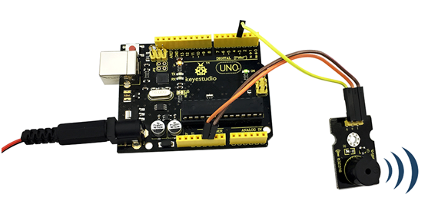

### *Project 7: Digital Push Button*

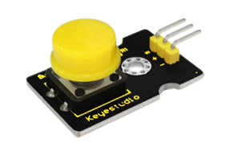

**Introduction:**  
This is a basic button module. You can simply plug it into an IO shield to have your first try of Arduino.

**Features:**

* Wide voltage range from 3.3V to 5V
* Easily recognizable interfaces of sensors ("A" for Analog and "D" for Digital)
* Standard assembled hole
* Clear icons illustration
* High quality connector
* Easy to plug and operate
* Large button and high-quality cap
* To achieve interesting and interactive works

**Specification:**

* Supply Voltage: 3.3V to 5V
* Interface: Digital
* Size: 30\*20mm
* Weight: 4g

**Connection Diagram:**  
First, you need to prepare the following parts before connection:  
UNO Board\*1  
Push button module \*1  
USB Cable\*1  
Jumper Wire\*3

Connect the S pin of module to Digital 3 of UNO board, connect the negative pin to GND port, positive pin to 5V port.  
  
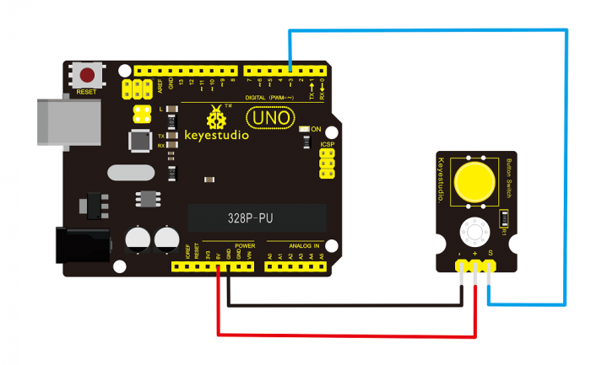

**Sample Code:**  
Copy and paste the below code to Arduino software.

/\* # When you push the digital button, the Led 13 on the board will be turned on. Otherwise,the led is turned off.

\*/

int ledPin = 13; // choose the pin for the LED

int inputPin = 3; // Connect sensor to input pin 3

void setup() {

pinMode(ledPin, OUTPUT); // set LED as output

pinMode(inputPin, INPUT); // set pushbutton as input

}

void loop(){

int val = digitalRead(inputPin); // read input value

if (val == HIGH) { // check if the input is HIGH

digitalWrite(ledPin, LOW); // turn LED OFF

} else {

digitalWrite(ledPin, HIGH); // turn LED ON

}

}

**Example Result:**  
Wire it up well as the figure shown below, and then upload the code to the board.   
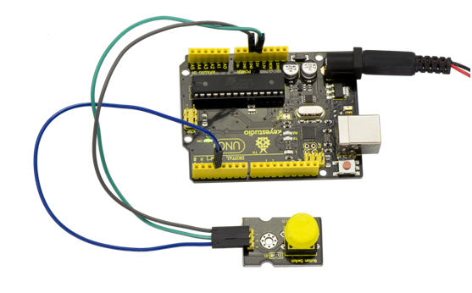

When you push the digital button, the Led 13 on UNO board will be on. When release the button,the led is off. Shown as below.   
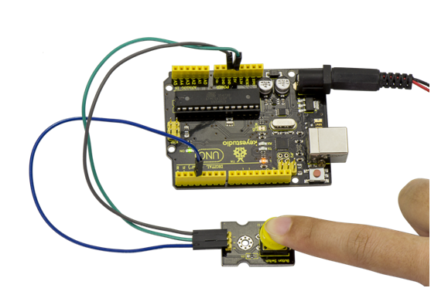

### *Project 8: Collision Flash*

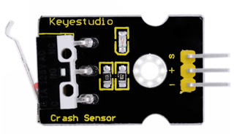

**Description:**  
Crash sensor, also known as electronic switch, is a digital on-off input module necessary for elementary electronic learning. By programming, it can realize to control over light, sound device, key choice function of LCD display, etc.   
Using 3P sensor cable to connect it to sensor shield, it can be installed to 4WD AL alloy mobile robot platform to realize collision detection function. It is both convenient and efficient.   
**Note:**You can make a collision flasher using collision module and built-in LED on interface 13. Connect the collision sensor to pin 3. When the collision sensor senses a collision signal, the LEDs on both mainboard and module will light up simultaneously.

**Parameters:**

* If collision happens upfront of where collision module is installed, module outputs low level signal; no collision, outputs high level signal.
* Module reserves M3 mounting hole, convenient for fixation on a car.
* Module size: 3.1cm \* 2.1cm
* With switch indicator light, if there is collision, light is on; no collision, light is off.

**Pin definition:**  
1.Positive pin (+): connect to 3v-12v power supply   
2.Negative pin (-): connect to GND   
3.Signal pin (S): connect to High-low level output

**Connection Diagram:**  
First, you need to prepare the following parts before connection:  
UNO Board\*1  
Crash module \*1  
USB Cable\*1  
Jumper Wire\*3

Connect the S pin of module to Digital 3 of UNO board, connect the negative pin to GND port, positive pin to 5V port.  
  
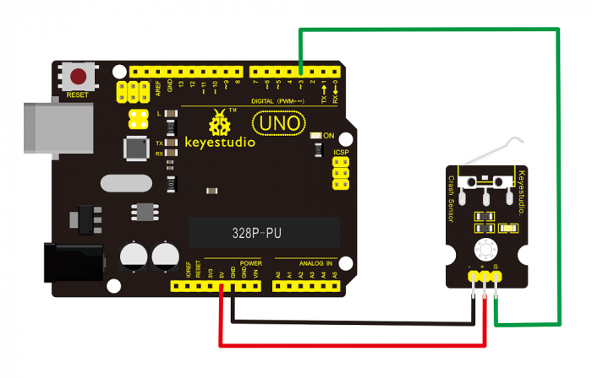

**Sample Code:**  
Copy and paste the below code to Arduino software.

int Led=13;// set pin for LED

int Shock=3// set pin for collision sensor

;int val;// set digital variable val

void setup()

{

pinMode(Led,OUTPUT);// set pin LED as output

pinMode(Shock,INPUT);// set collision sensor as input

}

void loop()

{

val=digitalRead(Shock);// read value on pin 3 and assign it to val

if(val==HIGH)// when collision sensor detects a signal, LED turns on.

{

digitalWrite(Led,LOW);

} else

{

digitalWrite(Led,HIGH);

}

}

**Example Result:**  
Wire it up well and then upload the code to the board.   
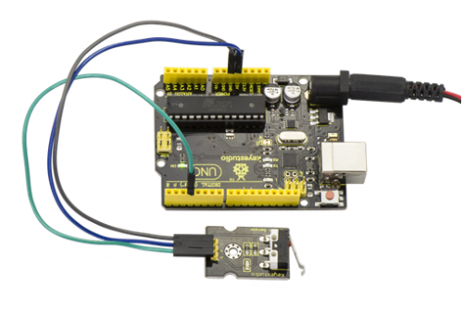  
When the object crashes the switch of sensor, both the led on the sensor and led 13 on the board are turned on.   
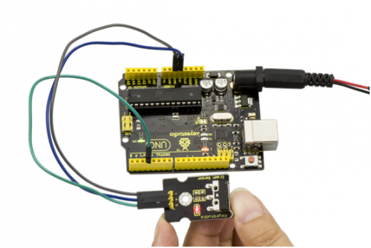

### *Project 9: Line Tracking*

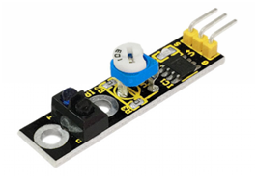

**Introduction:**  
This Line Tracking Sensor can detect white line in black or black line in white. The single line-tracking signal provides a stable output signal TTL for a more accurate and more stable line. Multi-channel option can be easily achieved by installing required line-tracking robot sensors.

**Specification:**

* Power supply: +5V
* Operating current: <10mA
* Operating temperature range: 0°C ~ + 50°C
* Output interface: 3-wire interface (1 - signal, 2 - power, 3 - power supply negative)
* Output Level: TTL level
* Size: 41.7\*10.7mm
* Weight: 3g

**Connection Diagram:**  
First, you need to prepare the following parts before connection:

* UNO Board\*1
* Line tracking module \*1
* USB Cable\*1
* Jumper Wire\*3

Connect the S pin of module to Digital 3 of UNO board, connect the GND pin to GND port, V+ pin to 5V port.   
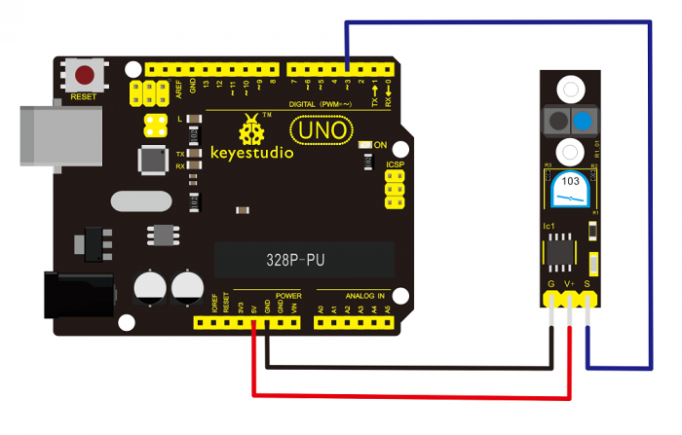

**Sample Code:**  
Copy and paste the below code to Arduino software.

//Arduino Sample Code

void setup()

{

Serial.begin(9600);

}

void loop()

{

Serial.println(digitalRead(3)); // print the data from the sensor

delay(500);

}

**Example Result:**  
Done uploading the code to board, open the serial monitor and set the baud rate as 9600, then you can see the data from the sensor. Shown below.   
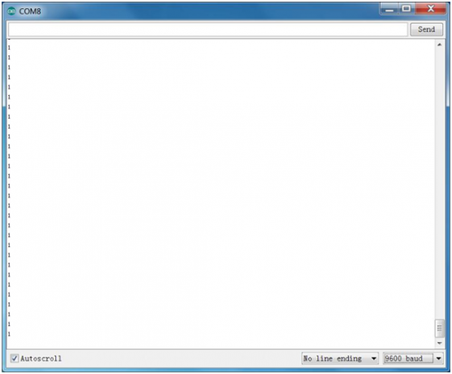

### *Project 10: Infrared Obstacle Avoidance*

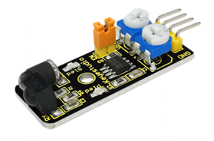

**Introduction:**  
Infrared obstacle detector sensor is equipped with distance adjustment function and is especially designed for wheeled robots. This sensor has strong adaptability to ambient light and is of high precision. It has a pair of infrared transmitting and receiving tube. When infrared ray launched by the transmitter tube encounters an obstacle (its reflector), the infrared ray will be reflected to the receiver tube, thus the indicator will light up, and signal output interface outputs digital signal.   
In addition, you can rotate the potentiometer knob to adjust detection distance ( effective distance: 2～40cm, working Voltage: 3.3V-5V ). Thanks to a wide voltage range, this sensor can work steadily even under fluctuating power supply voltage and is suitable for the use of various micro-controllers, Arduino controllers and BS2 controllers. A robot mounted with this sensor can sense obstaclein the environment.

**Specification:**

* Working voltage: DC 3.3V-5V
* Working current: ≥20mA
* Working temperature: －10℃—＋50℃
* Detection distance: 2-40cm
* IO Interface: 4 wire interface (-/+/S/EN)
* Output signal: TTL voltage
* Accommodation mode: Multi-circle resistance regulation
* Effective Angle: 35°
* Size: 41.7\*16.7mm
* Weight: 5g

**Connection Diagram:**  
First, you need to prepare the following parts before connection:  
UNO Board\*1  
Obstacle detector module \*1  
USB Cable\*1  
Jumper Wire\*3

Connect the Out pin of module to Digital 2 of UNO board, connect the V+ pin to 5V port, GND pin to GND port.  
  
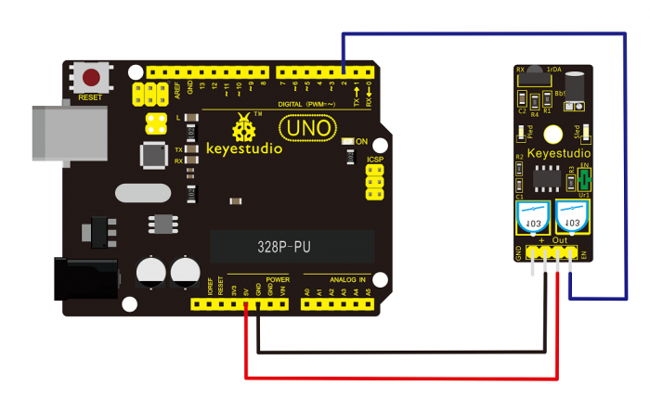

**Sample Code:**  
Copy and paste the below code to Arduino software.

const int sensorPin = 2; // the number of the sensor pin

const int ledPin = 13; // the number of the LED pin

int sensorState = 0; // variable for reading the sensor status

void setup() {

pinMode(ledPin, OUTPUT);

pinMode(sensorPin, INPUT); }

void loop(){

// read the state of the sensor value:

sensorState = digitalRead(sensorPin);

// if it is, the sensorState is HIGH:

if (sensorState == HIGH) {

digitalWrite(ledPin, HIGH);

}

else {

digitalWrite(ledPin, LOW);

}

}

**Example Result:**  
Done uploading the code to board, you can see the led on both UNO board and obstacle detector sensor is turned on.   
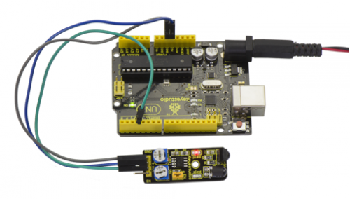  
If we put a foam block in front of the sensor, this time when sensor detects the obstacle, sled on the sensor will be turned on.   
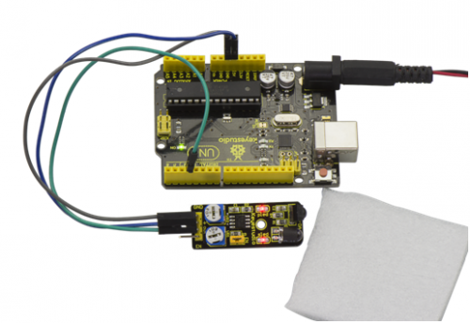

### *Project 11: Photo Interrupter*

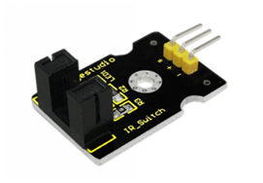

**Introduction:**  
Upright part of this sensor is an infrared emitter and on the other side, it’s a shielded infrared detector. By emitting a beam of infrared light from one end to other end, the sensor can detect an object when an object passes through the beam. It is used for many applications including optical limit switches, pellet dispensing, general object detection, etc.

**Specification:**

* Supply Voltage: 3.3V to 5V
* Interface: Digital
* Size: 30\*20mm
* Weight: 3g

**Connection Diagram:**  
First, you need to prepare the following parts before connection:  
UNO Board\*1  
Photo interrupter module \*1  
USB Cable\*1  
Jumper Wire\*3

Connect the S pin of module to Digital 3 of UNO board, connect the negative pin to GND port, positive pin to 5V port.  
  
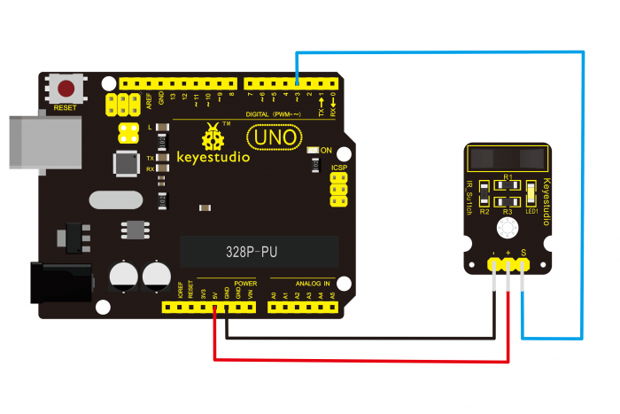

**Sample Code:**  
Copy and paste the below code to Arduino software.

// photo interrupter module

int Led = 13;// define LED Interface

int buttonpin = 3; // define the photo interrupter sensor interface

int val;// define numeric variables val

void setup ()

{

pinMode (Led, OUTPUT);// define LED as output interface

pinMode (buttonpin, INPUT);// define the photo interrupter sensor output interface

}

void loop ()

{

val = digitalRead (buttonpin);

//digitalRead (buttonpin);// digital interface will be assigned a value of 3 to read val

if (val == HIGH) // When the light sensor detects a signal is interrupted, LED flashes

{

digitalWrite (Led, HIGH);

}

else

{

digitalWrite (Led, LOW);

}

}

**Example Result:**  
Done uploading the code to board, you can see both led on UNO board and on module are turned on. Shown as below.   
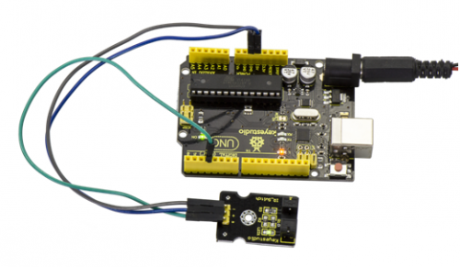  
When pick up a paper on groove joint of module, the signal is interrupted, and led1 on the module will be turned off. Shown as below.   
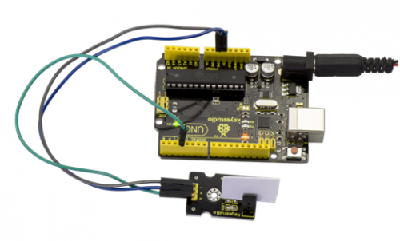

### *Project 12: Hall Magnetic*

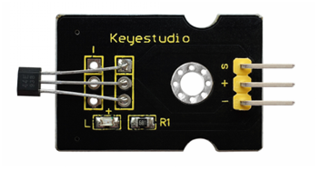

**Introduction:**  
This is a magnetic induction sensor. It can sense the magnetic materials within a detection range up to 3cm. The detection range and the strength of magnetic field areproportional. The output is digital on/off. This sensor uses the SFE Reed Switch - Magnetic Field Sensor.

**Specification:**

* Sensing magnetic materials
* Detection range: up to 3cm
* Output: digital on/off
* Size: 30\*20mm
* Weight: 3g

**Connection Diagram:**  
First, you need to prepare the following parts before connection:  
UNO Board\*1  
Hall sensor \*1  
USB Cable\*1  
Jumper Wire\*3

Connect the S pin of module to Digital 3 of UNO board, connect the negative pin to GND port, positive pin to 5V port.  
  
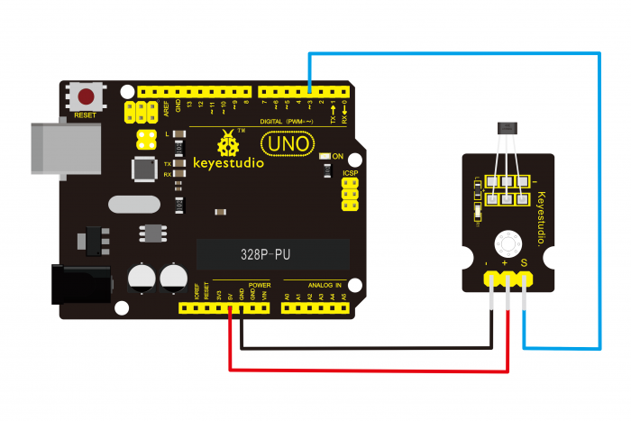

**Sample Code:**  
Copy and paste the below code to Arduino software.

int ledPin = 13; // choose the pin for the LED

int inputPin = 3; // Connect sensor to input pin 3

int val = 0; // variable for reading the pin status

void setup() {

pinMode(ledPin, OUTPUT); // declare LED as output

pinMode(inputPin, INPUT); // declare pushbutton as input

}

void loop(){

val = digitalRead(inputPin); // read input value

if (val == HIGH) { // check if the input is HIGH

digitalWrite(ledPin, LOW); // turn LED OFF

} else {

digitalWrite(ledPin, HIGH); // turn LED ON

}

}

**Example Result:**  
Wire it up and upload well the code to board, you will see that D13 indicator on UNO board is off, and led on the module is also off.   
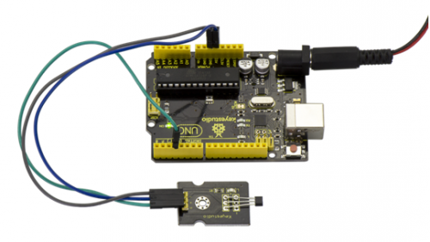  
But if put a magnetic ball close to the hall module, you will see the D13 indicator on UNO board is turned on, and led on the module is also turned on.   
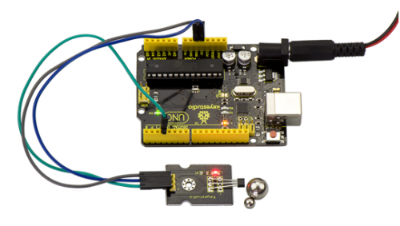

### *Project 13: Knock Sensor*

**Description:**  
This module is a knock sensor. When you knock it, it can send a momentary signal. You can combine it with Arduino to make some interesting experiments, e.g. electronic drum

**Specification:**

* Working voltage: 5V
* Size: 30\*20mm
* Weight: 3g

**Connection Diagram:**  
First, you need to prepare the following parts before connection:  
UNO Board\*1  
Knock sensor \*1  
USB Cable\*1  
Jumper Wire\*3

Connect the S pin of module to Digital 3 of UNO board, connect the negative pin to GND port, positive pin to 5V port.  
  
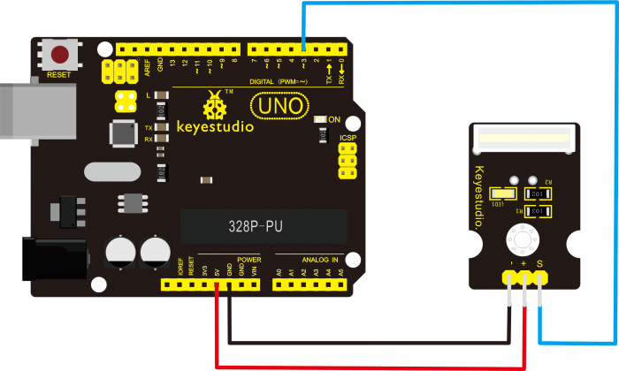

**Sample Code:**  
Copy and paste the below code to Arduino software.

int Led=13;//define LED interface

int Shock=3;//define knock sensor interface

int val;//define digital variable val

void setup()

{

pinMode(Led,OUTPUT);//define LED to be output interface

pinMode(Shock,INPUT);//define knock sensor to be output interface

}

void loop()

{

val=digitalRead(Shock);//read the value of interface3 and evaluate it to val

if(val==HIGH)//when the knock sensor detect a signal, LED will be flashing

{

digitalWrite(Led,LOW);

}

else

{

digitalWrite(Led,HIGH);

}

}

**Example Result:**  
Done wiring and powered up as above, upload well the code, then knock at the sensor, you will see both D13 led on the UNO board and D1 led on the sensor are turned on.   
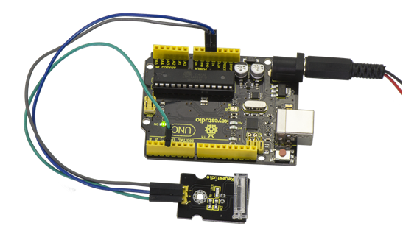

### *Project 14: Digital Tilt Sensor*

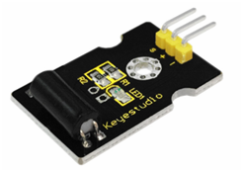

**Introduction:**  
Tilt Sensor is a digital tilt switch. It can be used as a simple tilt switch. Simply plug it to our IO/Sensor shield, easy for wire connection. With dedicated sensor shield and Arduino, you can make lots of interesting and interactive works.

**Specification:**

* Supply Voltage: 3.3V to 5V
* Interface: Digital
* Size: 30\*20mm
* Weight: 3g

**Connection Diagram:**  
Connect the S pin of module to Digital 3 of UNO board, connect the negative pin to GND port, positive pin to 5V port.   
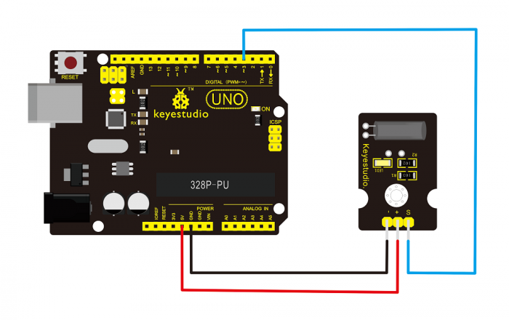

**Sample Code:**  
Copy and paste the below code to Arduino software.

int ledPin = 13; // Connect LED to pin 13

int switcher = 3; // Connect Tilt sensor to Pin3

void setup()

{

pinMode(ledPin, OUTPUT); // Set digital pin 13 to output mode

pinMode(switcher, INPUT); // Set digital pin 3 to input mode

}

void loop()

{

if(digitalRead(switcher)==HIGH) //Read sensor value

{

digitalWrite(ledPin, HIGH); // Turn on LED when the sensor is tilted

}

else

{

digitalWrite(ledPin, LOW); // Turn off LED when the sensor is not triggered

}

}

**Example Result:**  
Done wiring and powered up, then upload well the code to UNO board.   
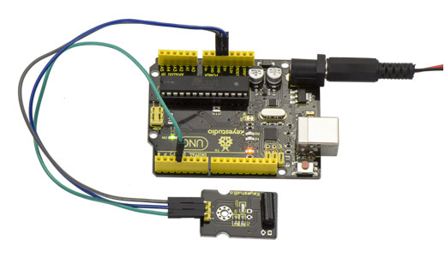  
Then tilt the sensor, you will see the led on the sensor is turned on. Shown as below.   
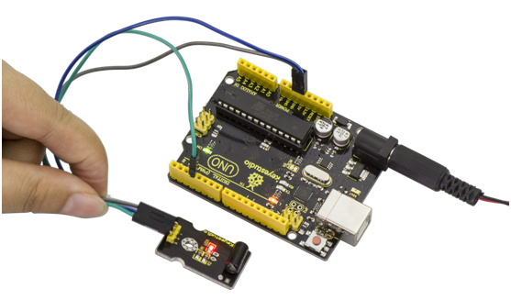

### *Project 15: Capacitive Touch*

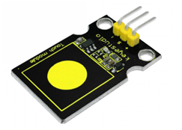

**Description:**  
Are you tired of clicking mechanic buttons? Well, try our capacitive touch sensor. You can find touch sensors mostly used on electronic device. So upgrade your Arduino project with this touch sensor to make it more cool.  
This little sensor can sense the touch of body and metal with feedback of a high/low voltage level. Even isolated by some cloth and papers, it can still feel the touch. But its sensitivity will decrease as isolation layer gets thicker. We will make further improvement on those sensor modules to give youbetter experience.

**Specification:**

* Supply Voltage: 3.3V to 5V
* Interface: Digital
* Size: 30\*20mm
* Weight: 3g

**Connection Diagram:**  
First, you need to prepare the following parts before connection:  
UNO Board\*1  
Capacitive touch sensor \*1  
USB Cable\*1  
Jumper Wire\*3

Connect the S pin of module to Digital 2 of UNO board, connect the negative pin to GND port, positive pin to 5V port.  
  
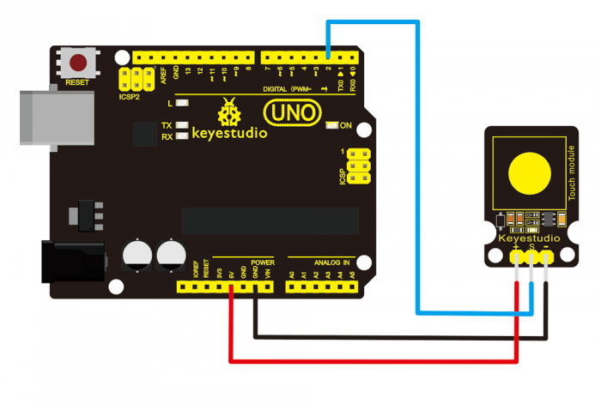

**Sample Code:**  
Copy and paste the below code to Arduino software.

int ledPin = 13; // Connect LED on pin 13, or use the onboard one

int KEY = 2; // Connect Touch sensor on Digital Pin 2

void setup(){

pinMode(ledPin, OUTPUT); // Set ledPin to output mode

pinMode(KEY, INPUT); //Set touch sensor pin to input mode

}

void loop(){

if(digitalRead(KEY)==HIGH) { //Read Touch sensor signal

digitalWrite(ledPin, HIGH); // if Touch sensor is HIGH, then turn on

}

else{

digitalWrite(ledPin, LOW); // if Touch sensor is LOW, then turn off the led

}

}

**Example Result:**  
Done wiring and powered up, upload well the code, then touch the sensor with your finger, both D2 led on the sensor and D13 indicator on UNO board are on. Otherwise, those two indicators are turned off.   
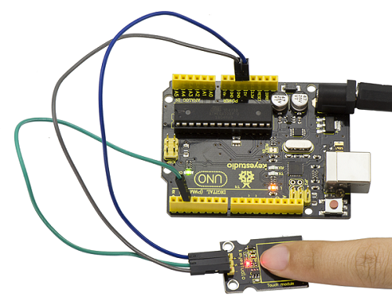

### **Project 16: Flame Alarm**

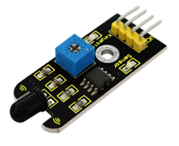

**Description:**  
This flame sensor can be used to detect fire or other lights with wavelength stands at 760 nm ~ 1100 nm. In the fire-fighting robot game, the flame plays an important role in the probing, which can be used as the robot's eyes to find fire source.

**Specification:**

* Supply Voltage: 3.3V to 5V
* Detection range: 20cm (4.8V) ~ 100cm (1V)
* Rang of Spectral Bandwidth: 760nm to 1100nm
* Operating temperature: -25℃to 85℃
* Interface: digital
* Size: 44\*16.7mm
* Weight: 4g

**Connection Diagram:**  
First, you need to prepare the following parts before connection:  
UNO Board\*1  
Flame sensor \*1  
USB Cable\*1  
Jumper Wire\*3

Connect the D0 pin of module to Digital 2 of UNO board, connect the GND pin to GND port, VCC pin to 5V port.   
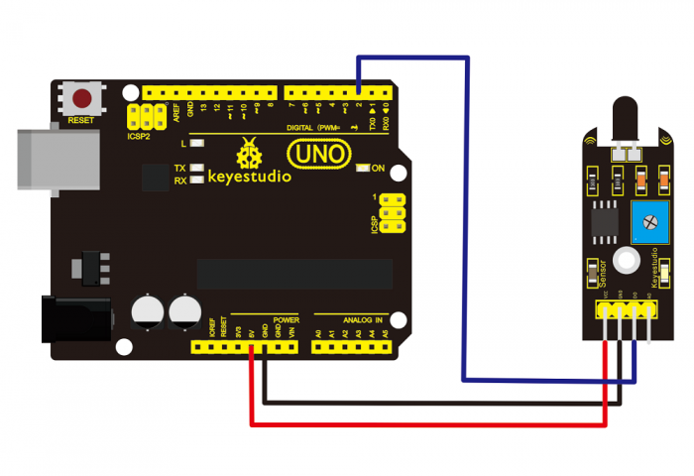

**Sample Code:**  
Copy and paste the below code to Arduino software.

const int flamePin = 2; // the number of the flame pin

const int ledPin = 13; // the number of the LED pin

// variables will change:

int State = 0; // variable for reading status

void setup() {

// initialize the LED pin as an output:

pinMode(ledPin, OUTPUT);

// initialize the pushbutton pin as an input:

pinMode(flamePin, INPUT);

}

void loop(){

// read the state of the value:

State = digitalRead(flamePin);

if (State == HIGH) {

// turn LED on:

digitalWrite(ledPin, HIGH);

}

else {

// turn LED off:

digitalWrite(ledPin, LOW);

}

}

**Example Result:**  
Done wiring and powered up, upload well the code to the board.   
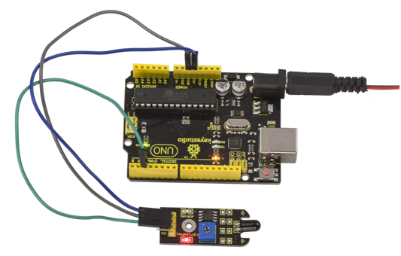  
Then if you put a lighter close to the sensor, when the sensor detects the flame, another led on the sensor is turned on.   
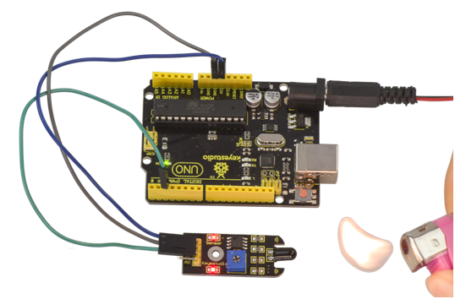

### *Project 17: Reed Switch*

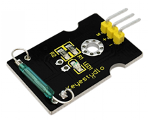

**Description:**  
Reed Switch is a special switch and a main component for reed relay and proximity switch. Reed switch is usually comprised of two soft magnetic materials and metal reed contacts which will disconnect itself when there is no magnetic.   
In addition, some reed switches are also equipped with another reed acting as the third normally-closed contact. These reed contacts are encapsulated in a glass tube fulled of inert gases(such as nitrogen and helium) or in a vacuum glass tube.   
The reeds encapsulated in the glass tube are placed in parallel with ends overlapped. Certain amount of space or mutual contact will be reserved to constitute the normally-open or normally-closed contacts of the switch.

Reed switch can be used as for count, limit or other purposes. For instance, a kind of bike-kilometer is constituted by sticking magnetic to the tire and mounting reed switch aside. You can also mount reed switch on the door for alarming purpose or as switches.  
Reed switch has been widely applied in household appliances, cars, communication, industry, healthcare and security areas.   
Furthermore, it can also be applied to other sensors and electric devices such as liquidometer, door magnet, reed relay, oil level sensor and proximity sensor(magnetic sensor). It can be used under high-risk environment.

**Specification:**

* Working voltage: DC 3.3V-5V
* Working current: ≥20mA
* Working temperature: －10℃ to ＋50℃
* Detection distance: ≤10mm
* IO Interface: 3 wire interfaces (-/+/S)
* Size: 30\*20mm
* Weight: 3g

**Connection Diagram:**  
First, you need to prepare the following parts before connection:  
UNO Board\*1  
Reed switch module\*1  
USB Cable\*1  
Jumper Wire\*3

Connect the S pin of module to Digital 3 of UNO board, connect the negative pin to GND port, positive pin to 5V port.  
  
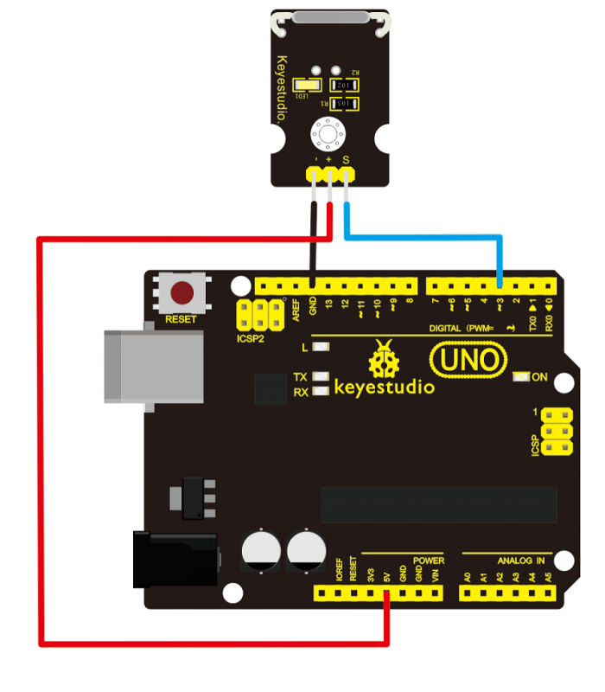

**Sample Code:**  
Copy and paste the below code to Arduino software.

int Led=13;//define LED interface

int buttonpin=3; //define magnetic ring sensor interface

int val;//define digital variable val

void setup()

{

pinMode(Led,OUTPUT);//define LED as output interface

pinMode(buttonpin,INPUT);//define magnetic ring sensor as output interface

}

void loop()

{

val=digitalRead(buttonpin);// read and assign the value of digital interface 3 to val

if(val==HIGH)//When a signal is detected by magnetic ring sensor, LED will flash

{

digitalWrite(Led,HIGH);

}

else

{

digitalWrite(Led,LOW);

}

}

**Example Result:**  
Done wiring and powered up, upload well the code to the board. You can see the D13 led on UNO board is on.   
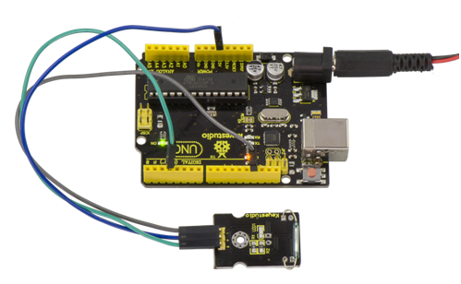  
Then we put some magnetic balls close to the sensor. When the sensor detects the magnetic field signal, the led on the sensor will be turned on but D13 led will be turned off.   
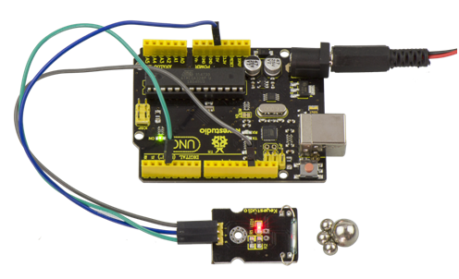

### *Project 18: PIR Motion Sensing*

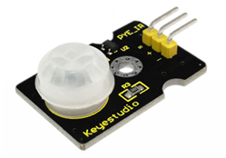

**Description:**  
Pyroelectric infrared motion sensor can detect infrared signals from a moving person or moving animal, and output switching signals. It can be applied to a variety of occasions to detect the movement of human body.   
Conventional pyroelectric infrared sensors require body pyroelectric infrared detector, professional chip and complex peripheral circuit, so the size is much more bigger, with complex circuit and lower reliability.   
Now we launch this new pyroelectric infrared motion sensor, specially designed for Arduino. It uses an integrated digital body pyroelectric infrared sensor, with smaller size, higher reliability, lower power consumption and simpler peripheral circuit.

**Specification:**

* Input Voltage: 3.3 ~ 5V, Maximum for 6V
* Working Current: 15uA
* Working Temperature: -20 ~ 85 ℃
* Output Voltage: High 3V, low 0V
* Output Delay Time (High Level): About 2.3 to 3 Seconds
* Detection angle: 100 °
* Detection distance: 7 meters
* Output Indicator LED (When output HIGH, it will be ON)
* Pin limit current: 100mA
* Size: 30\*20mm
* Weight: 4g

**Connection Diagram:**  
First, you need to prepare the following parts before connection:  
UNO Board\*1  
PIR motion sensor\*1  
USB Cable\*1  
Jumper Wire\*3

Connect the S pin of module to Digital 3 of UNO board, connect the negative pin to GND port, positive pin to 5V port.  
  
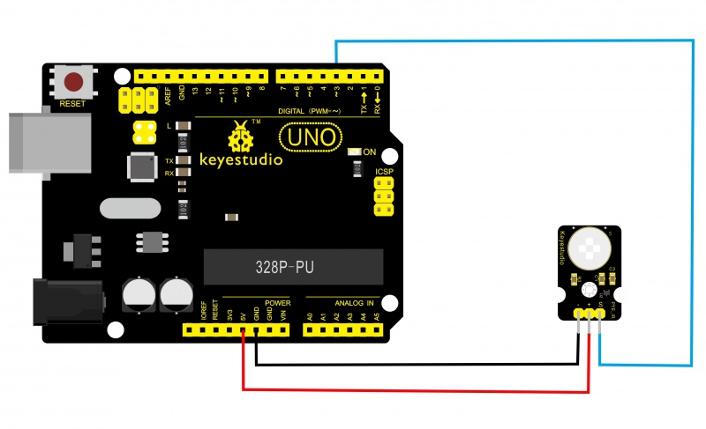

**Sample Code:**  
Copy and paste the below code to Arduino software.

byte sensorPin = 3;

byte indicator = 13;

void setup()

{

pinMode(sensorPin,INPUT);

pinMode(indicator,OUTPUT);

Serial.begin(9600);

}

void loop()

{

byte state = digitalRead(sensorPin);

digitalWrite(indicator,state);

if(state == 1)Serial.println("Somebody is in this area!");

else if(state == 0)Serial.println("No one!");

delay(500);

}

**Example Result:**  
Done wiring and powered up, upload well the code, if the sensor detects someone moving nearby, D13 indicator on UNO board will light up, and "Somebody is in this area!" is displayed on the serial monitor of Arudino software. If no detecting the movement, D13 indicator on UNO board will be off, and "No one!" is displayed on the serial monitor.   
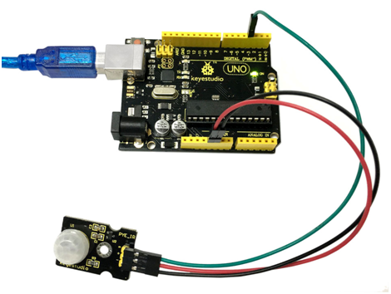  
  
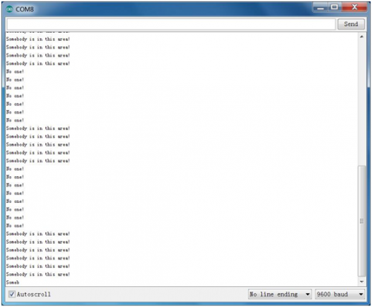

### *Project 19: Analog Temperature*

**Description:**  
This module is based on the working principle of a thermistor (resistance varies with temperature change in the environment). It can sense temperature changes in the surrounding and send the data to the analog IO of Arduino board. All we need to do is to convert the sensor’s output data into degrees Celsius temperature via simple programming, finally displaying it on the monitor.   
It's both convenient and effective, thus it is widely applied to gardening, home alarm system and other devices.

**Specification:**

* Interface type: analog
* Working voltage: 5V
* Temperature range: -55℃～315℃
* Size: 30\*20mm
* Weight: 3g

**Connection Diagram:**  
First, you need to prepare the following parts before connection:  
UNO Board\*1  
Analog temperature sensor\*1  
USB Cable\*1  
Jumper Wire\*3

Connect the S pin of module to Analog A0 of UNO board, connect the negative pin to GND port, positive pin to 5V port.  
  
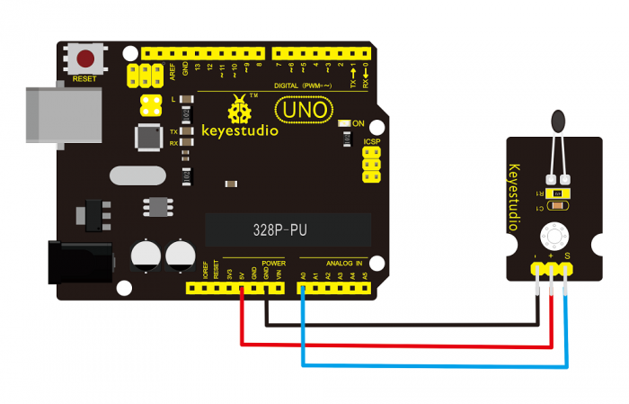

**Sample Code:**  
Copy and paste the below code to Arduino software.

void setup()

{Serial.begin(9600);

}

// the loop routine runs over and over again forever:

void loop()

{int sensorValue = analogRead(A0);

Serial.println(sensorValue);

delay(1); }

The above code is only for analog value.   
You can see that the analog value is changing according to the temperature change in the environment. But it’s not very obvious.  
Let’s solve this by using the following equation. Then upload the code below to the Arduino board. The value read from the serial port is similar to normal temperature. eg. The temperature right now is 30°C.

#include <math.h>

void setup()

{

Serial.begin(9600);

}

void loop()

{

double val=analogRead(0);

double fenya=(val/1023)\*5;

double r=(5-fenya)/fenya\*4700;

Serial.println( 1/( log(r/10000) /3950 + 1/(25+273.15))-273.15);

delay(1000);

}

**Example Result:**  
Done wiring and powered up, upload well the code, then open the serial monitor, you will see the current temperature value. Shown below.   
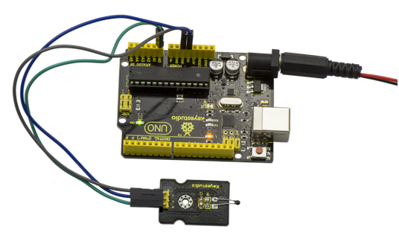  
  
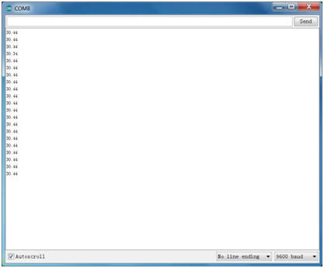

### *Project 20: Analog Rotation*

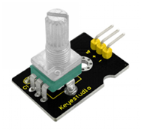

**Description:**  
This analog rotation sensor is Arduino compatible. It is based on a potentiometer. Its voltage can be subdivided into 1024, easy to be connected to Arduino with our sensor shield. Combined with other sensors, you can use it to make interesting projects by reading the analog value from the IO port.

**Specification:**

* Supply Voltage: 3.3V to 5V
* Interface: Analog
* Size: 30\*20mm
* Weight: 8g

**Connection Diagram:**  
Connect the S pin of module to Analog A0 of UNO board, connect the negative pin to GND port, positive pin to 5V port.   
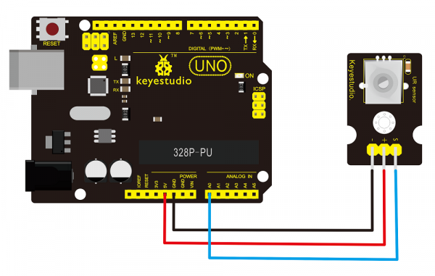

**Sample Code:**  
Copy and paste the below code to Arduino software.

void setup()

{

Serial.begin(9600); //Set serial baud rate to 9600 bps

}

void loop()

{

int val;

val=analogRead(0);//Read rotation sensor value from analog 0

Serial.println(val,DEC);//Print the value to serial port

delay(100);

}

**Example Result:**  
  
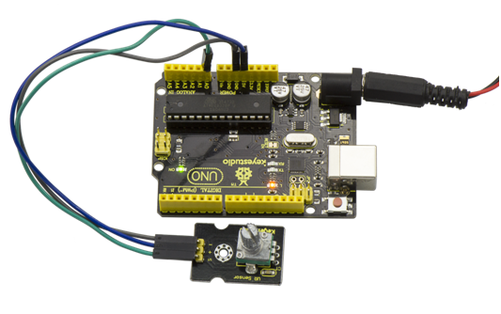  
Done wiring and powered up, upload well the above code, then open the serial monitor and set the baud rate as 9600, finally you will see the analog value. If rotate the knob on the rotation sensor, the value will be changed within 0-1023. Shown below.   
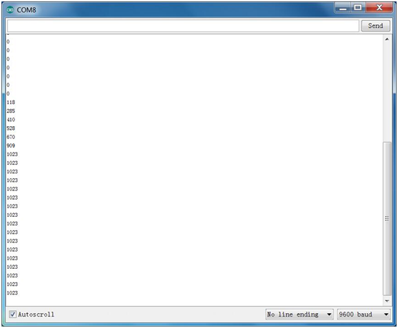

### *Project 21: Photocell*

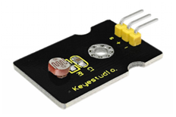

**Description:**  
Photocell is commonly seen in our daily life and is mainly used in intelligent switch, also in common electronic design. To make it easier and more effective, we supply the corresponding modules.  
Photocell is a semiconductor. It has features of high sensitivity, quick response, spectral characteristicand R-value consistence, maintaining high stability and reliability in environment extremely such as high temperature and high humidity.   
It’s widely used in automatic control switch fields like cameras, garden solar lights, lawn lamps, money detectors, quartz clocks, music cups, gift boxes, mini night lights, sound and light control switches, etc.

**Specification:**

* Interface type: analog
* Working voltage: 5V
* Size: 30\*20mm
* Weight: 3g

**Connection Diagram:**  
Connect the S pin of module to Analog A0 of UNO board, connect the negative pin to GND port, positive pin to 5V port.   
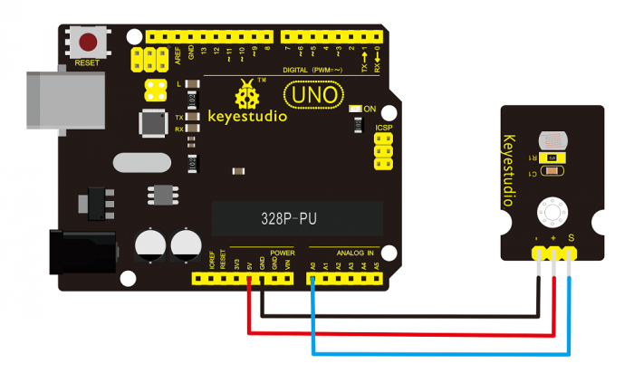

**Sample Code:**  
Copy and paste the below code to Arduino software.

int sensorPin =A0;

int value = 0;

void setup()

{

Serial.begin(9600);

}

void loop()

{

value = analogRead(sensorPin);

Serial.println(value, DEC);

delay(50);

}

**Example Result:**  
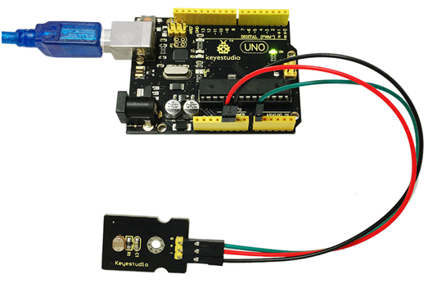  
Done wiring and powered up, upload well the code, then open the serial monitor, if cover the photocell on the sensor with your hand, you will see the analog value decrease. Shown as below.   
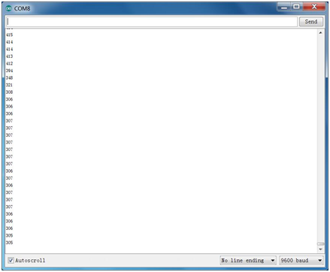

### *Project 22: Analog Sound*

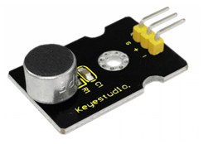

**Description:**  
Analog sound sensor is typically used in detecting the volume ofambient sounds. You can use it to make some interesting and interactive works, such as a voice operated switch.

**Specification:**

* Supply Voltage: 3.3V to 5V
* Interface: Analog
* Size: 30\*20mm
* Weight: 4g

**Connection Diagram:**  
Analog sound sensor is typically used in detecting the volume ofambient sounds. You can use it to make some interesting and interactive works, such as a voice operated switch.   
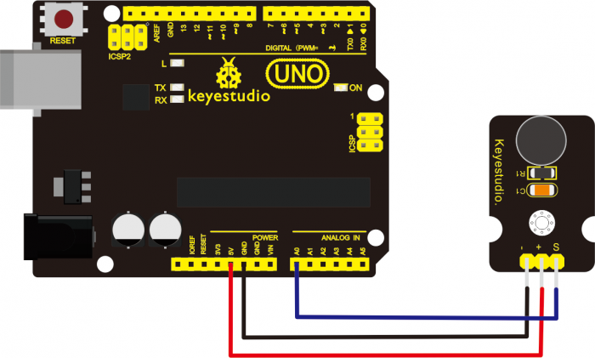

**Sample Code:**  
Copy and paste the below code to Arduino software.

void setup()

{

Serial.begin(9600); // open serial port, set the baud rate at 9600 bps

}

void loop()

{

int val;

val=analogRead(0); //connect mic sensor to Analog 0

Serial.println(val,DEC);//print the sound value on serial monitor

delay(100);

}

**Example Result:**  
  
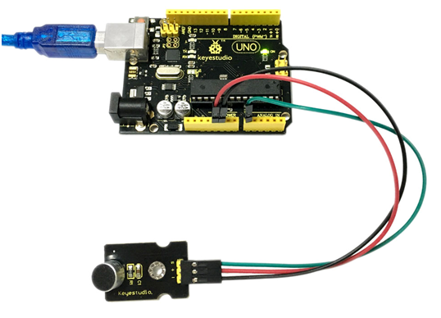

Done wiring and powered up, upload well the code, then open the serial monitor and set the baud rate as 9600, you will see the analog value. When talking toward the micro head, the value will increase. Shown below.   
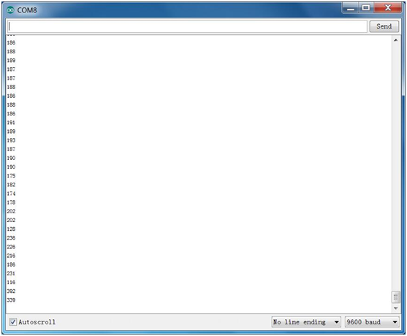

### **Project 23: Water Level**

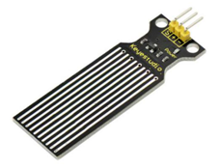

**Description:**  
Keyestudio water sensor is easy- to-use, portable and cost-effective, designed to identify and detect water level and water drop. This smaller sensor can measure the volume of water drop or water quantity through an array of traces of exposed parallel wires.

**Features:**

* smooth conversion between water quantity and analog quantity;
* strong flexibility, outputting basic analog value;
* low power consumption and high sensitivity;
* directly connect to microprocessor or other logic circuits, suitable for a variety of development boards and controllers such as Arduino controller, STC single-chip microcomputer, AVR single-chip microcomputer and more.

**Specification:**

* Operating voltage: DC5V
* Operating current: ﹤20mA
* Sensor type: Analog
* Detection area: 40mm x16mm
* Production process: FR4 double-side tinned
* Shape design: Anti-skid semi-lunar recess
* Working Temperature: 10℃-30℃
* Working Humidity: 10%-90% without condensation
* Weight: 3g
* Dimensions: 65mm x 20mm x 8mm

**Connection Diagram:**  
Connect the S pin of module to Analog A0 of UNO board, connect the negative pin to GND port, positive pin to 5V port.   
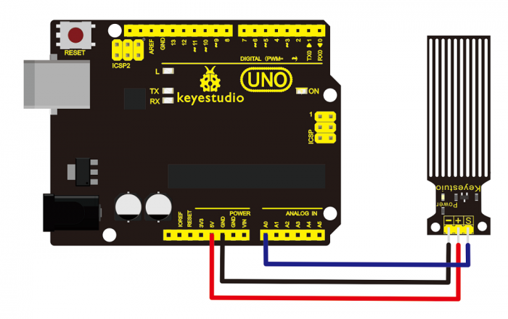

**Sample Code:**  
Copy and paste the below code to Arduino software.

int analogPin = 0; //connect water sensor to analog interface 0

int led = 13; //LED to digital interface 13

int val = 0; //define the initial value of variable ‘val’ as 0

int data = 0; //define the initial value of variable ‘data’ as 0

void setup()

{

pinMode(led, OUTPUT); //define led as output pin

Serial.begin(9600); //set baud rate at 9600

}

void loop()

{

val = analogRead(analogPin); //read and assign analog value to variable ’val’

if(val>700){ //decide whether variable ‘val’ is over 700

digitalWrite(led,HIGH); //turn on LED when variable ‘val’ is over 700

}

else{

digitalWrite(led,LOW); //turn off LED when variable ‘val’ is under 700

}

data = val; //variable ’val’ assigns value to variable ‘data’

Serial.println(data); //print variable ‘data’ by Serial.print

delay(100);

}

**Example Result:**  
  
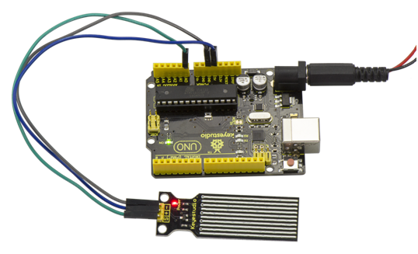  
After the above steps are done, let’s do a test on lower water level and check what happens ? upload well the code to UNO board, then open the serial monitor and set the baud rate as 9600. When place the sensor into the water at different level, you will see the value change correspondingly.   
  
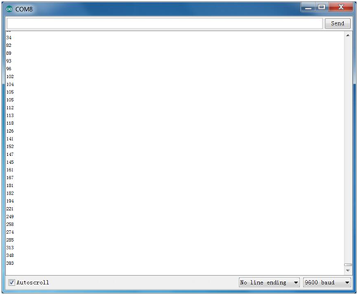  
Furthermore, you can set an alarm value and connect a buzzer to make an alarm.  
The LED can’t light up when water level haven’t reach alarm value. If water level reaches the alarm value, LED will be turned on and buzzer will sound to make an alarm.

### *Project 24: Soil Moisture*

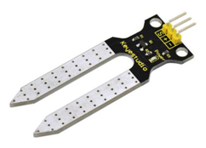

**Description:**  
This is a simple soil humidity sensor aimed to detect the soil humidity. If the soil is in lack of water, the analog value output by the sensor will decrease, otherwise, it will increase.   
If you use this sensor to make an automatic watering device, it can detect whether your botany is thirsty to prevent it from withering when you go out. Combine this sensor with Arduino controller can make your plant more comfortable and your garden more smarter.

The soil humidity sensor module is not as complicated as you might think, so if you need to detect the soil in your project, it will be your best choice.   
The sensor is set with two probes which are inserted into the soil.If the current goes through the soil, the sensor will get resistance value by reading the current changes between the two probes, then convert the resistance value into moisture content. The higher moisture (less resistance), the higher conductivity the soil has.   
The surface of the sensor has undergone metallization process to prolong its service life. Insert it into the soil and then use the AD converter to read it. With the help of this sensor, the plant can remind of you: I need water.

**Specification:**

* Power Supply Voltage: 3.3V or 5V
* Working Current: ≤ 20mA
* Output Voltage: 0-2.3V (When the sensor is totally immersed in water, the voltage will be 2.3V) The higher humidity, the higher the output voltage.
* Sensor type: Analog output
* Interface definition: Pin1- signal, Pin2- GND, Pin3 - VCC
* Servicelife: About one year (gold-plated surface for enhancing conductivity and corrosion resistance)
* Module size: 20\*60mm

**Connection Diagram:**  
Connect the S pin of module to Analog A0 of UNO board, connect the negative pin to GND port, positive pin to 5V port.   
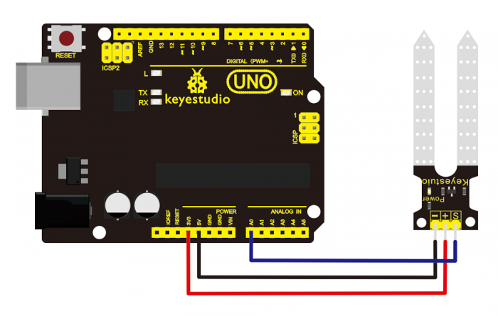

**Sample Code:**  
Copy and paste the below code to Arduino software.

/\*

# Example code for the moisture sensor

# Connect the sensor to the A0(Analog 0) pin on the Arduino board

# the sensor value description

# 0 ~300 dry soil

# 300~700 humid soil

# 700~950 in water

\*/

void setup(){

Serial.begin(57600);

}

void loop(){

Serial.print("Moisture Sensor Value:");

Serial.println(analogRead(0));

delay(100);

}

**Example Result:**  
  
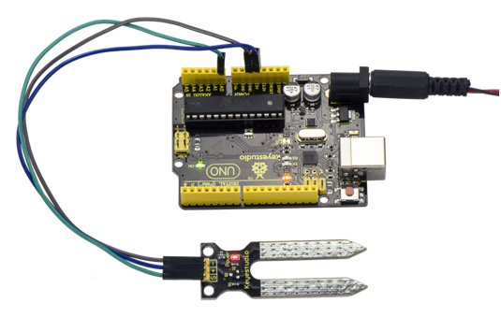  
Done wiring and powered up, upload well the code, then open the serial monitor and set the baud rate as 57600, you will see the value. When the sensor detects the moisture, the value will make corresponding changes. Shown below.   
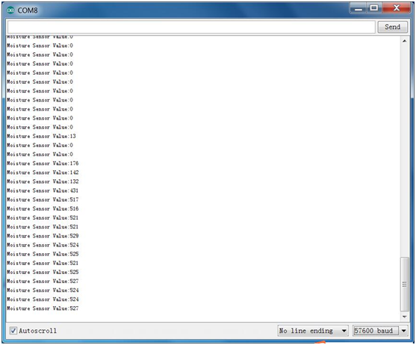

### *Project 25: Analog Gas*

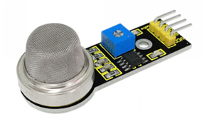

**Description:**  
This analog gas sensorMQ2 is used in gas leakage detecting equipment in both consumer electronics and industrial markets. This sensor is suitable for detecting LPG, I-butane, propane, methane, alcohol, Hydrogen and smoke. So the detecting scope of this sensor is very wide and it has high sensitivity and quick response. In addition, the sensitivity can be adjusted by rotating the potentiometer on the sensor.

**Specification:**

* Power supply: 5V
* Interface type: Analog
* Size: 49.7\*20mm
* Weight: 8g
* Simple drive circuit
* Stable and long lifespan

**Connection Diagram:**  
Connect the A0 pin of module to Analog A0 of UNO board, connect the GND pin to GND port, VCC pin to 5V port.   
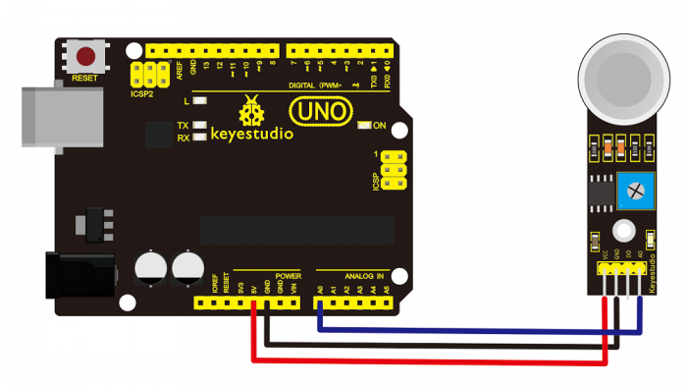

**Sample Code:**  
Copy and paste the below code to Arduino software.

//Arduino Sample Code

void setup()

{

Serial.begin(9600); //Set serial baud rate to 9600 bps

}

void loop()

{

int val;

val=analogRead(0);//Read Gas value from analog 0

Serial.println(val,DEC);//Print the value to serial port

delay(100);

}

**Example Result:**  
  
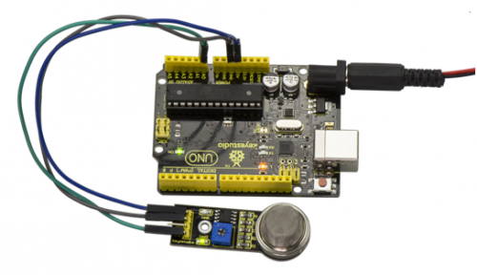  
Done wiring and powered up, upload well the code, then open the serial monitor and set the baud rate as 9600, you will see the analog value. When detecting the gas, the value will make a change.   
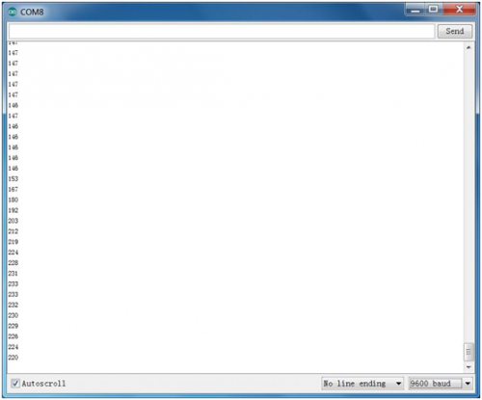

### *Project 26: Analog Alcohol*

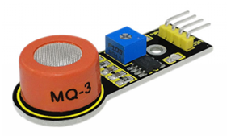

**Description:**  
This analog sensor-MQ3 is suitable for detecting the alcohol. It can be used in a breath analyzer. It has good selectivity because it has higher sensitivity to alcohol and lower sensitivity to Benzine. The sensitivity can be adjusted by rotating the potentiometer on the sensor.

**Specification:**

* Power supply: 5V
* Interface type: Analog
* Size: 49.7\*20mm
* Weight: 6g
* Simple drive circuit
* Stable and long service life
* Quick response and High sensitivity

**Connection Diagram:**  
Connect the A0 pin of module to Analog A0 of UNO board, connect the GND pin to GND port, VCC pin to 5V port.   
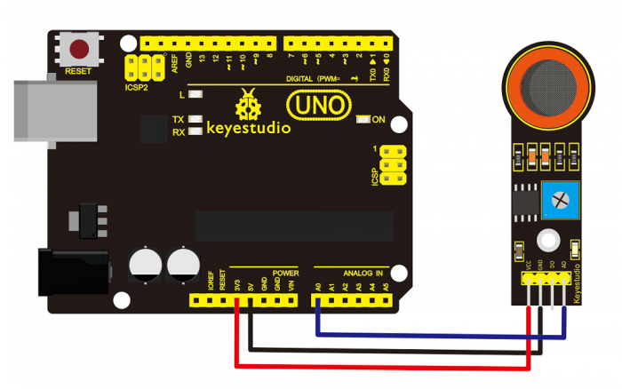

**Sample Code:**  
Copy and paste the below code to Arduino software.

//Arduino Sample Code

void setup()

{

Serial.begin(9600); //Set serial baud rate to 9600 bps

}

void loop()

{

int val;

val=analogRead(0);//Read Gas value from analog 0

Serial.println(val,DEC);//Print the value to serial port

delay(100);

}

**Example Result:**  
  
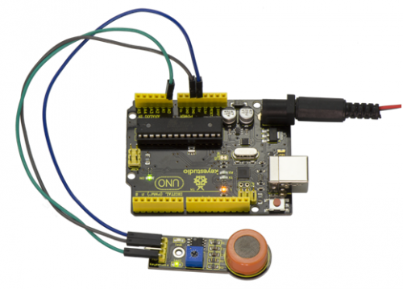  
Done wiring and powered up, upload well the code, then open the serial monitor and set the baud rate as 9600, you will see the analog value. When detecting the alcohol gas, the value will make a change.   
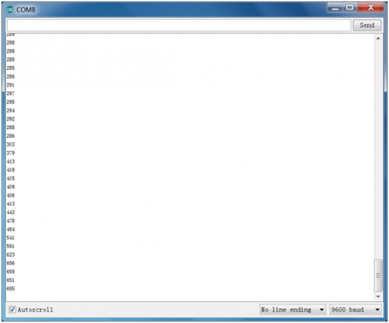

### *Project 27: Steam Moisture*

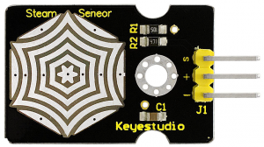

**Description:**  
Vapor Sensor is an analog sensor and can make a simple rainwater detector and liquid level switch. When humidity on the face of this sensor rises, output voltage will increase.   
Caution: connection parts is non-waterproof, so please don’t put them into water.

**Parameters:**

* Working Voltage: 3.3V or 5V
* Working Current: <20mA
* Range of Working Temperature: －10℃～＋70℃
* Interface Type: Analog Signal Output
* Size: 36mm x 20mm

**Pin Definition:**

* S pin: for Signal Output
* Positive pin (+): for Power Supply (VCC)
* Negative pin (-): for Ground (GND)

**Connection Diagram:**  
First, you need to prepare the following parts before connection:  
UNO board\*1  
Steam sensor\*1  
USB Cable\*1  
Jumper wire\*3

Connect the S pin of module to Analog A0 of UNO board, connect the negative pin to GND port, positive pin to 5V port.  
  
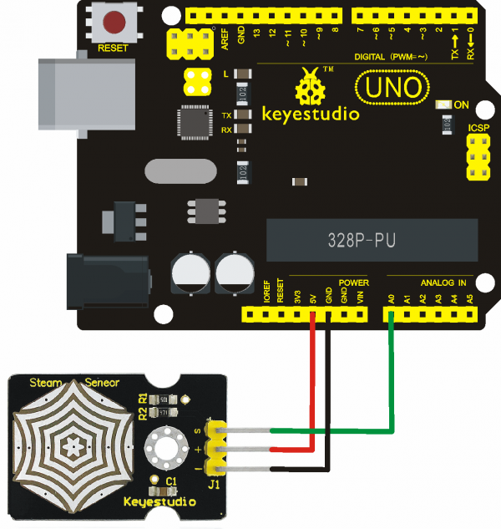

**Sample Code:**  
Copy and paste the below code to Arduino software.

void setup()

{

Serial.begin(9600); //open serial port, and set baud rate at 9600bps

}

void loop()

{

int val;

val=analogRead(0); //plug vapor sensor into analog port 0

Serial.print("Moisture is ");

Serial.println(val,DEC); //read analog value through serial port printed

delay(100);

}

**Example Result:**  
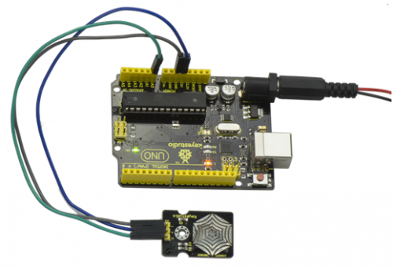  
When detecting different degrees of humidity, the sensor will get the feedback of different current value. Shown as the following picture.Due to the limited condition, you can put a drop of water on the sensor, the moisture value will be changed on serial monitor of Arduino software.   
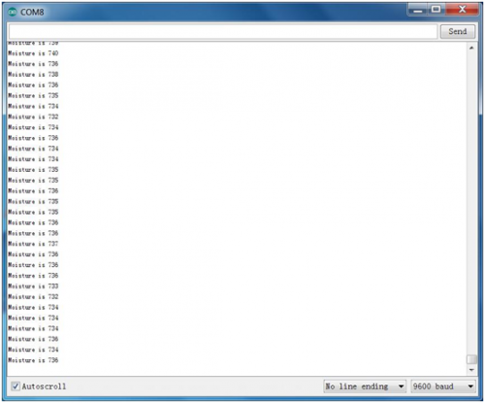

### *Project 28: Analog Ceramic Vibration*

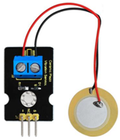

**Description:**  
This vibration sensor is based on piezoelectric ceramic chip analog vibration. It makes use of the anti-conversion process that piezoelectric ceramic vibration will generate the electric signals. When vibrating the piezoelectric ceramic chip, the sensor’s signal terminal will generate electrical signals.  
The sensor can be used with Arduino dedicated sensor shield, and Arduino analog port can perceive weak vibration signals, so that it can make interactiveworks related to vibration, such as electronic drum.  
Connect the vibration sensor to the analog port A0 of Arduino UNO. When vibrating the sensor in different degrees, you will see the different output value displayed on serial monitor of Arduino software.

**Parameters:**

* Supply Voltage: 3.3V to 5V
* Working Current：<1mA
* WorkingTemperature Range：－10℃～＋70℃
* Output Signal：analog signal
* Weight: 4.4g

**Connection Diagram:**  
First, you need to prepare the following parts before connection:  
UNO board\*1  
vibration sensor\*1  
USB Cable\*1  
Jumper wire\*3

Connect the S pin of module to Analog A0 of UNO board, connect the negative pin to GND port, NC pin to 5V port.  
  
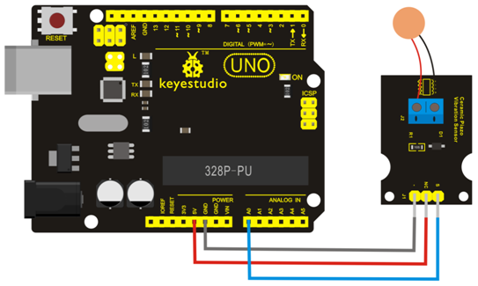

**Sample Code:**  
Copy and paste the below code to Arduino software.

void setup()

{

Serial.begin(9600); //Open the serial to set the baud rate as 9600bps

}

void loop()

{

int val;

val=analogRead(0); //Connect the sensor to analog interface A0

Serial.print("Vibration is ");

Serial.println(val,DEC);//Print the analog value read on serial port

delay(100);

}

**Example Result:**  
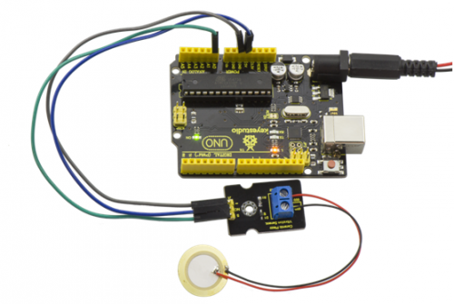  
Wiring as the above diagram and upload well the code, then open the serial monitor and set the baud rate as 9600. When vibrating the ceramic chip, you will see the data change as the figure shown below.   
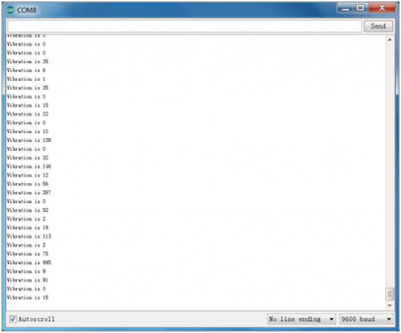

### *Project 29: Voltage Detection*

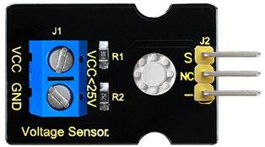

**Description:**  
Since the electronic products are various, the voltage of the power supply is also different. It is indeed necessary to detect it with a suitable voltage detection module or controller. The maximum input voltage of the controller’s analog interface is 5V, which means that the voltage greater than 5V will not be detected.  
However, this voltage detection module canachieve to detect the voltagegreater than 5 V. It is designed on the basis of resistive voltage divider principle, which can make the input voltage of bindingpost interface narrow 5 times, and the analog input voltage is up to 5 V, thus the input voltage of voltage detection module is not greater than 5V \* 5 = 25 V (if using 3.3 V system, the input voltage is not greater than 3.3 V\*5 = 16.5 V).  
The AVR chip is 10-bit AD, so the analog resolution of this module is 0.00489 V (5V / 1023), and the minimum input voltage is 0.00489V \* 5 = 0.02445 V.  
When connect this sensor to expansion board using 3Pinwire, it can not only easily detect the magnitude of the voltage power and monitor the electric quantity of battery for interactive media works or robot, but also can combine with IICLCD1602 LCD module to display the voltage or make a voltage monitor.

**Parameters:**

* Working voltage: 0V-25VDC
* Signal type: analog signal
* Size: 35\*20\*14mm

**Connection Diagram:**  
First, you need to prepare the following parts before connection:  
UNO board\*1  
Voltage sensor\*1  
USB Cable\*1  
Jumper wire\*3

Connect the S pin of module to Analog A0 of UNO board, connect the negative pin to GND port, NC pin to 5V port.  
  
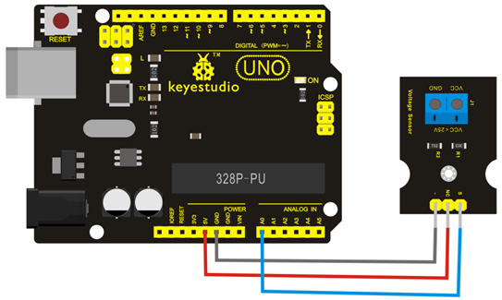

**Sample Code:**  
Copy and paste the below code to Arduino software.

int analogpin=0; // Define analogpin as analog port 0

int val,val5; //Define variablesval,val5

int val2=0; //Define variablesval2

int val3=0; //Define variablesval3

int val4=0; //Define variablesval4

void setup()

{

Serial.begin(9600); //Set baud rate of 9600

}

void loop()

{

int val,val5;

float val1;

val=analogRead(analogpin); //Read the value of the analog port and assign it to the variableval

val1=val/3.9;

val5=(int)val1;

val3=val5/100;

val2=(val5%100)/10;

val4=val5%10;

Serial.print("$CLEAR\r\n"); //clear the screen

Serial.print("$GO 1 1\r\n");

Serial.print("$PRINT Voltage:\r\n");

Serial.print("$GO 1 9\r\n");

Serial.print("$PRINT ");

Serial.print(val3); //The serial port prints the value of the variable val3

Serial.print(val2); //The serial port prints the value of the variable val2

Serial.print("."); //The serial port prints out a point"."

Serial.print(val4); //The serial port prints the value of the variable val4

Serial.println("V"); //The serial port prints out capital “ V”

delay(100); //delay 0.1 second

}

**Example Result:**  
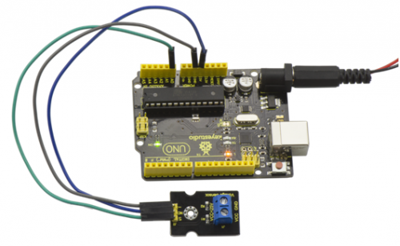  
Done as the above wiring, compile and upload the code, powered-on, then open the serial port monitor, it will print out the detected voltage value shown below.   
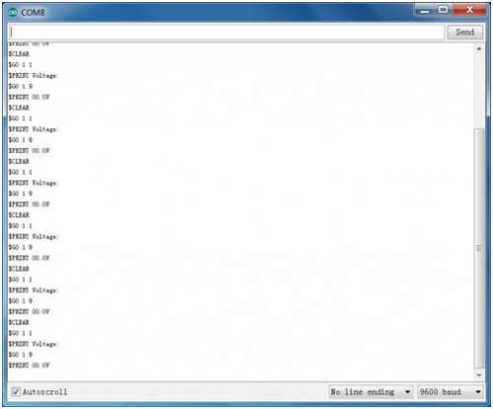

### *Project 30: Pressure Detection*

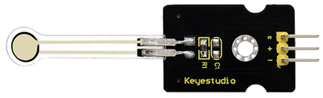

**Description:**  
This sensor adopts the new flexible nano pressure sensitive material with ultra thin film pad. It has the functions of water-proof and pressure detection. When the sensor detects the outside pressure, the resistance of sensor will make a change.   
So using the circuit, it can convert the pressure signal that senses pressure change into the corresponding electric signal output. In this way, we can get the conditions of pressure changes by detecting the signal changes.

**Parameters:**

* Working Voltage：DC 3.3V—5V
* Range：0-10KG
* Thickness：＜0.25mm
* Response Point：＜20g
* Repeatability：＜±5.8%（50% load）
* Accuracy：±2.5%（85% range interval）
* Durability：＞100 thousand times
* Initial Resistance：＞100MΩ(no load)
* Response Time：＜1ms
* Recovery Time：＜15ms
* Working Temperature：﹣20℃—60℃

**Connection Diagram:**  
Firstly you need to prepare the following parts before connection.  
UNO Board\*1  
Pressure sensor\*1  
USB Cable\*1  
Jumper Wire\*3

Connect the S pin of module to Analog A0 of UNO board, connect the negative pin to GND port, positive pin to 5V port.  
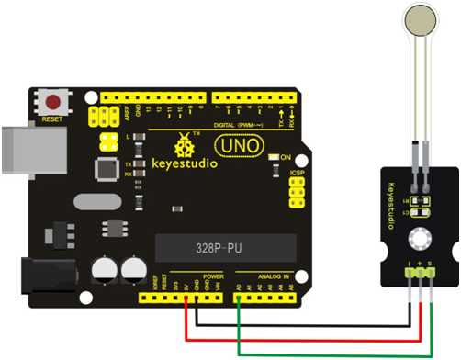

**Sample Code:**  
Copy and paste the below code to Arduino software.

int s\_pin = A0;

void setup()

{

Serial.begin(9600);

pinMode(s\_pin,INPUT);

}

void loop()

{

Serial.println(analogRead(s\_pin));

delay(500);

}

**Example Result:**  
Wiring well and uploading the code, then open the serial monitor on Arduino software.   
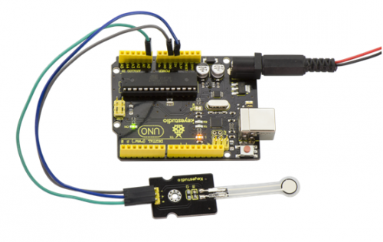  
Then, press the sensor with your hand tightly, the value shown on the monitor is increasing, so the sensor works normally. Shown as below.   
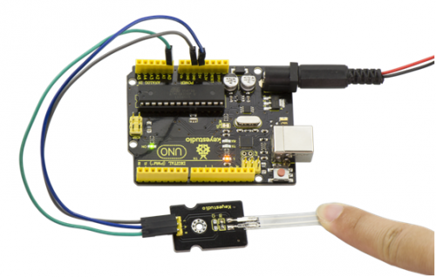  
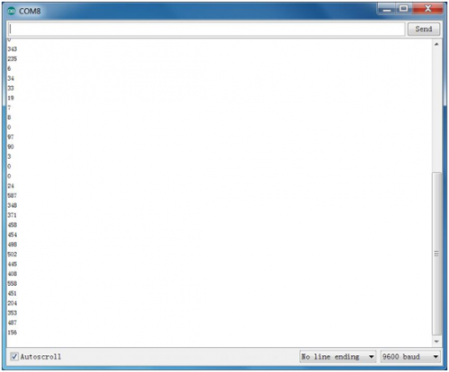

### *Project 31: Ambient Light*

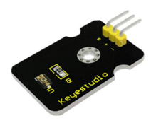

**Description:**  
At some point you are going to sense ambient brightness with better precision than your trusty photoresistor without adding complexity to your project. When that day comes, go get yourself a TEMT6000 ambient light sensor.  
The TEMT6000 is supposed to be adapted to the sensitivity of the human eye, but found it preformed sub-par in low light conditions. It does however work very well reacting to very small changes in a large range of brightness. Because it is meant to mimic the human eye, it does not react well to IR or UV light, so just make sure to note that when using it in your project.

**Specification:**

* Supply Voltage: +5VDC 50mA
* Size: 36.5\*16mm
* Weight: 4g

**Connection Diagram:**  
Firstly you need to prepare the following parts before connection.  
UNO Board\*1  
TEMT6000 ambient light sensor\*1  
USB Cable\*1  
Jumper Wire\*3

This is an incredibly simple part, just connect power and ground, and the signal pin to analog input port, if done connecting, the sensor will output analog voltage, that ramps up when it gets brighter. You can power it with 3.3V as you like, the output value will just be lower.  
  
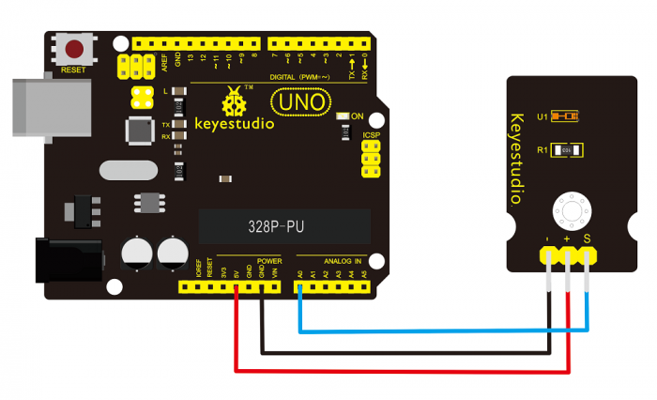

**Sample Code:**  
You can not get more simpler than this – This just reports the reading value from the sensor to the serial terminal: 0-1023 with 1023 being very bright, and 0 being very dark.

int temt6000Pin = 0;

void setup() {

Serial.begin(9600);

}

void loop() {

int value = analogRead(temt6000Pin);

Serial.println(value);

delay(100); //only here to slow down the output so it is easier to read

}

**Example Result:**  
Wiring well and uploading the code above, open the serial monitor of Arduino software.   
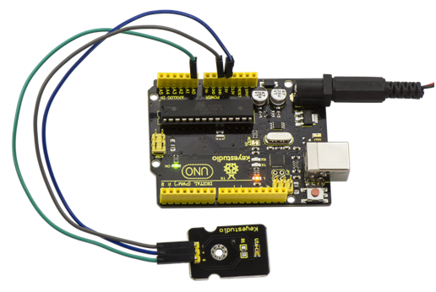  
Then cover the sensor with your hand or a paper, the light becomes weak, finally you will see the value showed on monitor decrease.   
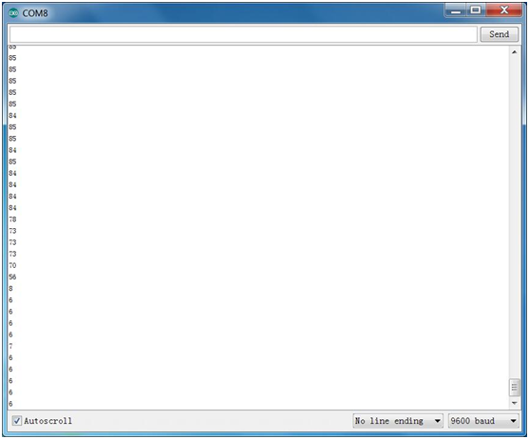

### *Project 32: Ultraviolet Light*

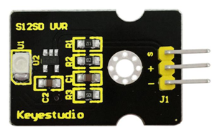

**Description:**  
keyestudio GUVA-S12SD ultraviolet sensor is used to detect ultraviolet light. It includes GUVA-S12SD applied to measure ultraviolet index of intelligent wearable device, such as watches,smart phone and outdoor device with UV index detecting. It can be also used to monitor the intensity of ultraviolet light or used as a UV flame detector when disinfecting things by ultraviolet light.

**Parameters:**

* Size:15mm×30mm×0.7mm
* Supply Voltage:2.5V～5V
* Output Signal:Analog Signal
* Detecting Range of Spectrum:240-370nm
* Active Region: 0.076mm2
* Responsivity:0.14A/W
* Dark Current:1nA
* Light Current:101~125nA UVA Light,1mW/cm2

**Connection Diagram:**  
Firstly you need to prepare the following parts before connection.  
UNO Board\*1  
GUVA-S12SD 3528 Ultraviolet Sensor \*1  
USB Cable\*1  
Jumper Wire\*3

Connect the S pin of module to Analog A0 of UNO board, connect the negative pin to GND port, positive pin to 3V3 port.  
  
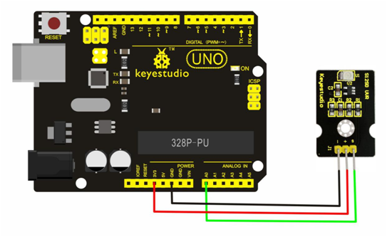

**Sample Code:**  
Copy and paste the code below to Arduino software.

/\*

AnalogReadSerial

Reads an analog input on pin 0, prints the result to the serial monitor.

Attach the center pin of a potentiometer to pin A0, and the outside pins to +5V and ground.

This example code is in the public domain.

\*/

// the setup routine runs once when you press reset:

void setup() {

// initialize serial communication at 9600 bits per second:

Serial.begin(9600);

}

// the loop routine runs over and over again forever:

void loop() {

// read the input on analog pin 0:

int sensorValue = analogRead(A0);

// print out the value you read:

Serial.println(sensorValue);

delay(1); // delay in between reads for stability

}

**Example Result:**  
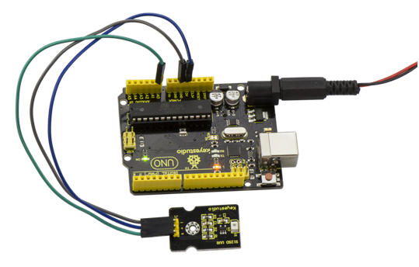  
Wire it up well as above and upload the program code, then open serial monitor, it will display the data shown as the following picture.   
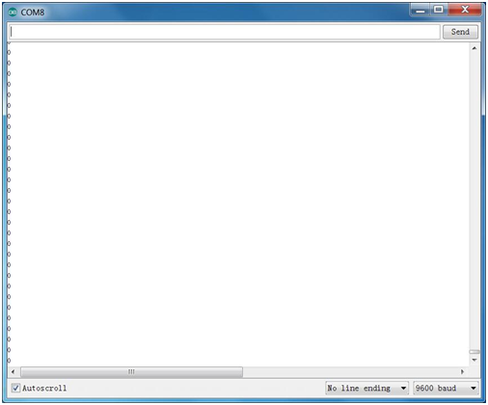

If shine UV light to the sensor, the data on serial monitor is changing shown as the following picture.   
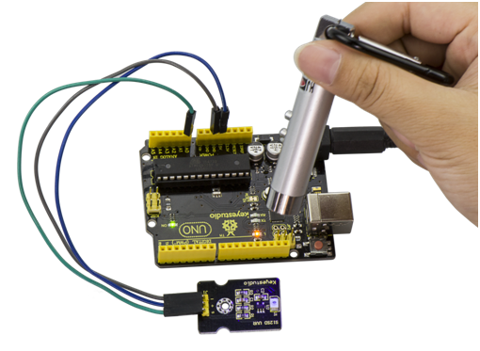  
  
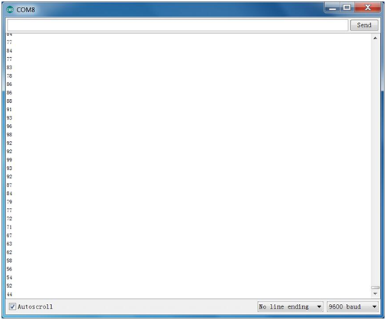

### *Project 33: Digital IR Receiver*

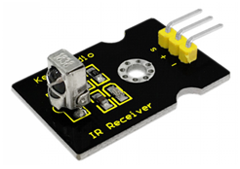

**Description:**  
IR is widely used in remote control. With this IR receiver, Arduino project is able to receive command from any IR remoter controllers if you have the right decoder. Well, it will be also easy to make your own IR controller using IR transmitter.

**Specification:**

* Power Supply: 5V
* Interface:Digital
* Modulation Frequency: 38Khz
* Module Interface Socket:JST PH2.0
* Size: 30\*20mm
* Weight: 4g

**Connection Diagram:**  
Firstly you need to prepare the following parts before connection.  
UNO Board\*1  
IR Receiver module\*1  
USB Cable\*1  
Jumper Wire\*3

Connect the S pin of module to Digital 11 of UNO board, connect the negative pin to GND port, positive pin to 5V port.  
  
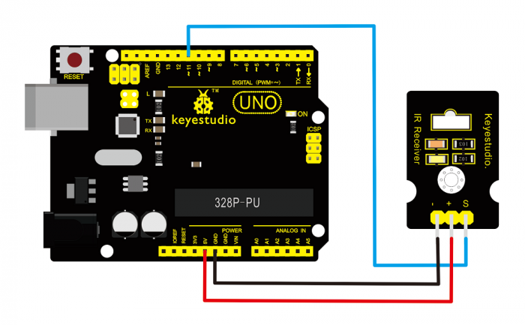

**NOTE:** In the sample code below Digital pin 11 is in use, you may either change your wiring or change the sample code to match.

**Sample Code:**  
Copy and paste the code below to Arduino software.

#include <IRremote.h>

int RECV\_PIN = 11;

IRrecv irrecv(RECV\_PIN);

decode\_results results;

void setup()

{

Serial.begin(9600);

irrecv.enableIRIn(); // Start the receiver

}

void loop() {

if (irrecv.decode(&results)) {

Serial.println(results.value, HEX);

irrecv.resume(); // Receive the next value

}

}

**Note:** before compiling the code, do remember to place the library into libraries directory of Arduino IDE. Otherwise, compiling will fail.  
IR Remote Library Includes some sample codes for sending and receiving.  
<https://github.com/shirriff/Arduino-IRremote>

**Example Result:**  
  
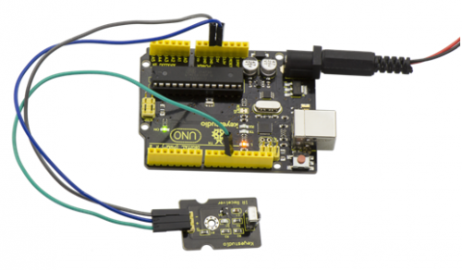  
Done wiring and uploading the code, then control the IR receiver module by an infrared remote control, D1 led will flash. Shown as below.   
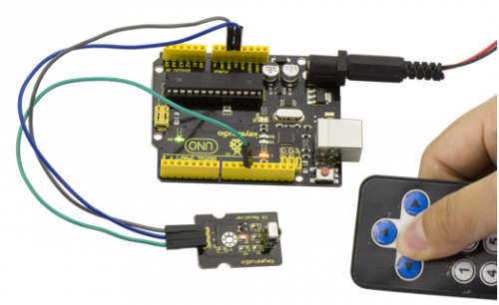

### *Project 34: Digital IR Transmitter*

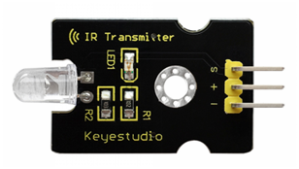

**Description:**  
IR transmitter module is designed for IR communication, which is widely used for operating the television device from a short line-of-sight distance.   
Since infrared (IR) remote control uses light, it requires line of sight to operate the destination device. The signal can, however, be reflected by mirrors, just like any other light sources.  
If operation is required where no line of sight is possible, for instance, when controlling equipment in another room or installed in a cabinet, many brands of IR extenders are available for this on the market. Most of these have an IR receiver, picking up the IR signal and relaying it via radio waves to the remote part, which has an IR transmitter mimicking the original IR control.  
Infrared receivers also tend to have a more or less limited operating angle, which mainly depends on the optical characteristics of the phototransistor. However, it’s easy to increase the operating angle using a matte transparent object in front of the receiver.

**Specification:**

* Power Supply: 3-5V
* Infrared center frequency: 850nm-940nm
* Infrared emission angle: about 20degrees
* Infrared emission distance: about 1.3m (5V 38Khz)
* Interface socket: JST PH2.0
* Mounting hole: inner diameter is 3.2mm, spacing is 15mm
* Size: 35\*20mm
* Weight: 3g

**Connection Diagram:**  
Firstly you need to prepare the following parts before connection.  
UNO Board\*1  
IR Transmitter module\*1  
USB Cable\*1  
Jumper Wire\*3

Connect the S pin of module to Digital 3 of UNO board, connect the negative pin to GND port, positive pin to 5V port.  
  
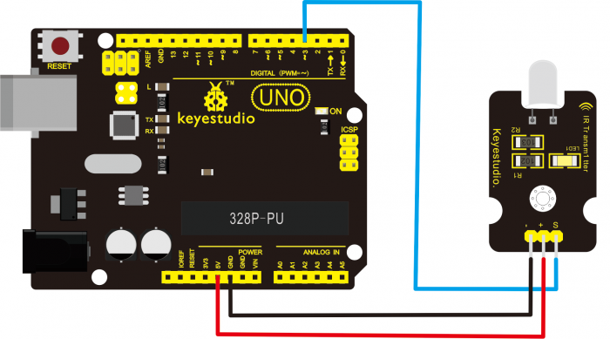

NOTE: In the sample code below Digital pin 11 is in use, you may either change your wiring or change the sample code to match.

**Sample Code:**  
Copy and paste the code below to Arduino software.

int led = 3;

void setup() {

pinMode(led, OUTPUT);

}

void loop() {

digitalWrite(led, HIGH);

delay(1000);

digitalWrite(led, LOW);

delay(1000);

}

Upload well the above code to the board, the led on the sensor will blink red light.  
In the following, let’s move on to an interactive example between IR receiver and IR transmitter module.

**Infrared Remote/Communication:**  
**Hardware Required**  
UNO R3 x2  
Digital IR Receiver x1  
IR Transmitter Module x1  
Jumper Wire x6  
USB cable x2

**Note:** here if you have no two main boards, you can replace it with the breadboard for connection, may be more easier and convenient.   
Get Arduino library [Arduino-IRremote](https://github.com/shirriff/Arduino-IRremote) and install it

**Connection Diagram:**  
For IR Transmitter:as same as the above diagram, but note that Arduino-IRremote only supports D3 as transmitter.   


For IR Receiver: connect the signal pin to D11 port.   
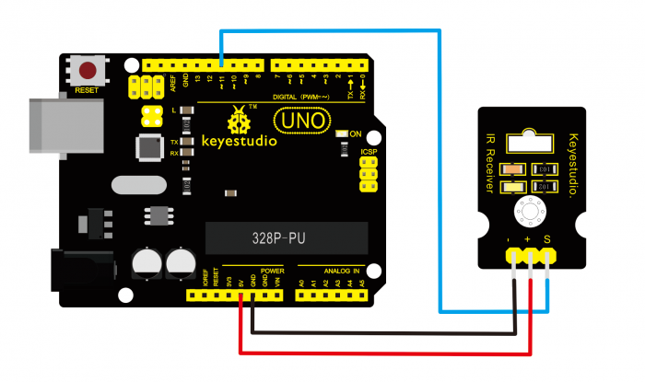

**Sample Code:**   
Upload Code to UNO Board Connected with IR Transmitter:

#include <IRremote.h>

IRsend irsend;

void setup()

{}

void loop() {

irsend.sendRC5(0x0, 8); //send 0x0 code (8 bits)

delay(200);

irsend.sendRC5(0x1, 8);

delay(200); }

Upload Code to UNO Board Connected with IR Receiver:

#include <IRremote.h>

const int RECV\_PIN = 11;

const int LED\_PIN = 13;

IRrecv irrecv(RECV\_PIN);

decode\_results results;

void setup()

{Serial.begin(9600);

irrecv.enableIRIn(); // Start the receiver

}

void loop()

{if (irrecv.decode(&results))

{ if ( results.bits > 0 )

{

int state;

if ( 0x1 == results.value )

{

state = HIGH;

}

else

{

state = LOW;

}

digitalWrite( LED\_PIN, state );

}

irrecv.resume(); // prepare to receive the next value

}

}

**Example Result:**  
  
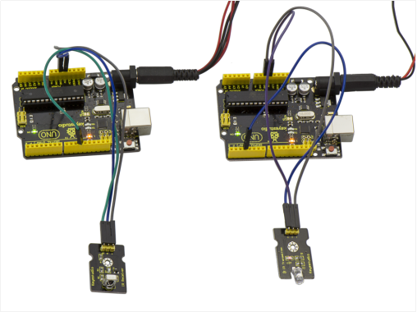  
When IR Receiver module receives the infrared signal from IR Transmitter, D1 ledon the IR Receiver module will blink.Shown as below figure.   
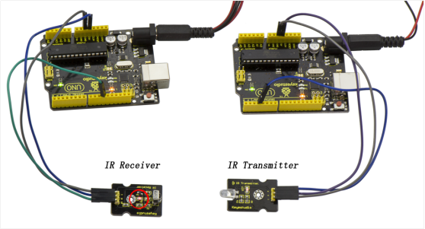

### *Project 35: Pulse Rate Monitor*

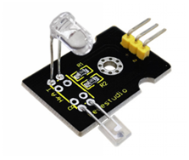

**Description:**  
This module makes use of a ultra-clear infrared LED and a phototransistor to detect the pulse in your finger. The red LED will flash in time with your pulse.   
Working principle: Shine the bright LED onto one side of your finger while the phototransistor on the other side of your finger picks up the amount of transmitted light. The resistance of the phototransistor will vary slightly as the blood pulses go through your finger.

**Part List:**  
Firstly you need to prepare the following parts before making a test.   
UNO Board\*1   
Pulse module\*1  
USB Cable\*1  
Jumper Wire\*3

**Connection Diagram:**  
Connect the Signal pin of module to Analog A0 of UNO board, connect the positive pin to 5V port, negative pin to GND port.   
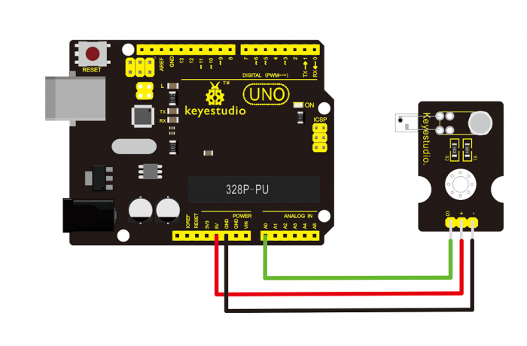

**Sample Code:**  
Copy and paste the code below to Arduino software.

int ledPin = 13;

int sensorPin = 0;

double alpha = 0.75;

int period = 20;

double change = 0.0;

void setup()

{

pinMode(ledPin, OUTPUT);

Serial.begin(115200);

}

void loop()

{

static double oldValue = 0;

static double oldChange = 0;

int rawValue = analogRead(sensorPin);

double value = alpha \* oldValue + (1 - alpha) \* rawValue;

Serial.print(rawValue);

Serial.print(",");

Serial.println(value);

oldValue = value;

delay(period);

}

**Example Result:**  
Wire it up well as the above diagram, then upload well the code to the board and click the icon of serial monitor on the upper right corner of Arduino software. Set the baud rate as 115200, you will see the data is displayed on the monitor. You can copy and paste the data to the excel, finally it will generate the corresponding picture shown below.   
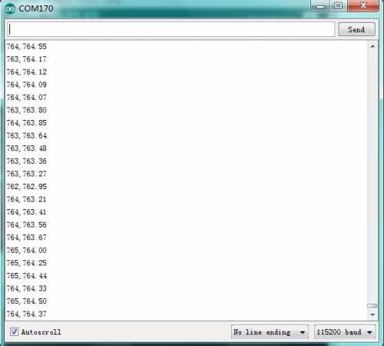 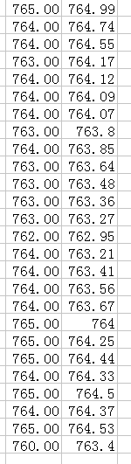   
  
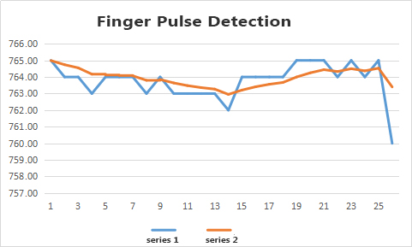

### *Project 36: Joystick*

**Description:**   
Lots of robot projects need joystick. This module provides an affordable solution. By simply connecting to two analog inputs, the robot is at your commands with X, Y control. It also has a switch that is connected to a digital pin.

**Specification:**

* Supply Voltage: 3.3V to 5V
* Interface: Analog x2, Digital x1
* Size: 40\*28mm
* Weight: 12g

**Connection Diagram:**  
Firstly you need to prepare the following parts before connection.  
UNO Board\*1   
Joystick module\*1  
USB Cable\*1  
Jumper Wire\*5

Connect the Y pin of module to Analog A1 of UNO board, connect the X pin to Analog A0, B pin to Digital 3; Connect negative pin to GND port, positive pin to 5V port.   
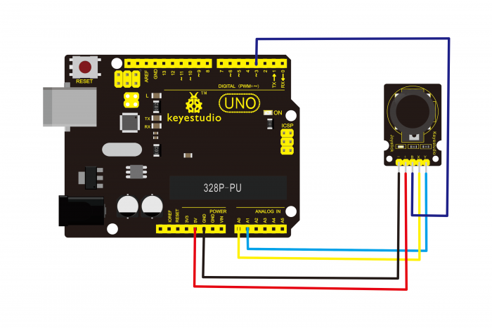

**Sample Code:**  
Copy and paste the code below to Arduino software.

int JoyStick\_X = 0; //x

int JoyStick\_Y = 1; //y

int JoyStick\_Z = 3; //key

  void setup()

{

  pinMode(JoyStick\_Z, INPUT);

  Serial.begin(9600); // 9600 bps

}

void loop()

{

  int x,y,z;

  x=analogRead(JoyStick\_X);

  y=analogRead(JoyStick\_Y);

  z=digitalRead(JoyStick\_Z);

  Serial.print(x ,DEC);

  Serial.print(",");

  Serial.print(y ,DEC);

  Serial.print(",");

  Serial.println(z ,DEC);

  delay(100);

}

**Example Result:**  
  
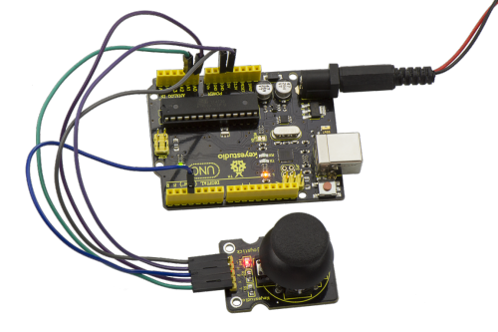

Wiring well and uploading the code, open the serial monitor on Arduino software, and set the baud rate as 9600, you will see the value shown below.   
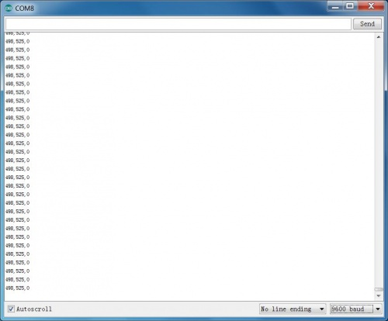  
  
If you push the joystick downward/upward/leftward/rightward, the data will be changed. Shown as the figure below.

**Push downward**   
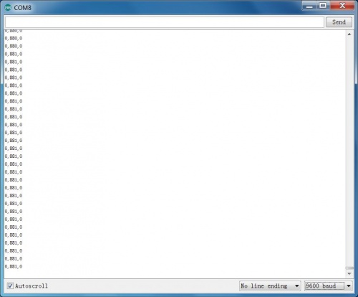

**Push upward**   
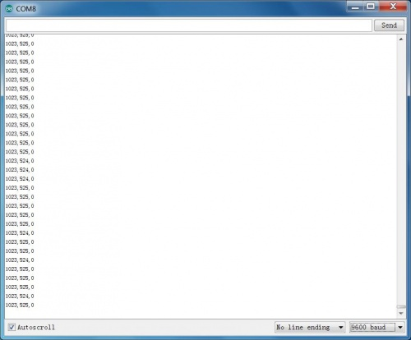

**Push leftward**   
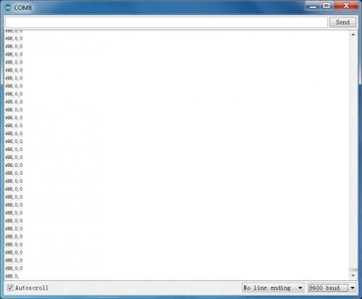

**Push rightward**   
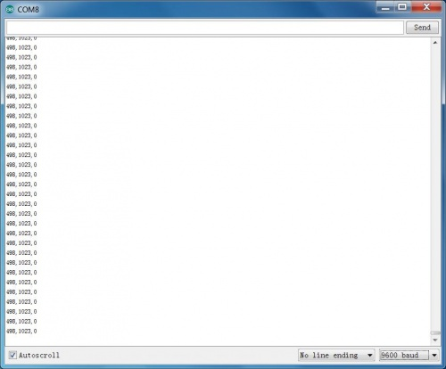

### *Project 36: Joystick*

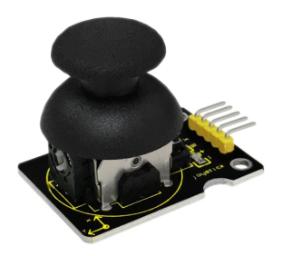

**Description:**   
Lots of robot projects need joystick. This module provides an affordable solution. By simply connecting to two analog inputs, the robot is at your commands with X, Y control. It also has a switch that is connected to a digital pin.

**Specification:**

* Supply Voltage: 3.3V to 5V
* Interface: Analog x2, Digital x1
* Size: 40\*28mm
* Weight: 12g

**Connection Diagram:**  
Firstly you need to prepare the following parts before connection.  
UNO Board\*1   
Joystick module\*1  
USB Cable\*1  
Jumper Wire\*5

Connect the Y pin of module to Analog A1 of UNO board, connect the X pin to Analog A0, B pin to Digital 3; Connect negative pin to GND port, positive pin to 5V port.   


**Sample Code:**  
Copy and paste the code below to Arduino software.

int JoyStick\_X = 0; //x

int JoyStick\_Y = 1; //y

int JoyStick\_Z = 3; //key

  void setup()

{

  pinMode(JoyStick\_Z, INPUT);

  Serial.begin(9600); // 9600 bps

}

void loop()

{

  int x,y,z;

  x=analogRead(JoyStick\_X);

  y=analogRead(JoyStick\_Y);

  z=digitalRead(JoyStick\_Z);

  Serial.print(x ,DEC);

  Serial.print(",");

  Serial.print(y ,DEC);

  Serial.print(",");

  Serial.println(z ,DEC);

  delay(100);

}

**Example Result:**  


Wiring well and uploading the code, open the serial monitor on Arduino software, and set the baud rate as 9600, you will see the value shown below.   
  
  
If you push the joystick downward/upward/leftward/rightward, the data will be changed. Shown as the figure below.

**Push downward**   


**Push upward**   


**Push leftward**   


**Push rightward**   


### *Project 37: Rotary Encoder*

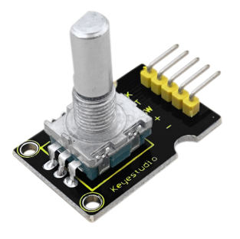

**Introduction:**  
The rotary encoder can count the pulse outputting times during the process of rotation in positive and reverse direction. This rotating counting is unlimited, not like potential counting. It can be restored to initial state to count from 0.

**Specification:**

* Power Supply: 5V
* Interface: Digital
* Size: 30\*20mm
* Weight: 7g

**Connection Diagram:**   
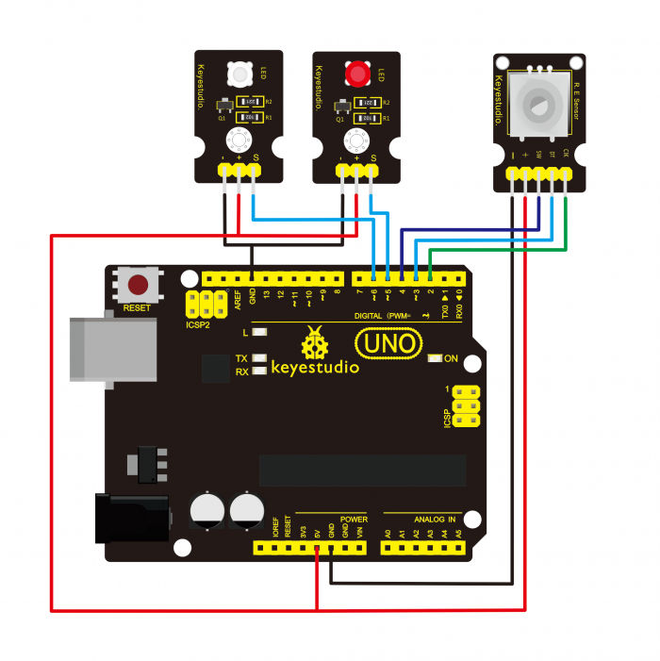  
  
As seen in the diagram, we connect rotary encoder module and two LED modules to the breadboard and UNO board. This way use the rotary encoder module to control two LED modules on and off.

**Sample Code:**  
Copy and paste the code below to Arduino software.

const int interruptA = 0;

const int interruptB = 1;

int CLK = 2; // PIN2

int DAT = 3; // PIN3

int BUTTON = 4; // PIN4

int LED1 = 5; // PIN5

int LED2 = 6; // PIN6

int COUNT = 0;

void setup()

{

attachInterrupt(interruptA, RoteStateChanged, FALLING);

// attachInterrupt(interruptB, buttonState, FALLING);

pinMode(CLK, INPUT);

digitalWrite(2, HIGH); // Pull High Resistance

pinMode(DAT, INPUT);

digitalWrite(3, HIGH); // Pull High Resistance

pinMode(BUTTON, INPUT);

digitalWrite(4, HIGH); // Pull High Resistance

pinMode(LED1, OUTPUT);

pinMode(LED2, OUTPUT);

Serial.begin(9600);

}

void loop()

{

if (!(digitalRead(BUTTON)))

{

COUNT = 0;

Serial.println("STOP COUNT = 0");

digitalWrite(LED1, LOW);

digitalWrite(LED2, LOW);

delay (2000);

}

Serial.println(COUNT);

}

//-------------------------------------------

void RoteStateChanged() //When CLK FALLING READ DAT

{

if (digitalRead(DAT)) // When DAT = HIGH IS FORWARD

{

COUNT++;

digitalWrite(LED1, HIGH);

digitalWrite(LED2, LOW);

delay(20);

}

else // When DAT = LOW IS BackRote

{

COUNT--;

digitalWrite(LED2, HIGH);

digitalWrite(LED1, LOW);

delay(20);

}

}

**Example Result:**   
Wiring well and uploading the above code, you can rotate the encoder module to randomly control two LED modules on and off. When you rotate the encoder module, one LED module is turned on first but another one is off. If you continue to rotate the encoder module, one LED module becomes off while another one is turned on, repeatedly.   
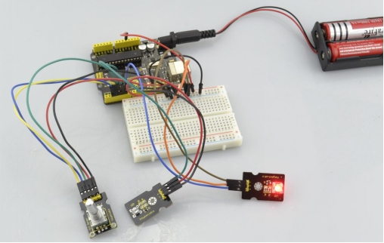

### *Project 38: Single Relay*

**Introduction:**   
This single relay module can be used in interactive projects. This module uses SONGLE 5v high-quality relay. It can also be used to control lighting, electrical and other equipment. The modular design makes it easy to expand with Arduino board. The relay output is by a light-emitting diode. It can be controlled through digital IO port, such as solenoid valves, lamps, motors and other high current or high voltage devices.

**Specification:**

* 1.Type: Digital
* 2.Rated current: 10A (NO) 5A (NC)
* 3.Maximum switching voltage: 150VAC 24VDC
* 4.Digital interface
* 5.Control signal: TTL level
* 6.Rated load: 8A 150VAC (NO), 10A 24VDC (NO), 5A 250VAC (NO/NC), 5A 24VDC (NO/NC)
* 7.Maximum switching power: AC1200VA DC240W (NO), AC625VA DC120W (NC)
* 8.Contact action time: 10ms
* 9.Size: 40\*28mm
* 10.Weight: 15g

**Connection Diagram:**   
Firstly you need to prepare the following parts before connection.  
UNO Board\*1   
Relay module\*1  
LED module \*1  
Breadboard \*1  
USB Cable\*1  
Jumper Wire\*9

Here we use the single relay module to control an LED module on or off. So first connect well all the components as the below diagram shown.  
For relay module, connect the Signal pin to Digital port 8 of UNO board, then connect its positive pin to anode row of breadboard, lead off the row to 5V port of UNO board. Connect its negative pin to cathode row of breadboard, lead off the row to GND port of UNO board.   
For LED module, connect its Signal pin to one terminal block of relay module, another terminal block on the relay is connected to Digital port 13 of UNO board. Connect its positive pin to anode row, negative pin to cathode row of breadboard.

**Sample Code:**  
Copy and paste the code below to Arduino software.

 int Relay = 8;

  void setup()

{

  pinMode(13, OUTPUT);         //Set Pin13 as output

  digitalWrite(13, HIGH);     //Set Pin13 High

  pinMode(Relay, OUTPUT);     //Set Pin3 as output

}

void loop()

{

          digitalWrite(Relay, HIGH);   //Turn off relay

          delay(2000);

          digitalWrite(Relay, LOW);    //Turn on relay

          delay(2000);

}

**Example Result:**

This relay module is active HIGH level. Wire it up well, powered up, then upload the above code to the board, you will see the relay is turned on（ON connected, NC disconnected）for two seconds, then turned off for two seconds（NC closed,ON disconnected）, repeatedly and circularly. When the relay is turned on, external LED is on. If relay is turned off, external LED is off.

### *Project 39: Linear Temperature*

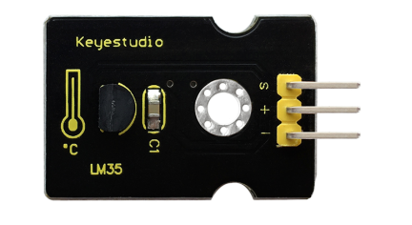

**Introduction:**   
LM35 Linear Temperature Sensor is based on semiconductor LM35 temperature sensor. It can be used to detect ambient air temperature. This sensor offers a functional range among 0 degree Celsius to 100 degree Celsius. Sensitivity is 10mV per degree Celsius. The output voltage is proportional to the temperature.   
This sensor is commonly used as a temperature measurement sensor. It includes thermocouples, platinum resistance, thermal resistance and temperature semiconductor chips. The chip is commonly used in high temperature measurement thermocouples. Platinum resistance temperature sensor is used in the measurement of 800 degrees Celsius, while the thermal resistance and semiconductor temperature sensor is suitable for measuring the temperature of 100-200 degrees or below, in which the application of a simple semiconductor temperature sensor is good in linearity and high in sensitivity. The LM35 linear temperature sensor can be easily connected to Arduino shield.

**Specification:**

* Sensitivity: 10mV per degree Celsius
* Functional range: 0 degree Celsius to 100 degree Celsius
* Size: 30\*20mm
* Weight: 3g

**Connection Diagram:**   
Firstly you need to prepare the following parts before testing.   
UNO Board\*1  
LM35 temperature sensor\*1  
USB Cable\*1  
Jumper Wire\*3

Then follow the wiring diagram, connect the signal pin of sensor to A0 port of UNO board, negative pin to GND port, positive pin to 5V port.   
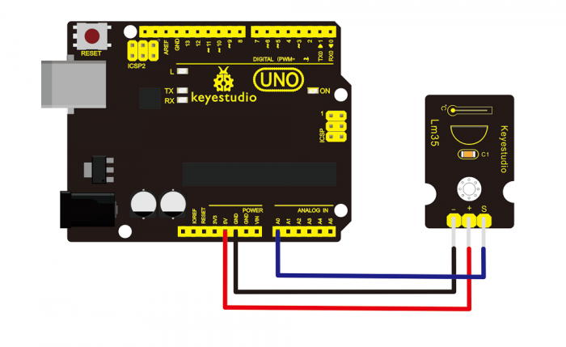

**Sample Code:**   
Copy and paste the code below to Arduino software.

void setup()

{

    Serial.begin(9600);//Set Baud Rate to 9600 bps

}

 void loop()

{  int val;

    int dat;

    val=analogRead(0);//Connect LM35 on Analog 0

    dat=(500 \* val) /1024;;

    Serial.print("Temp:"); //Display the temperature on Serial monitor

    Serial.print(dat);

    Serial.println("C");

    delay(500);

}

**Example Result:**

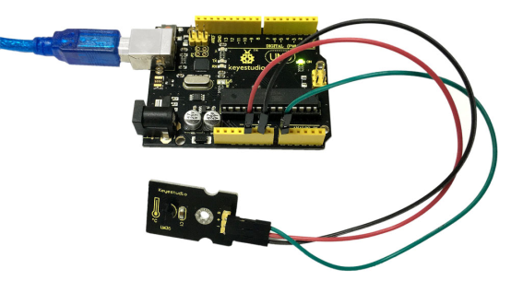  
Wire it up as the above diagram and upload well the code to the board, then open the serial monitor and set the baud rate as 9600, finally you will see the current temperature value shown below. The value may be slight difference due to different place and weather.   
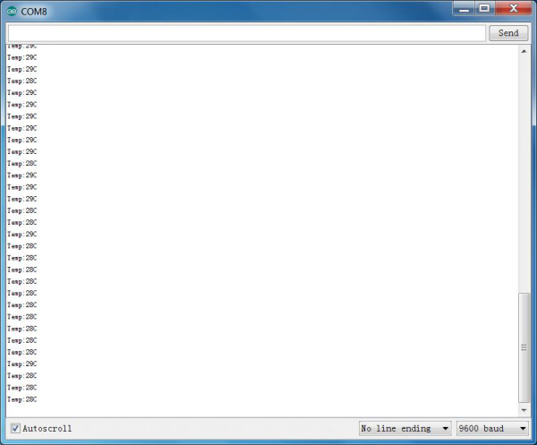

### *Project 40: Temperature and Humidity Display*

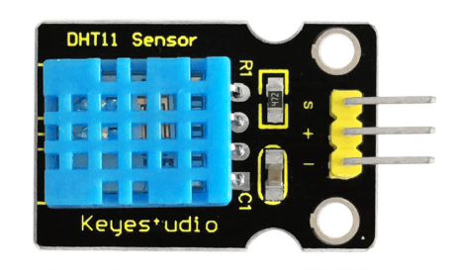

**Introduction:**   
This DHT11 sensor features calibrated digital signal output with the temperature and humidity sensor complex. Its technology ensures high reliability and excellent long-term stability.   
A high-performance 8-bit microcontroller is connected on the sensor. This sensor includes a resistive element and a sense of wet NTC temperature measuring devices. It has advantages of excellent quality, fast response, anti-interference ability and high cost performance.  
Each DHT11 sensor features extremely accurate calibration data of humidity calibration chamber. The calibration coefficients stored in the OTP program memory, internal sensors detect signals in the process, and we should call these calibration coefficients.  
The single-wire serial interface system is integrated to make it quick and easy. Qualities of small size, low power, and 20-meter signal transmission distance make it a wide applied application or even the most demanding one.

**Specification:**

* Supply Voltage: +5 V
* Temperature range: 0-50 °C error of ± 2 °C
* Humidity: 20-90% RH ± 5% RH error
* Interface: Digital
* Size: 30\*20mm
* Weight: 4g

**Connection Diagram:**  
Firstly you need to prepare the following parts before testing.  
UNO Board\*1   
DHT11 sensor\*1   
USB Cable\*1   
Jumper Wire\*3

Then follow the wiring diagram, connect the Signal pin of sensor to Digital 4 port of UNO board, negative pin to GND port, positive pin to 5V port.   
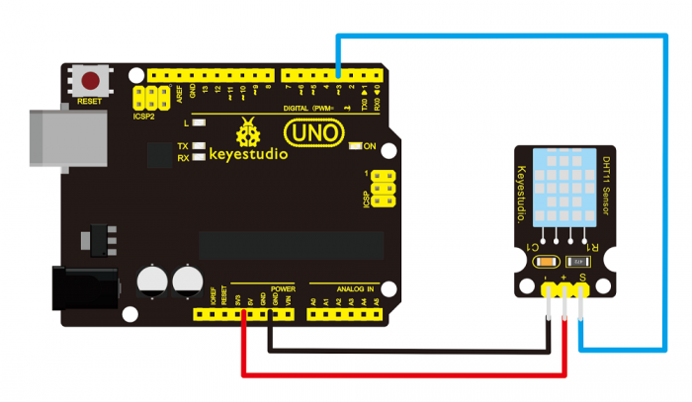

**Sample Code:**   
Please download the [DHT11Lib](https://github.com/RobTillaart/Arduino/tree/master/libraries/DHTlib) firstly. Or [visit the website](https://playground.arduino.cc/Main/DHTLib)   
Copy and paste the code below to Arduino software.

#include <dht11.h>

dht11 DHT;

#define DHT11\_PIN 4

void setup(){

Serial.begin(9600);

Serial.println("DHT TEST PROGRAM ");

Serial.print("LIBRARY VERSION: ");

Serial.println(DHT11LIB\_VERSION);

Serial.println();

Serial.println("Type,\tstatus,\tHumidity (%),\tTemperature (C)");

}

void loop(){

int chk;

Serial.print("DHT11, \t");

chk = DHT.read(DHT11\_PIN); // READ DATA

switch (chk){

case DHTLIB\_OK:

Serial.print("OK,\t");

break;

case DHTLIB\_ERROR\_CHECKSUM:

Serial.print("Checksum error,\t");

break;

case DHTLIB\_ERROR\_TIMEOUT:

Serial.print("Time out error,\t");

break;

default:

Serial.print("Unknown error,\t");

break;

}

// DISPLAT DATA

Serial.print(DHT.humidity,1);

Serial.print(",\t");

Serial.println(DHT.temperature,1);

delay(1000);

}

**Example Result:**   
Wire it up well and upload the above code to UNO board.  
  
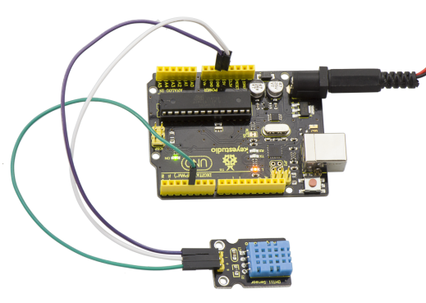

Then open the serial monitor and set the baud rate as 9600, finally you will see the current temperature and humidity value.   
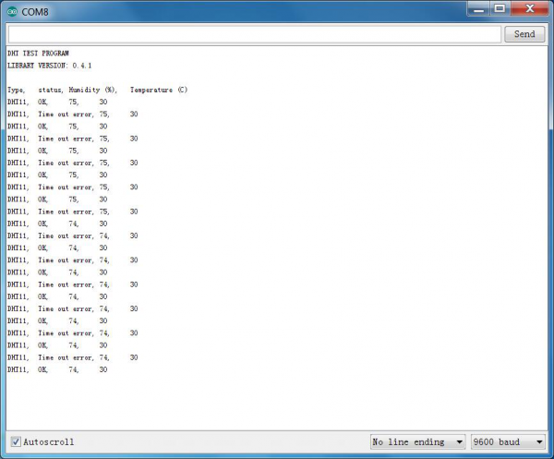

### *Project 41: Magical Light Cup*

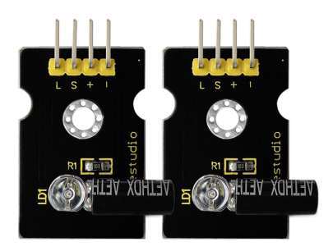

**Introduction:**   
Magic light cup module is able to interact with ARDUINO. The principle is based on PWM dimming. The mercury switch on the module can provide a digital signal and trigger PWM regulation. The brightness of two modules will be changed together through the program design, finally you can see the changing effect that two set of cups are pouring the light.

**Specification:**

* Supply Voltage: 3.3V to 5V
* Interface: Digital

**Connection Diagram:**  
Firstly you need to prepare the following parts by yourself before connection.  
UNO Board\*1  
Light cap module\*2  
USB Cable\*1  
Breadboard \*1  
Jumper Wire\*10

Follow the wiring diagram below, for one light cap module, connect its Signal pin to Digital port 4 of UNO board, L pin to Digital port 6. For the other one, connect its Signal pin to Digital port 7 of UNO board, L pin to Digital port 5.

Connect the positive pin to anode row of breadboard, lead off the row to 5V port of UNO board; connect the negative pin to cathode row of breadboard, lead off the row to ground port.   
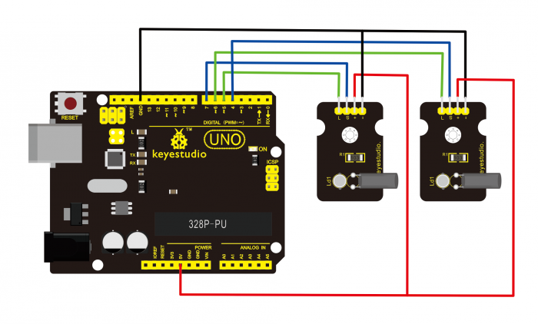

**Sample Code:**   
Copy and paste the code below to Arduino software.

int LedPinA = 5;

int LedPinB = 6;

int ButtonPinA = 7;

int ButtonPinB = 4;

int buttonStateA = 0;

int buttonStateB = 0;

int brightnessA = 0;

int brightnessB= 255;

void setup()

{

Serial.begin(9600);

pinMode(LedPinA, OUTPUT);

pinMode(LedPinB, OUTPUT);

pinMode(ButtonPinA, INPUT);

pinMode(ButtonPinB, INPUT);

}

void loop()

{

buttonStateA = digitalRead(ButtonPinA);

if (buttonStateA == HIGH && brightnessA != 255)

{

brightnessA ++;

}

if (buttonStateA == LOW && brightnessA != 0)

{

brightnessA --;

}

analogWrite(LedPinB, brightnessA);

Serial.print(brightnessA);

Serial.print(" ");

buttonStateB = digitalRead(ButtonPinB);

if (buttonStateB == HIGH && brightnessB != 0)

{

brightnessB --;

}

if (buttonStateB == LOW && brightnessB != 255)

{

brightnessB++;

}

analogWrite(LedPinA, brightnessB);

Serial.println(brightnessB);

delay(5);

}

**Example Result:**   
  
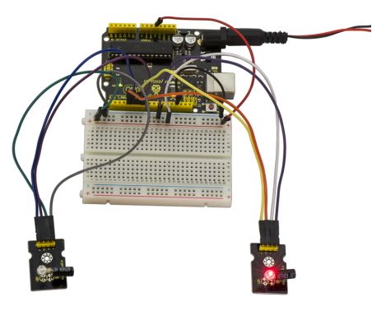

Wire it up as the above diagram and upload well the code to the board, then you can see one cap lights up while the other one is off. When tilt these two caps towards the same side, one cap is gradually become bright, another bright cap is gradually off.   
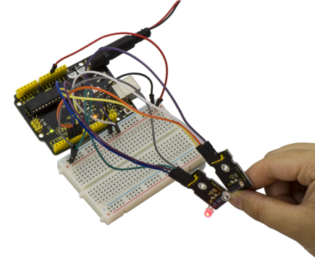

### *Project 42: Attitude Sensor*

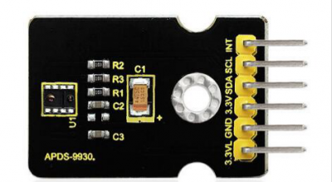

**Introduction:**   
Keyestudio attitude sensor module mainly uses APDS-9930 chip. APDS-9930 in a single 8 pin package can provide the ambient light sensor which is compatible with I2C interface and infrared LED proximity sensor.   
The ambient light sensor uses double light diode to approximate the visual response of low lumen human under 0.01 lux illumination, and its high sensitivity allows the device to operate in the back of dark glass.   
The proximity sensor which is completely adjusted can detect 100 mm object, and exempt the factory calibration requirements of terminal equipment as well as sub-components. From the bright sunlight to the dark room, proximity sensor’s proximity detection function can operate well.   
This module added micro optical lens can provide infrared energy efficient transmission and reception, which can reduce the overall power consumption. In addition, its internal state machine can make the device into a low power mode, bringing a very low average power consumption.

**Performance Parameters:**

* Working Voltage：DC 3.3-3.8V
* Output Current：0-20mA
* Temperature Range：-40℃—85℃

**Features:**

* 1.Optical module integrated with ALS, infrared LED and proximity detector;
* 2.Ambient Light Sensing, similar to the human eye’s visual response;
* 3.Programmable interruption function with upper and lower thresholds;
* 4.Up to 16-bit resolution;
* 5.High sensitivity of operation in the back of dark glass;
* 6.0.01lux low lumen performance;
* 7.Proximity detection, fully calibrated to 100 mm detection;
* 8.Integrate infrared LED and synchronous LED driver;
* 9.Eliminate factory calibration for proximity sensors;
* 10.Programmable waiting timer, waiting state’s power consumption - 90μA (typical value);
* 11.Programmable range is from 2.7 milliseconds to 8 seconds;
* 12.Compatible with I2C interface, up to 400kHz (I2C fast mode);
* 13.Dedicated interruption pin;
* 14.Sleep mode power - 2.2μA (typical value).

**Connection Diagram:**  
Firstly you need to prepare the following parts by yourself before testing.  
UNO Board\*1  
Attitude sensor\*1  
USB Cable\*1  
Jumper Wire\*5

Then follow the wiring diagram, connect the INT pin of sensor to Digital 2 port of UNO board, SCL pin to Analog A5 port, SDA pin to Analog A4 port; Connect 3V3 pin to 3V3 port, GND pin to GND port.   
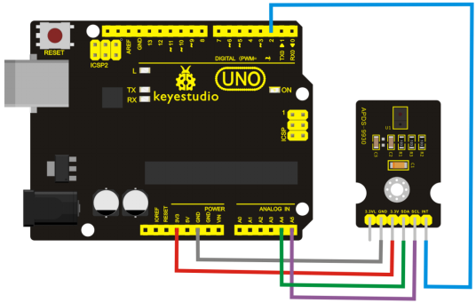

**Sample Code**

IMPORTANT: The APDS-9960 can only accept 3.3V!

Hardware Connections:

Arduino Pin APDS-9960 Board Function

3.3V VCC Power

GND GND Ground

A4 SDA I2C Data

A5 SCL I2C Clock

D2 INT Interrupt

D13 - LED

Resources:   
Include Wire.h and SparkFun\_APDS-9960.h   
Development environment specifics:   
Written in Arduino 1.0.5

Copy and paste the code below to Arduino software.

\*\*\*\*\*\*\*\*\*\*\*\*\*\*\*\*\*\*\*\*\*\*\*\*\*\*\*\*\*\*\*\*\*\*\*\*\*\*\*\*\*\*\*\*\*\*\*\*\*\*\*\*\*\*\*\*\*\*\*\*\*\*\*\*/

#include <Wire.h>

#include <SparkFun\_APDS9960.h>

// Pins

#define APDS9960\_INT 2 // Needs to be an interrupt pin

#define LED\_PIN 13 // LED for showing interrupt

// Constants

#define LIGHT\_INT\_HIGH 1000 // High light level for interrupt

#define LIGHT\_INT\_LOW 10 // Low light level for interrupt

// Global variables

SparkFun\_APDS9960 apds = SparkFun\_APDS9960();

uint16\_t ambient\_light = 0;

uint16\_t red\_light = 0;

uint16\_t green\_light = 0;

uint16\_t blue\_light = 0;

int isr\_flag = 0;

uint16\_t threshold = 0;

void setup() {

// Set LED as output

pinMode(LED\_PIN, OUTPUT);

pinMode(APDS9960\_INT, INPUT);

// Initialize Serial port

Serial.begin(9600);

Serial.println();

Serial.println(F("-------------------------------------"));

Serial.println(F("SparkFun APDS-9960 - Light Interrupts"));

Serial.println(F("-------------------------------------"));

// Initialize interrupt service routine

attachInterrupt(0, interruptRoutine, FALLING);

// Initialize APDS-9960 (configure I2C and initial values)

if ( apds.init() ) {

Serial.println(F("APDS-9960 initialization complete"));

} else {

Serial.println(F("Something went wrong during APDS-9960 init!"));

}

// Set high and low interrupt thresholds

if ( !apds.setLightIntLowThreshold(LIGHT\_INT\_LOW) ) {

Serial.println(F("Error writing low threshold"));

}

if ( !apds.setLightIntHighThreshold(LIGHT\_INT\_HIGH) ) {

Serial.println(F("Error writing high threshold"));

}

// Start running the APDS-9960 light sensor (no interrupts)

if ( apds.enableLightSensor(false) ) {

Serial.println(F("Light sensor is now running"));

} else {

Serial.println(F("Something went wrong during light sensor init!"));

}

// Read high and low interrupt thresholds

if ( !apds.getLightIntLowThreshold(threshold) ) {

Serial.println(F("Error reading low threshold"));

} else {

Serial.print(F("Low Threshold: "));

Serial.println(threshold);

}

if ( !apds.getLightIntHighThreshold(threshold) ) {

Serial.println(F("Error reading high threshold"));

} else {

Serial.print(F("High Threshold: "));

Serial.println(threshold);

}

// Enable interrupts

if ( !apds.setAmbientLightIntEnable(1) ) {

Serial.println(F("Error enabling interrupts"));

}

// Wait for initialization and calibration to finish

delay(500);

}

void loop() {

// If interrupt occurs, print out the light levels

if ( isr\_flag == 1 ) {

// Read the light levels (ambient, red, green, blue) and print

if (  !apds.readAmbientLight(ambient\_light) ||

 !apds.readRedLight(red\_light) ||

 !apds.readGreenLight(green\_light) ||

 !apds.readBlueLight(blue\_light) ) {

Serial.println("Error reading light values");

} else {

Serial.print("Interrupt! Ambient: ");

Serial.print(ambient\_light);

Serial.print(" R: ");

Serial.print(red\_light);

Serial.print(" G: ");

Serial.print(green\_light);

Serial.print(" B: ");

Serial.println(blue\_light);

}

// Turn on LED for a half a second

digitalWrite(LED\_PIN, HIGH);

delay(500);

digitalWrite(LED\_PIN, LOW);

// Reset flag and clear APDS-9960 interrupt (IMPORTANT!)

isr\_flag = 0;

if ( !apds.clearAmbientLightInt() ) {

Serial.println("Error clearing interrupt");

}

}

}

void interruptRoutine() {

isr\_flag = 1;

}

**Note:** before compiling the code, do remember to place the library into libraries directory of Arduino IDE. Otherwise, compiling will fail.

**Example Result:**  
  
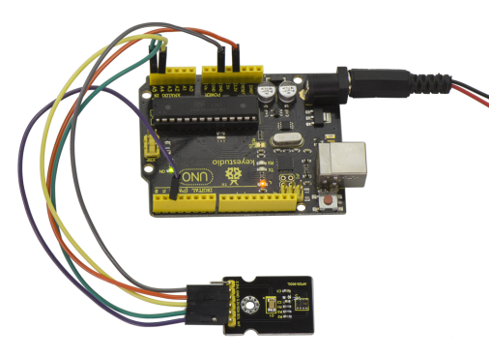  
Wiring as the above diagram and burning the code, after powered-on, open the serial monitor and set the baud rate as 9600, as the graph shown below.   
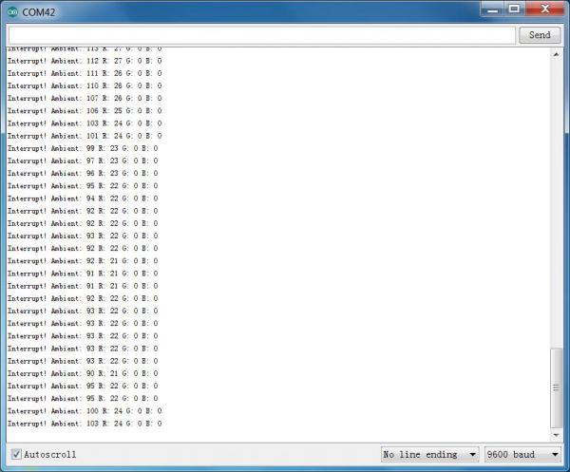

### *Project 43: Optical Proximity Detection*

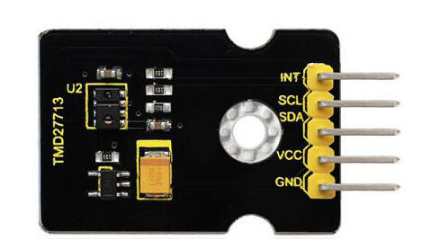

**Introduction:**   
It is a triple sensor integrated with ambient light, proximity sensor and infrared LED. It has two functions.  
For one thing, it is used to detect the current ambient brightness (ALS). It can in accordance with the current ambient brightness automatically adjust the backlight brightness to conform to ambient light by the mean of software adjustment. This way can make backlight brightness soft to protect your vision and to achieve the effect of energy saving.  
For another feature we are referred to as proximity sensor function (PROX). Sensor has been integrated transmitter/receiver and minimized the design, besides, design and installation have no more space restrictions, and for part of a structure is relatively simple.

**Parameters:**

* Working voltage：DC 3.3V
* Detection distance：100mm
* Communication way：IIC communication
* Temperature range：-30℃ to 85℃

**Connection Diagram**  
Firstly you need to prepare the following parts by yourself before testing.  
UNO Board\*1  
TMD27713 sensor\*1  
USB Cable\*1  
Jumper Wire\*5

Then follow the wiring diagram, connect the INT pin of sensor to Digital 2 port of UNO board, SCL pin to Analog A5 port, SDA pin to Analog A4 port; Connect VCC pin to 3V3 port, GND pin to GND port.   
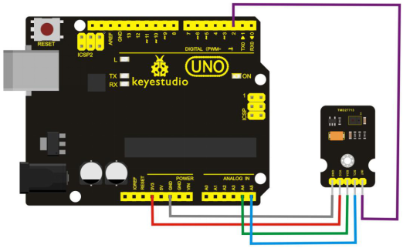

**Sample Code:**   
/\*\*\*\*\*\*\*\*\*\*\*\*\*\*\*\*\*\*\*\*\*\*\*\*\*\*\*\*\*\*\*\*\*\*\*\*\*\*\*\*\*\*\*\*\*\*\*\*\*\*\*\*\*\*\*\*\*\*\*\*\*\*\*\*  
Tests the proximity interrupt abilities of the APDS-9930.   
Configures the APDS-9930 over I2C and waits for an external interrupt based on high or low proximity conditions. Move your hand near the sensor and watch the LED on pin 13.

Hardware Connections:

IMPORTANT: The APDS-9930 can only accept 3.3V!

Arduino Pin APDS-9930 Board Function

3.3V VCC Power

GND GND Ground

A4 SDA I2C Data

A5 SCL I2C Clock

2 INT Interrupt

13 - LED

Resources:   
Include Wire.h and APDS9930.h   
Development environment specifics:  
Written in Arduino 1.0.5

Copy and paste the code below to Arduino software.

\*\*\*\*\*\*\*\*\*\*\*\*\*\*\*\*\*\*\*\*\*\*\*\*\*\*\*\*\*\*\*\*\*\*\*\*\*\*\*\*\*\*\*\*\*\*\*\*\*\*\*\*\*\*\*\*\*\*\*\*\*\*\*\*/

#define DUMP\_REGS

#include <Wire.h>

#include <APDS9930.h>

// Pins

#define APDS9930\_INT 2 // Needs to be an interrupt pin

#define LED\_PIN 13 // LED for showing interrupt

// Constants

#define PROX\_INT\_HIGH 600 // Proximity level for interrupt

#define PROX\_INT\_LOW 0 // No far interrupt

// Global variables

APDS9930 apds = APDS9930();

float ambient\_light = 0; // can also be an unsigned long

uint16\_t ch0 = 0;

uint16\_t ch1 = 1;

uint16\_t proximity\_data = 0;

volatile bool isr\_flag = false;

void setup() {

// Set LED as output

pinMode(LED\_PIN, OUTPUT);

pinMode(APDS9930\_INT, INPUT);

// Initialize Serial port

Serial.begin(9600);

Serial.println();

Serial.println(F("------------------------------"));

Serial.println(F("APDS-9930 - ProximityInterrupt"));

Serial.println(F("------------------------------"));

// Initialize interrupt service routine

attachInterrupt(digitalPinToInterrupt(APDS9930\_INT), interruptRoutine, FALLING);

// Initialize APDS-9930 (configure I2C and initial values)

if (apds.init()) {

Serial.println(F("APDS-9930 initialization complete"));

}

else {

Serial.println(F("Something went wrong during APDS-9930 init!"));

}

// Adjust the Proximity sensor again

if (!apds.setProximityGain(PGAIN\_2X)) {

Serial.println(F("Something went wrong trying to set PGAIN"));

}

// Set proximity interrupt thresholds

if (!apds.setProximityIntLowThreshold(PROX\_INT\_LOW)) {

Serial.println(F("Error writing low threshold"));

}

if (!apds.setProximityIntHighThreshold(PROX\_INT\_HIGH)) {

Serial.println(F("Error writing high threshold"));

}

// Start running the APDS-9930 proximity sensor (interrupts)

if (apds.enableProximitySensor(true)) {

Serial.println(F("Proximity sensor is now running"));

}

else {

Serial.println(F("Something went wrong during sensor init!"));

}

// Start running the APDS-9930 light sensor (no interrupts)

if (apds.enableLightSensor(false)) {

Serial.println(F("Light sensor is now running"));

}

else {

Serial.println(F("Something went wrong during light sensor init!"));

}

#ifdef DUMP\_REGS

/\* Register dump \*/

uint8\_t reg;

uint8\_t val;

for (reg = 0x00; reg <= 0x19; reg++) {

if ((reg != 0x10) && \

(reg != 0x11))

{

apds.wireReadDataByte(reg, val);

Serial.print(reg, HEX);

Serial.print(": 0x");

Serial.println(val, HEX);

}

}

apds.wireReadDataByte(0x1E, val);

Serial.print(0x1E, HEX);

Serial.print(": 0x");

Serial.println(val, HEX);

#endif

}

void loop() {

// If interrupt occurs, print out the proximity level

if (isr\_flag) {

// Read proximity level and print it out

if (!apds.readProximity(proximity\_data)) {

Serial.println("Error reading proximity value");

}

else {

Serial.print("Proximity detected! Level: ");

Serial.print(proximity\_data);

Serial.print(" ");

}

apds.readAmbientLightLux(ambient\_light);

// Read the light levels (ambient, red, green, blue)

if (!apds.readAmbientLightLux(ambient\_light) ||

 !apds.readCh0Light(ch0) ||

 !apds.readCh1Light(ch1)) {

Serial.println(F("Error reading light values"));

}

else {

Serial.print(F("Ambient: "));

Serial.print(ambient\_light);

Serial.print(F(" Ch0: "));

Serial.print(ch0);

Serial.print(F(" Ch1: "));

Serial.println(ch1);

}

// Turn on LED for a half a second

digitalWrite(LED\_PIN, HIGH);

delay(300);

digitalWrite(LED\_PIN, LOW);

// Reset flag and clear APDS-9930 interrupt (IMPORTANT!)

isr\_flag = false;

if (!apds.clearProximityInt()) {

Serial.println("Error clearing interrupt");

}

}

}

void interruptRoutine() {

isr\_flag = true;

}

**Note:** before compiling the code, do remember to place the library into libraries directory of Arduino IDE. Otherwise, compiling will fail.

**Example Result:**   
  
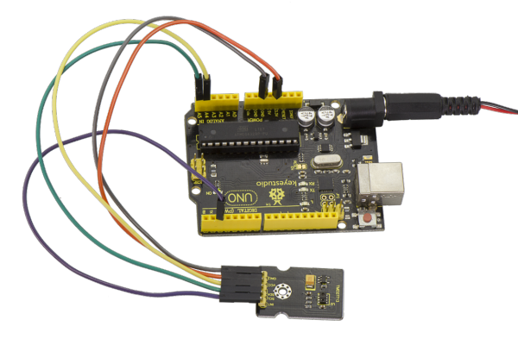  
Tested by Arduino-1.8.2 version software, then open serial monitor, you can see the data as the figure shown below.   
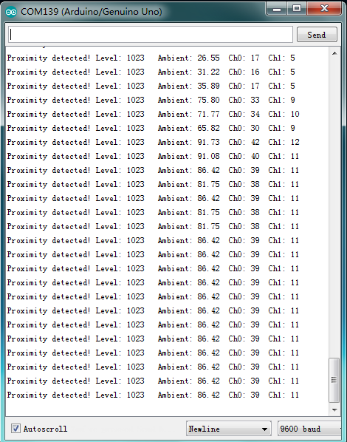

### *Project 44: Triaxial Digital Acceleration Detection*

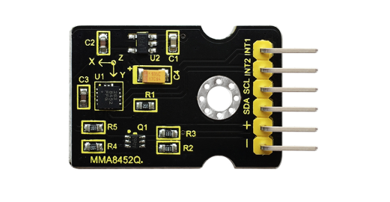

**Introduction:**   
MMA8452Q is a smart low-power, three-axis, capacitive micromachine acceleration sensor with 12-bit resolution.   
This acceleration sensor has a rich embedded performance, featured with flexible user programmable options and two interruption pins configuration. The embedded interruption function can save the overall power consumption and remove the burden of constantly polling the data in the main processor.  
Besides, MMA8452Q has a user optional range of ±2g / ±4g/ ±8g, which can output high-pass filtering data and non-filtered data in real time. This device can configure an embedded function to generate an inertial wake-up interrupt signal, which enables MMA8452Q to maintain a low-power mode in the static state while monitoring the event.

**Performance Parameters:**

* 1.Power Supply Voltage：1.95 V to 3.6 V
* 2.Interface Voltage：1.6 V to 3.6 V
* 3.±2g/±4g/±8g Optional dynamic range
* 4.Output data rate (ODR) range: 1.56 Hz to 800 Hz
* 5.Noise：99μg/√Hz
* 6.12 bits and 8 bits digital outputs;
* 7.I2C digital output interface (up to 2.25 MHz when the pull-up resistor is 4.7 kΩ);
* 8.Two programmable interruption pins applied to six interruption sources;
* 9.Three motion detection embedded channels: free fall detection, pulse detection, shaking detection;
* 10.Direction (transverse/longitudinal) detection with setting lag compensation;
* 11.Automatic arousal and auto-dormant ODR can be automatically altered;
* 12.High-pass filtering data can be exported in real time;
* 13.Power consumption: 6 μA – 165 μA

**Connection Diagram:**  
Firstly you need to prepare the following parts by yourself before testing.  
UNO Board\*1  
MMA8452Q sensor\*1  
USB Cable\*1  
Jumper Wire\*4

Then follow the wiring diagram, connect the SCL pin to Analog A5 port, SDA pin to Analog A4 port; Connect positive pin to 3V3 port, negative pin to GND port.   
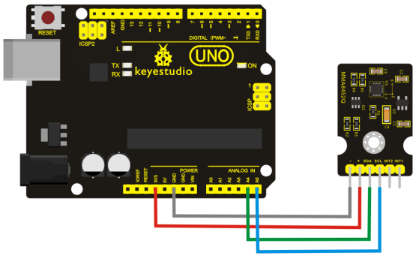

**Sample Code:**   
Copy and paste the code below to Arduino software.

#include <Wire.h> // Must include Wire library for I2C

#include <SparkFun\_MMA8452Q.h> // Includes the SFE\_MMA8452Q library

// Begin using the library by creating an instance of the MMA8452Q

// class. We'll call it "accel". That's what we'll reference from

// here on out.

MMA8452Q accel;

// The setup function simply starts serial and initializes the

// accelerometer.

void setup()

{

Serial.begin(9600);

Serial.println("MMA8452Q Test Code!");

// Choose your adventure! There are a few options when it comes

// to initializing the MMA8452Q:

// 1. Default init. This will set the accelerometer up

// with a full-scale range of +/-2g, and an output data rate

// of 800 Hz (fastest).

accel.init();

// 2. Initialize with FULL-SCALE setting. You can set the scale

// using either SCALE\_2G, SCALE\_4G, or SCALE\_8G as the value.

// That'll set the scale to +/-2g, 4g, or 8g respectively.

//accel.init(SCALE\_4G); // Uncomment this out if you'd like

// 3. Initialize with FULL-SCALE and DATA RATE setting. If you

// want control over how fast your accelerometer produces

// data use one of the following options in the second param:

// ODR\_800, ODR\_400, ODR\_200, ODR\_100, ODR\_50, ODR\_12,

// ODR\_6, or ODR\_1.

// Sets to 800, 400, 200, 100, 50, 12.5, 6.25, or 1.56 Hz.

//accel.init(SCALE\_8G, ODR\_6);

}

// The loop function will simply check for new data from the

// accelerometer and print it out if it's available.

void loop()

{

// Use the accel.available() function to wait for new data

// from the accelerometer.

if (accel.available())

{

// First, use accel.read() to read the new variables:

accel.read();

// accel.read() will update two sets of variables.

// \* int's x, y, and z will store the signed 12-bit values

// read out of the accelerometer.

// \* floats cx, cy, and cz will store the calculated

// acceleration from those 12-bit values. These variables

// are in units of g's.

// Check the two function declarations below for an example

// of how to use these variables.

printCalculatedAccels();

//printAccels(); // Uncomment to print digital readings

// The library also supports the portrait/landscape detection

// of the MMA8452Q. Check out this function declaration for

// an example of how to use that.

printOrientation();

Serial.println(); // Print new line every time.

}

}

// The function demonstrates how to use the accel.x, accel.y and

// accel.z variables.

// Before using these variables you must call the accel.read()

// function!

void printAccels()

{

Serial.print(accel.x, 3);

Serial.print("\t");

Serial.print(accel.y, 3);

Serial.print("\t");

Serial.print(accel.z, 3);

Serial.print("\t");

}

// This function demonstrates how to use the accel.cx, accel.cy,

// and accel.cz variables.

// Before using these variables you must call the accel.read()

// function!

void printCalculatedAccels()

{

Serial.print(accel.cx, 3);

Serial.print("\t");

Serial.print(accel.cy, 3);

Serial.print("\t");

Serial.print(accel.cz, 3);

Serial.print("\t");

}

// This function demonstrates how to use the accel.readPL()

// function, which reads the portrait/landscape status of the

// sensor.

void printOrientation()

{

// accel.readPL() will return a byte containing information

// about the orientation of the sensor. It will be either

// PORTRAIT\_U, PORTRAIT\_D, LANDSCAPE\_R, LANDSCAPE\_L, or

// LOCKOUT.

byte pl = accel.readPL();

switch (pl)

{

case PORTRAIT\_U:

Serial.print("Portrait Up");

break;

case PORTRAIT\_D:

Serial.print("Portrait Down");

break;

case LANDSCAPE\_R:

Serial.print("Landscape Right");

break;

case LANDSCAPE\_L:

Serial.print("Landscape Left");

break;

case LOCKOUT:

Serial.print("Flat");

break;

}

}

**Note:** Before compiling the code, do remember to place the library into libraries directory of Arduino IDE. Otherwise, compiling will fail.

**Example Result:**   
  
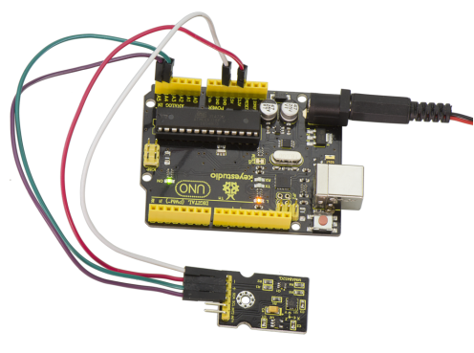  
Wiring as the above diagram and power on, then upload the code and open the serial monitor, it will display the triaxial acceleration of sensor and its status, as the graph shown below.   
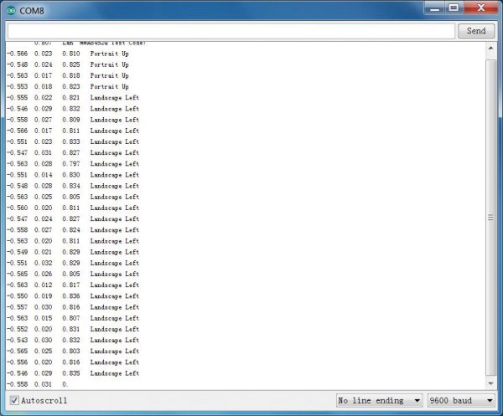

### *Project 45: Micro Servo*

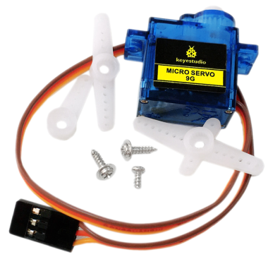

**Introduction:**   
Servomotor is a position control rotary actuator. It mainly consists of housing, circuit board, core-less motor, gear and position sensor. The receiver or MCU outputs a signal to the servomotor.   
The motor has a  built-in reference circuit that gives out reference signal, cycle of 20ms and width of 1.5ms. The motor compares the acquired DC bias voltage to the voltage of the potentiometer and outputs a voltage difference. The IC on the circuit board will decide the rotate direction accordingly and drive the core-less motor. The gear then pass the force to the shaft. The sensor will determine if it has reached the commanded position according to the feedback signal.   
Servomotors are used in control systems that requires to have and maintain different angles. When the motor speed is definite, the gear will cause the potentiometer to rotate. When the voltage difference reduces to zero, the motor stops. Normally, the rotation angle range is among 0-180 degrees.  
Servomotor comes with many specifications. But all of them have three connection wires, distinguished by brown, red, orange colors (different brand may have different color). Brown one is for GND, red one for power positive, orange one for signal line.  
  
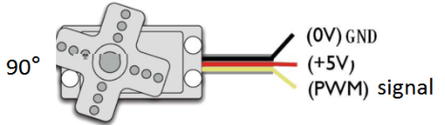

The rotation angle of the servo motor is controlled by regulating the duty cycle of the PWM(Pulse-Width Modulation) signal. The standard cycle of the PWM signal is 20ms（50Hz）. Theoretically, the width is distributed between 1ms-2ms, but in fact, it's between 0.5ms-2.5ms. The width corresponds the rotation angle from 0° to 180°. But note that for different brand motor, the same signal may have different rotation angle.    
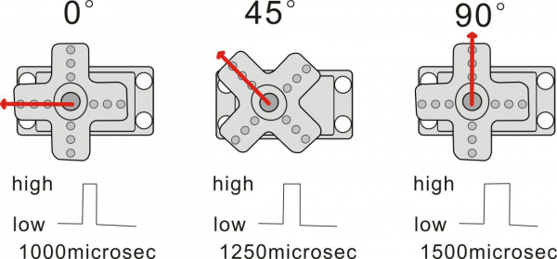

Next, let's learn how to control a servomotor. In this experiment, you only need a servomotor and several jumper wires.

**Connection Diagram:**   
Connection for UNO R3:   
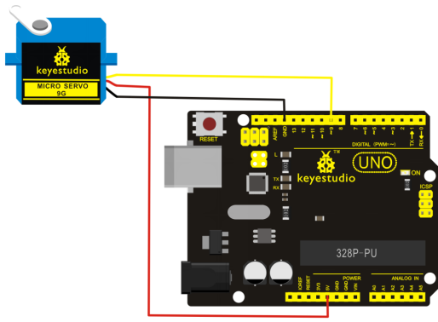

Connection for 2560 R3:   
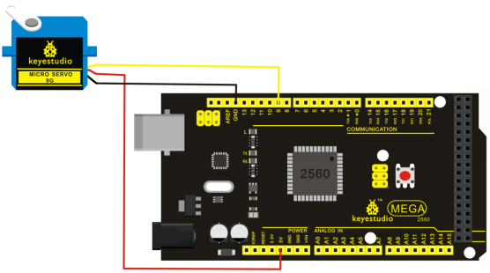

Connect the motor to digital pin 9.   
Compile a program to control the motor rotate to the commanded angle, and display the angle on the screen.

**Sample Program:**   
There are two ways to control a servomotor with Arduino. One is to use a common digital sensor port of Arduino to produce square wave with different duty cycle to simulate PWM signal and use that signal to control the positioning of the motor.   
Another way is to directly use the Servo function of the Arduino to control the motor. In this way, the program will be easier but it can only control two-contact motor for the servo function, only digital pin 9 and 10 can be used. The Arduino drive capacity is limited. So if you need to control more than one motor, you will need external power.

**Method 1:**   
**Sample Program A**

int servopin=9;// select digital pin 9 for servomotor signal line

int myangle;// initialize angle variable

int pulsewidth;// initialize width variable

int val;

void servopulse(int servopin,int myangle)// define a servo pulse function

{

pulsewidth=(myangle\*11)+500;// convert angle to 500-2480 pulse width

digitalWrite(servopin,HIGH);// set the level of servo pin as “high”

delayMicroseconds(pulsewidth);// delay microsecond of pulse width

digitalWrite(servopin,LOW);// set the level of servo pin as “low”

delay(20-pulsewidth/1000);

}

void setup()

{

pinMode(servopin,OUTPUT);// set servo pin as “output”

Serial.begin(9600);// connect to serial port, set baud rate at “9600”

Serial.println("servo=o\_seral\_simple ready" ) ;

}

void loop()// convert number 0 to 9 to corresponding 0-180 degree angle, LED blinks corresponding number of time

{

val=Serial.read();// read serial port value

if(val>='0'&&val<='9')

{

val=val-'0';// convert characteristic quantity to numerical variable

val=val\*(180/9);// convert number to angle

Serial.print("moving servo to ");

Serial.print(val,DEC);

Serial.println();

for(int i=0;i<=50;i++) // giving the servo time to rotate to commanded position

{

servopulse(servopin,val);// use the pulse function

}

}

}

**Method 2:**

Let's first take a look at the Arduino built-in servo function and some common statements.  
1. attach（interface）——select pin for servo, can only use pin 9 or 10.   
2. write（angle）——used to control the rotate angle of the servo, can set the angle among 0 degree to 180 degree.   
3. read（）——used to read the angle of the servo, consider it a function to read the value in the write() function.   
4. attached（）——determine whether the parameter of the servo is sent to the servo pin.   
5. detach（）—— disconnect the servo and the pin, and the pin(digital pin 9 or 10) can be used for PWM port.

**Note:** The written form of the above statements are " servo variable name. specific statement ()", e.g. myservo. Attach (9). Still, connect the servo to pin 9.

**Sample Program B:**

#include <Servo.h>

// define a header file. Special attention here, you can call the servo function directly from Arduino's software menu

//bar Sketch>Importlibrary>Servo, or input #include <Servo.h>. Make sure there is a space between #include and <Servo.h>. Otherwise, it will cause compile error.

Servo myservo;// define servo variable name

void setup()

{

myservo.attach(9);// select servo pin(9 or 10)

}

void loop()

{

myservo.write(90);// set rotating angle of the motor

}

**Example Result:**   
  
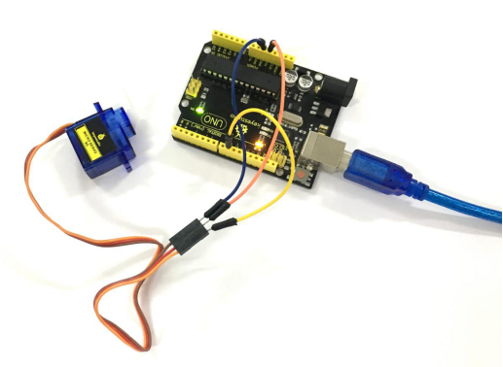  
Wire it up well, powered up, upload the Program A to the board, then click to open the serial monitor of Arduino software, set the baud rate as 9600, and on the upper bar enter a number and click “Send”, you will see the servo rotate to the corresponding angle, and moving angle will be displayed on the monitor. Shown below.   
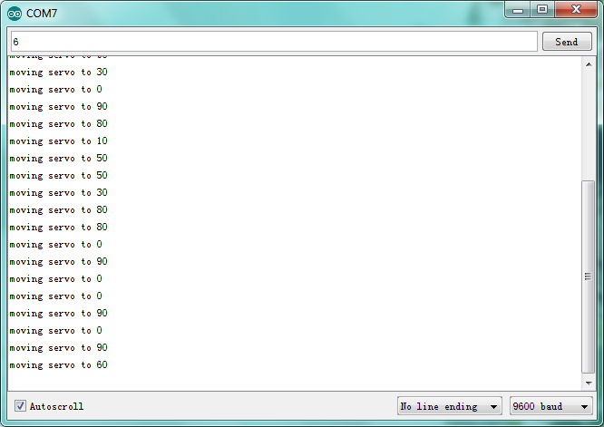  
  
Powered up, upload well the Program B to the board, first servo will turn to the angle of 90 degree.

### *Project 46: Ultrasonic Ranger*

**Description:**   
As the ultrasonic has strong directivity, slow energy consumption and far spread distance in the media, so it is commonly used in the measurement of distance, such as range finder and position measuring instrument. Using ultrasonic is more rapid, convenient, simple to calculate and more easier to achieve real-time con trol, so it has also been widely used in the development of mobile robots.   
Ultrasonic detector module can provide 2cm-450cm non-contact sensing distance, and its ranging accuracy is up to 3mm, very good to meet the normal requirements. The module includes an ultrasonic transmitter and receiver as well as the corresponding control circuit.

**Working Schematics:**   
Please refer to the working sequence as below：   
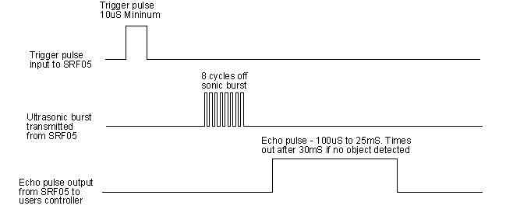

1. First pull down the TRIG, and then trigger it with at least 10us high level signal;   
2. After triggering, the module will automatically transmit eight 40KHZ square waves, and automatically detect whether there is a pulse signal back.   
3. If there is a signal back, through the ECHO to output a high level, the duration time of high level is actually the time from sending ultrasonic to returning back.

Test distance = high level duration \* velocity of sound (340m/s) \* 0.5

**Parameters:**

* 1.Working voltage：0.5V(DC)
* 2.Working current：15mA
* 3.Detecting range：2-450cm
* 4.Detecting angle：15 degrees
* 5.Input trigger pulse：10us TTL Level
* 6.Output echo signal： output TTL level signal(HIGH)，proportional to range.

**Pinout Diagram:**   
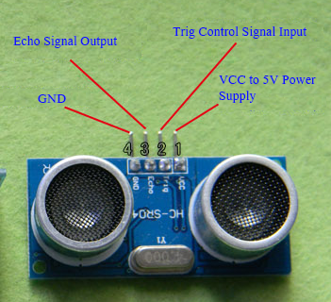

**Connection Diagram:**   
First, you need to prepare the following components:   
UNO board\*1   
Ultrasonic sensor\*1   
USB Cable\*1   
Jumper wire\*4

Next, please refer to the following connection table:   
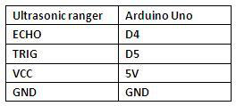

Note: D4、D5 are the digital pin 4 and pin 5.

You can refer to the connection diagram shown below:

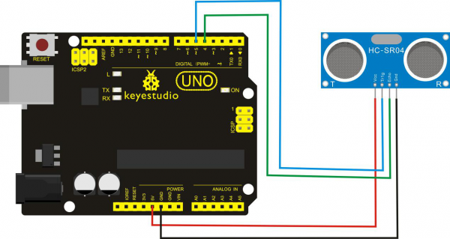

After connecting well, you can use it to measure the distance, displaying the distance value on the monitor.

**Test Code:**   
Finally, copy and paste the test code below to Arduino software.

int inputPin=4; // define ultrasonic signal receiver pin ECHO to D4

int outputPin=5; // define ultrasonic signal transmitter pin TRIG to D5

void setup()

{

Serial.begin(9600);

pinMode(inputPin, INPUT);

pinMode(outputPin, OUTPUT);

}

void loop()

{

digitalWrite(outputPin, LOW); delayMicroseconds(2);

digitalWrite(outputPin, HIGH); // Pulse for 10μ s to trigger ultrasonic detection

delayMicroseconds(10);

digitalWrite(outputPin, LOW);

int distance = pulseIn(inputPin, HIGH); // Read receiver pulse time

distance= distance/58; // Transform pulse time to distance

Serial.println(distance); //Output distance

delay(50);

}

**Example Result:**   
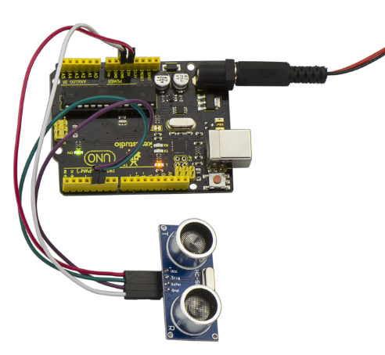  
After upload well the code to UNO board, then open the serial monitor. When place an object in front of the ultrasonic sensor (from near and far), it will detect the distance of object. Thus the value will be displayed on the monitor shown below.   
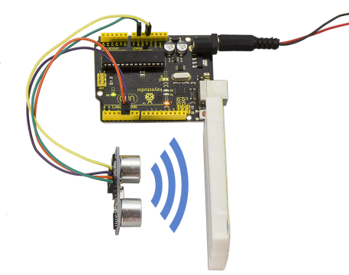  
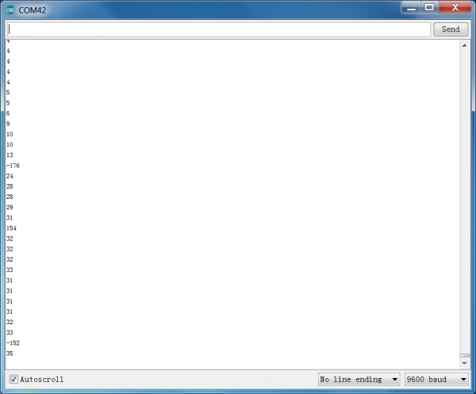

### *Project 47: LCD Display*

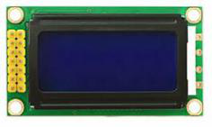

**Description:**   
This project we are going to drive this 0802 LCD display the text combined with UNO R3 board. The display capacity of LCD is 8x2 characters, and operating voltage of the chip is 4.5～5.5V. There are two connection method for 0802 LCD displaying the text, respectively 4-bit and 8-bit connection. You can refer to the related explanation below.

**Interfaces Explanation:**

|  |  |  |
| --- | --- | --- |
| Interface | Pin | Explanation |
| 1 | VSS | Logic Power Ground |
| 2 | VDD | Logic Power |
| 3 | V0 | LCD adjustable voltage, connect to the middle pin of 10K potentiometer |
| 4 | RS | Data\ Command option |
| 5 | RW | read\write option |
| 6 | E | Enable read\write, active at HIGH, falling edge lock the data |
| 7 | DB0 | Data input/output pin |
| 8 | DB1 | Data input/output pin |
| 9 | DB2 | Data input/output pin |
| 10 | DB3 | Data input/output pin |
| 11 | DB4 | Data input/output pin |
| 12 | DB5 | Data input/output pin |
| 13 | DB6 | Data input/output pin |
| 14 | DB7 | Data input/output pin |
| 15 | LED-A | backlight power positive end |
| 16 | LED-K | backlight power negative end |

**Hardware Required**   
Firstly you need to prepare the following parts on your own before connection.  
UNO Board\*1  
0802 LCD\*1   
Rotary potentiometer\*1  
Breadboard \*1   
USB Cable\*1  
Jumper wire\*several  
Dupont wire \*several

**Connection Diagram:**

**4-bit Connection:**   
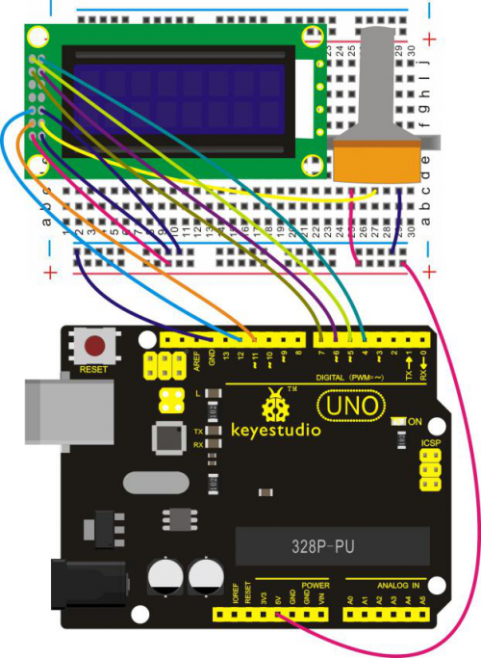

**8-bit Connection:**   
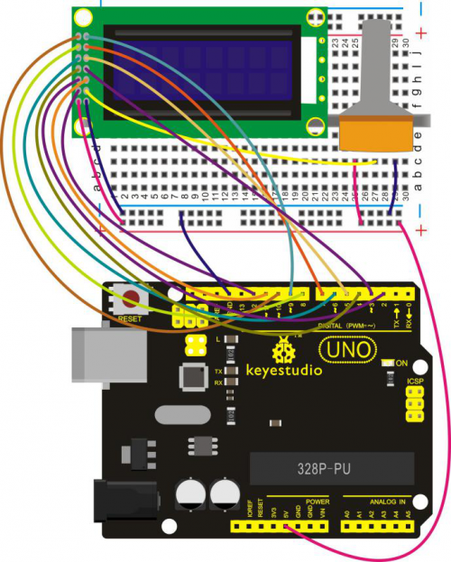

**Source Code:**

**For 4-bit Connection:**

#include <LiquidCrystal.h>

// initialize the library with the numbers of the interface pins

LiquidCrystal lcd(11, 12, 6, 7, 4, 5);

void setup() {

// set up the LCD's number of columns and rows:

lcd.begin(8, 2);

// Print a message to the LCD.

lcd.setCursor(0, 0);

lcd.print(" Hello");

lcd.setCursor(0, 1);

lcd.print(" world!");

}

void loop() {

}

**For 8-bit Connection:**

int DI = 12;

int RW = 11;

int DB[] ={3, 4, 5, 6, 7, 8, 7, 10};// use array to select pin for bus

int Enable = 2;

void LcdCommandWrite(int value) {

// define all pins

int i = 0;

for (i=DB[0]; i <= DI; i++) // assign value for bus

{

digitalWrite(i,value & 01);// for 1602 LCD, it uses D7-D0( not D0-D7) for signal identification; here, it’s used for signal inversion.

value >>= 1;

}

digitalWrite(Enable,LOW);

delayMicroseconds(1);

digitalWrite(Enable,HIGH);

delayMicroseconds(1); // wait for 1ms

digitalWrite(Enable,LOW);

delayMicroseconds(1); // wait for 1ms

}

void LcdDataWrite(int value) {

// initialize all pins

int i = 0;

digitalWrite(DI, HIGH);

digitalWrite(RW, LOW);

for (i=DB[0]; i <= DB[7]; i++) {

digitalWrite(i,value & 01);

value >>= 1;

}

digitalWrite(Enable,LOW);

delayMicroseconds(1);

digitalWrite(Enable,HIGH);

delayMicroseconds(1);

digitalWrite(Enable,LOW);

delayMicroseconds(1); // wait for 1ms

}

void setup (void) {

int i = 0;

for (i=Enable; i <= DI; i++) {

pinMode(i,OUTPUT);

}

delay(100);

// initialize LCD after a brief pause

// for LCD control

LcdCommandWrite(0x38); // select as 8-bit interface, 2-line display, 5x7 character size

delay(64);

LcdCommandWrite(0x38); // select as 8-bit interface, 2-line display, 5x7 character size

delay(50);

LcdCommandWrite(0x38); // select as 8-bit interface, 2-line display, 5x7 character size

delay(20);

LcdCommandWrite(0x06); // set input mode

// auto-increment, no display of shifting

delay(20);

LcdCommandWrite(0x0E); // display setup

// turn on the monitor, cursor on, no flickering

delay(20);

LcdCommandWrite(0x01); // clear the scree, cursor position returns to 0

delay(100);

LcdCommandWrite(0x80); // display setup

// turn on the monitor, cursor on, no flickering

delay(20);

}

void loop (void) {

LcdCommandWrite(0x01); // clear the scree, cursor position returns to 0

delay(10);

LcdCommandWrite(0x80);

delay(10);

// write in welcome message

LcdDataWrite('A');

LcdDataWrite('B');

LcdDataWrite('C');

LcdDataWrite('D');

LcdDataWrite('E');

LcdDataWrite('F');

LcdDataWrite('G');

LcdDataWrite('H');

delay(10);

LcdCommandWrite(0xc0); // set cursor position at second line, second position

delay(10);

LcdDataWrite('1');

LcdDataWrite('2');

LcdDataWrite('3');

LcdDataWrite('4');

LcdDataWrite('5');

LcdDataWrite('6');

LcdDataWrite('7');

LcdDataWrite('8');

delay(3000);

LcdCommandWrite(0x01); // clear the screen, cursor returns to 0

delay(10);

LcdDataWrite('T');

LcdDataWrite('E');

LcdDataWrite('S');

LcdDataWrite('T');

LcdDataWrite('-');

LcdDataWrite('-');

LcdDataWrite('-');

LcdDataWrite('-');

delay(3000);

LcdCommandWrite(0x02); // set mode as new characters replay old ones, where there is no new ones remain the same

delay(10);

LcdCommandWrite(0x80+4); // set cursor position at first line, sixth position

delay(10);

LcdDataWrite('1');

LcdDataWrite('2');

LcdDataWrite('3');

LcdDataWrite('4');

LcdCommandWrite(0xc0); // set cursor position at second line, second position

delay(10);

LcdDataWrite('T');

LcdDataWrite('E');

LcdDataWrite('S');

LcdDataWrite('T');

LcdDataWrite(' ');

LcdDataWrite(' ');

LcdDataWrite('O');

LcdDataWrite('K');

delay(3000);

}

**Example Result:**   
Wire it up well, powered up, upload the above code to the board, this time you can adjust the backlight of LCD through rotating the potentiometer, finally you can see the character is displayed on the LCD screen. If you use the 4-bit connection, you should see the LCD display the character "Hello" on its first line, and the second line display the character "world!" shown as below.   
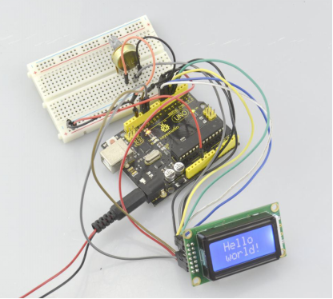

If using the 8-bit connection, you will see other characters are displayed on the LCD. Shown below.

### **Project 48: Dot Matrix**

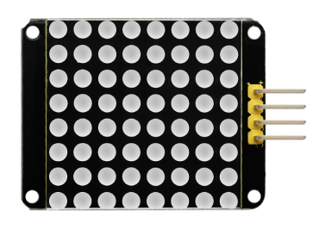

**Introduction:**   
What's better than a single LED? Lots of LEDs! A fun way to make a small display is to use an 8x8 matrix or 4-digit 7-segment display. Matrices like these are 'multiplexed' - so to control 64 LEDs you need 16 pins. That's a lot of pins, and there are driver chips like the MAX7219 that can control a matrix for you but there's a lot of wiring to set up and they take up a ton of space. Here we feel your pain! After all, wouldn't it be awesome if you could control a matrix without tons of wiring? That's where these lovely LED matrix backpacks come in.   
The matrices use a driver chip that does all the heavy lifting for you: They have a built in clock so they multiplex the display. They use constant-current drivers for ultra-bright, consistent color, 1/16 step display dimming, all via a simple I2C interface. These 1.2" matrix backpacks come with three address-selection jumpers, so you can connect up to eight 1.2" 8x8's together (or a combination, such as four 1.2" 8x8's and four 7-segments) on a single I2C bus.

**Specification:**

* Input voltage: 5V
* Rated input frequency: 400KHZ
* Input power: 2.5W
* Input current: 500mA

**Connection Diagram:**  
First, you need to prepare the following components:  
UNO board\*1  
Dot matrix \*1  
USB Cable\*1  
Jumper wire\*4

Then follow the wiring diagram, connect the SCL pin to Analog A5 port, SDA pin to Analog A4 port; Connect VCC pin to 5V port, GND pin to GND port.   
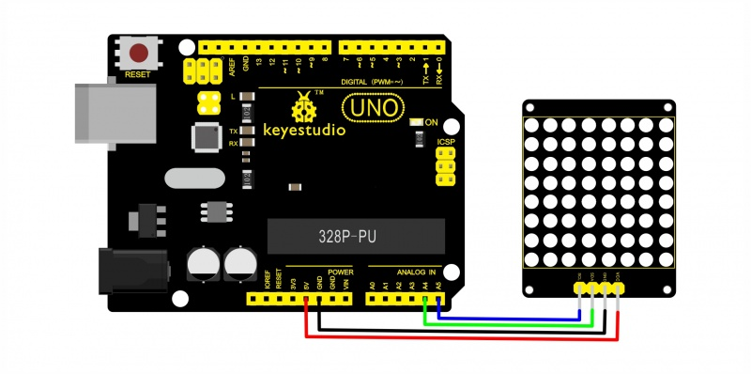

**Sample Code:**  
<https://github.com/adafruit/Adafruit-LED-Backpack-Library>

Copy and paste the code below to Arduino software:

#include <Wire.h>

#include "Adafruit\_LEDBackpack.h"

#include "Adafruit\_GFX.h"

#ifndef \_BV

#define \_BV(bit) (1<<(bit))

#endif

Adafruit\_LEDBackpack matrix = Adafruit\_LEDBackpack();

uint8\_t counter = 0;

void setup() {

Serial.begin(9600);

Serial.println("HT16K33 test");

matrix.begin(0x70); // pass in the address

}

void loop() {

// paint one LED per row. The HT16K33 internal memory looks like

// a 8x16 bit matrix (8 rows, 16 columns)

for (uint8\_t i=0; i<8; i++) {

// draw a diagonal row of pixels

matrix.displaybuffer[i] = \_BV((counter+i) % 16) | \_BV((counter+i+8) % 16)  ;

}

// write the changes we just made to the display

matrix.writeDisplay();

delay(100);

counter++;

if (counter >= 16) counter = 0;

}

**Note:** Before compiling the code, do remember to place the library into libraries directory of Arduino IDE. Otherwise, compiling will fail.

**Example Result:**   
  
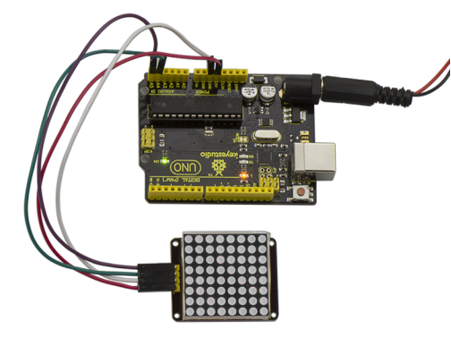  
Wire it up as above figure and upload well the code to UNO board, you will see the dot matrix display the image shown below.   
